Evolution and hereditary

QnA app

Target - C

Task P – 5.1 c

LUIS and QnA Maker

Saurabh Dharmadhikari

Saurabh.dharma01@gmail.com

Table of Contents

Introduction: 2

Step 1: Creating a language resource group 3

Step 2: Log into Language Studio 7

Step 3: Creating a new project 9

Step 4: Adding source to our project, testing and deployment 11

Step 5: Editing and testing project created 19

Step 6: Deployment of the project 24

Step 7: Create a bot 26

Step 8: Testing our bot in Azure resource 28

Step 9: Creating an app on Meta for Developers 31

Step 10: Messenger setup 35

Step 11: Attaching Facebook app to azure 39

Step 12: Testing app created 43

Conclusion: 46

# Introduction:

We are required to build bot question and answering chat bot and link it to Facebook messenger. The domain on which we are working is organic evolution. Custom built bot is built using Azure Cognitive Services Language Studio, it will be deployed to Azure and attached to Facebook Messenger.

This bot will be able to answer questions related to evolution and how hereditary traits are transferred from one generation to other. It is a simple bot with limited data base on evolution and much complicated bots can be built using the same tools. This is to demonstrate how these QnA bots are built. Building process is explained step by step and attached to other applications for public use.

# Step 1: Creating a language resource group

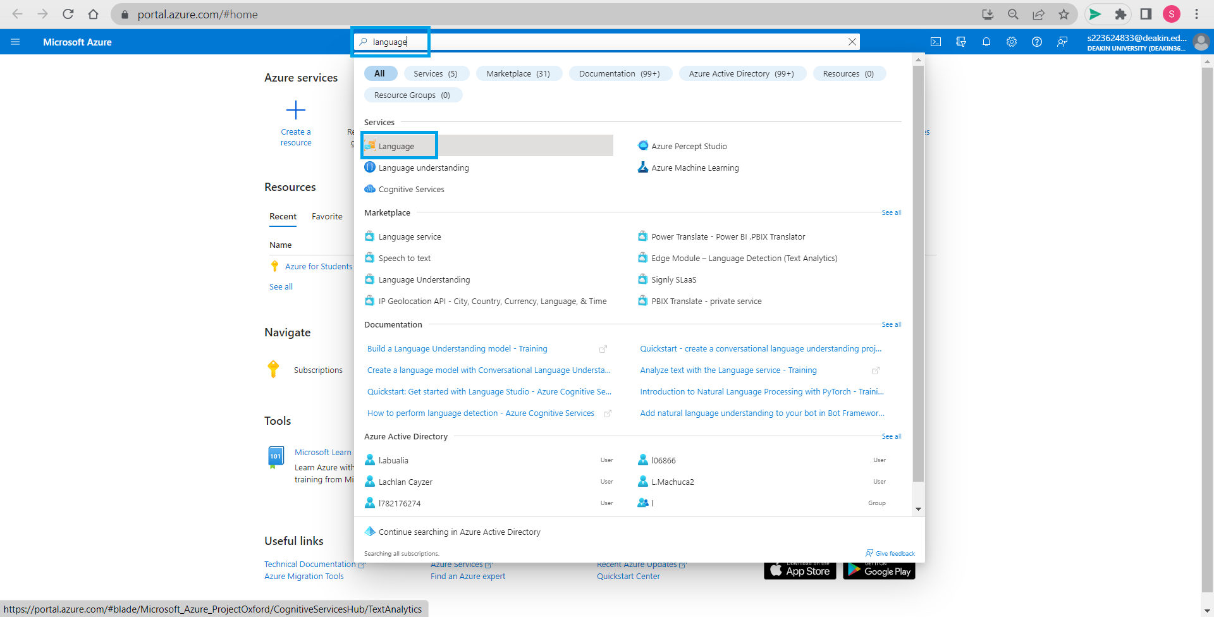

Open Azure portal and log in to your account then search language and select it.

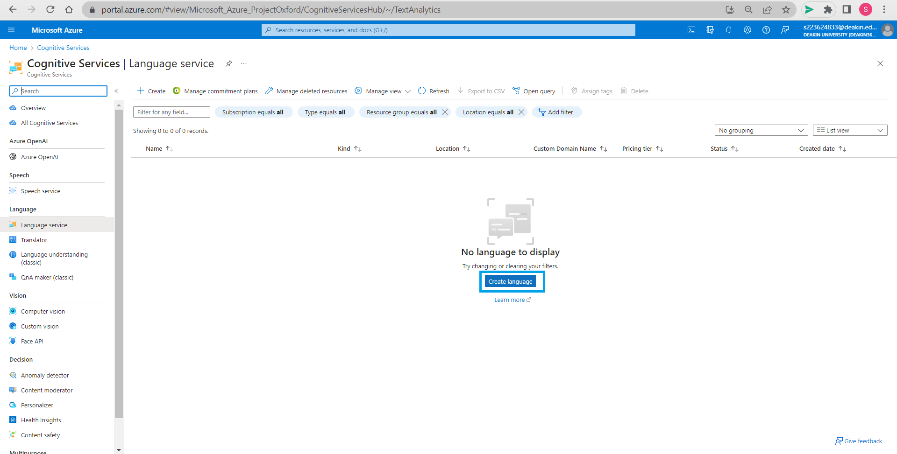

Click on create language in language service resource provided by Azure.

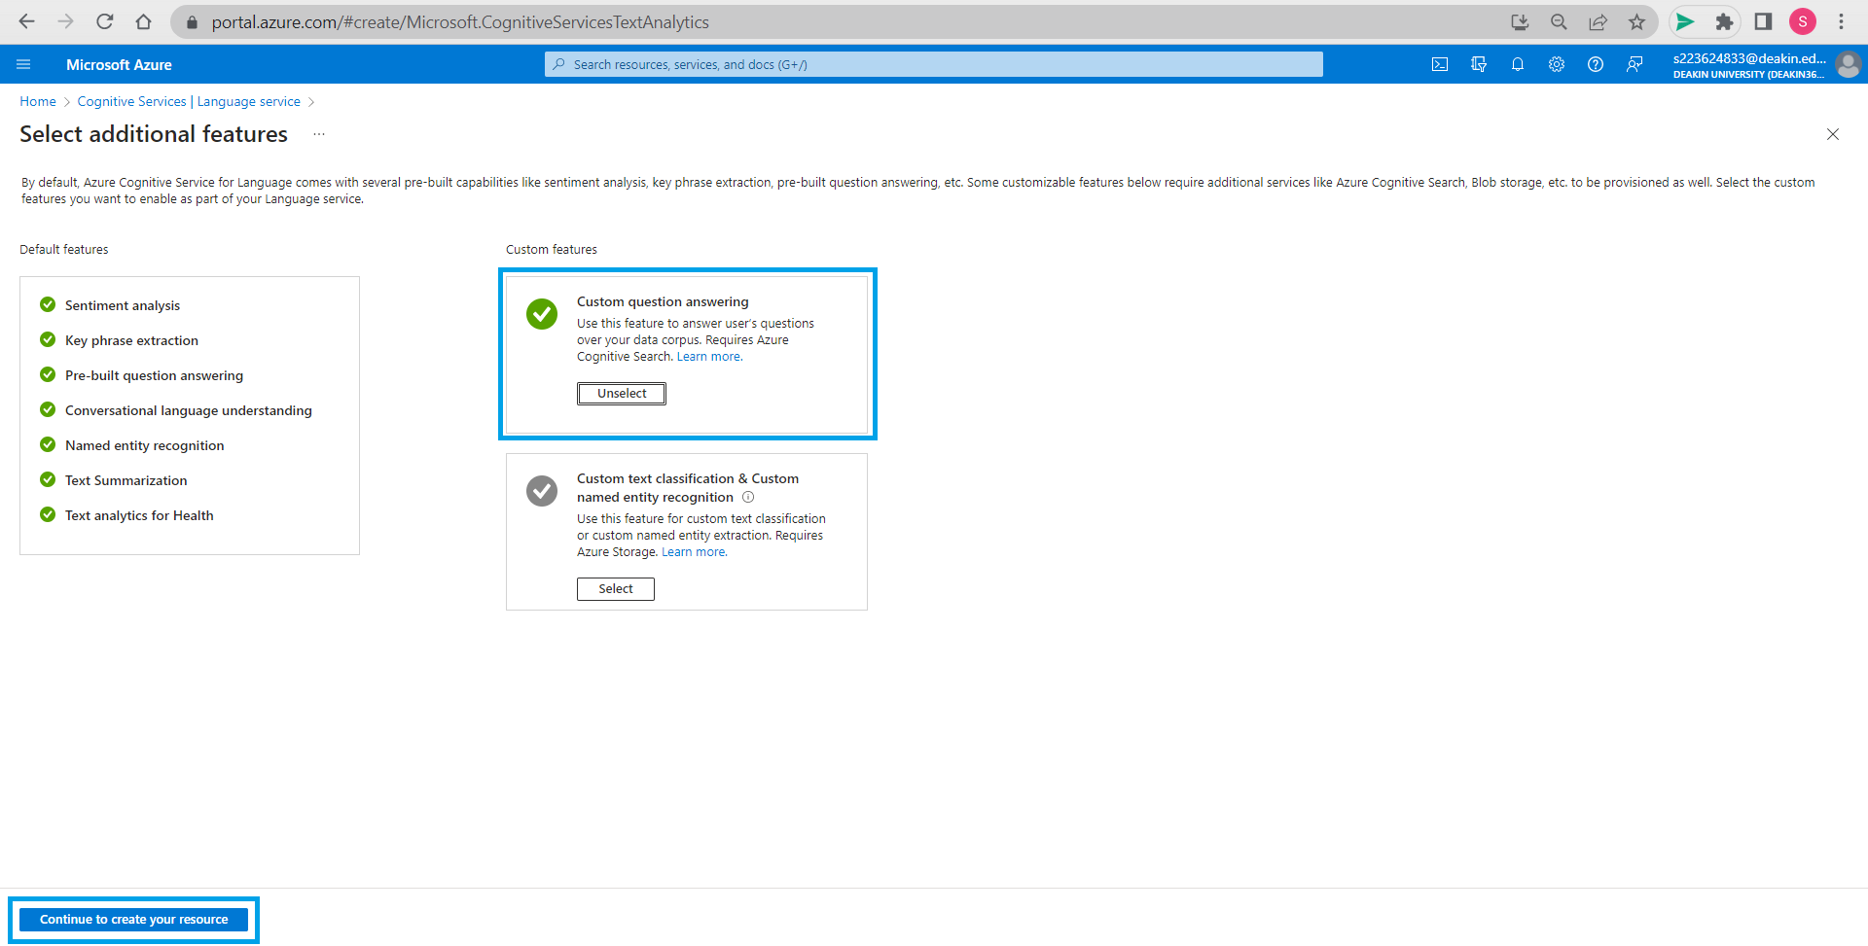

We select *Custom question answering* settings for our bot but if required we can select other custom features as well. We continue to create our resource.

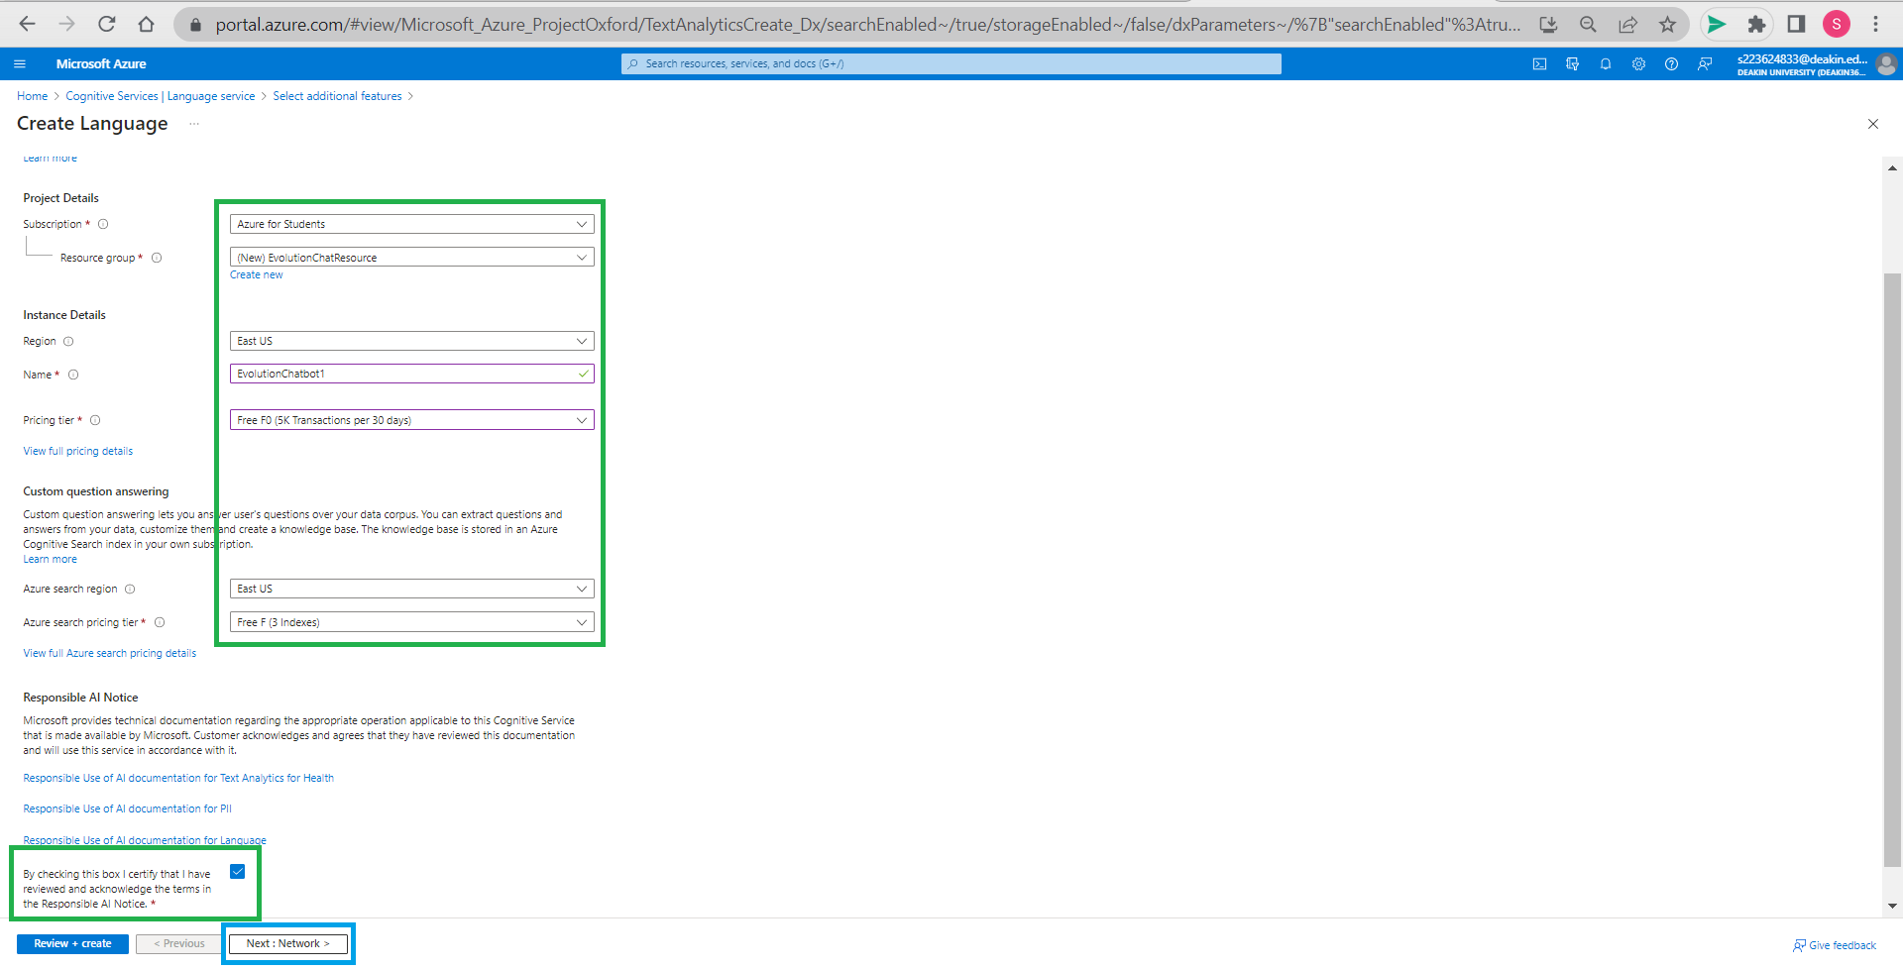

We fill in all the required details selecting region as East US and pricing tier Free and click on next.

We created new resource group named EvolutionChatResource by clicking on create resource and named language resource as EvolutionChatbot1. Also check the box that you have reviewed and acknowledged the terms for responsible AI Notice.

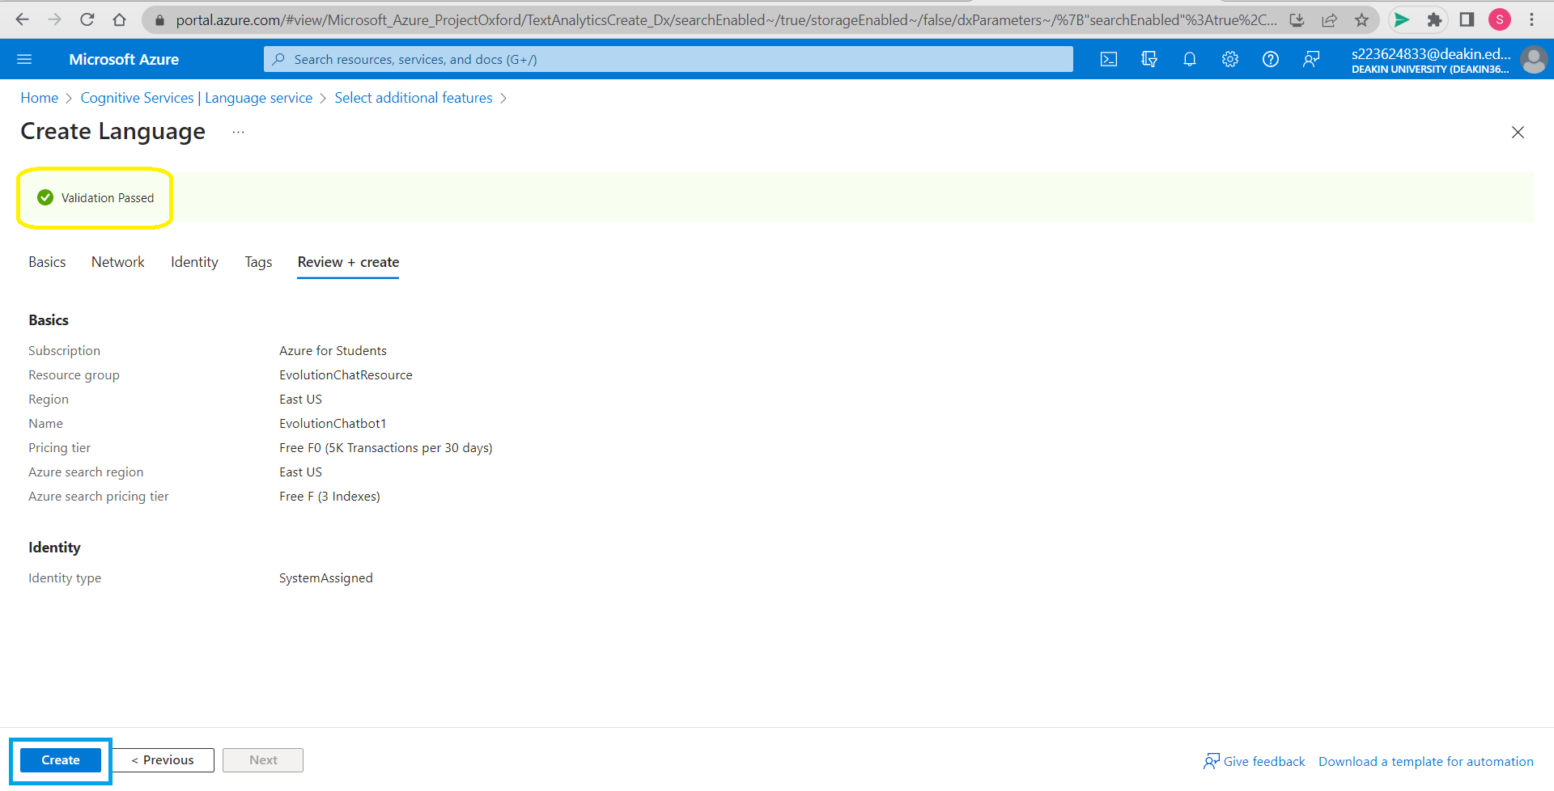

Next and check all details, come to review + create. Once validation is passed, we are ready to create this resource group, click on *Create*.

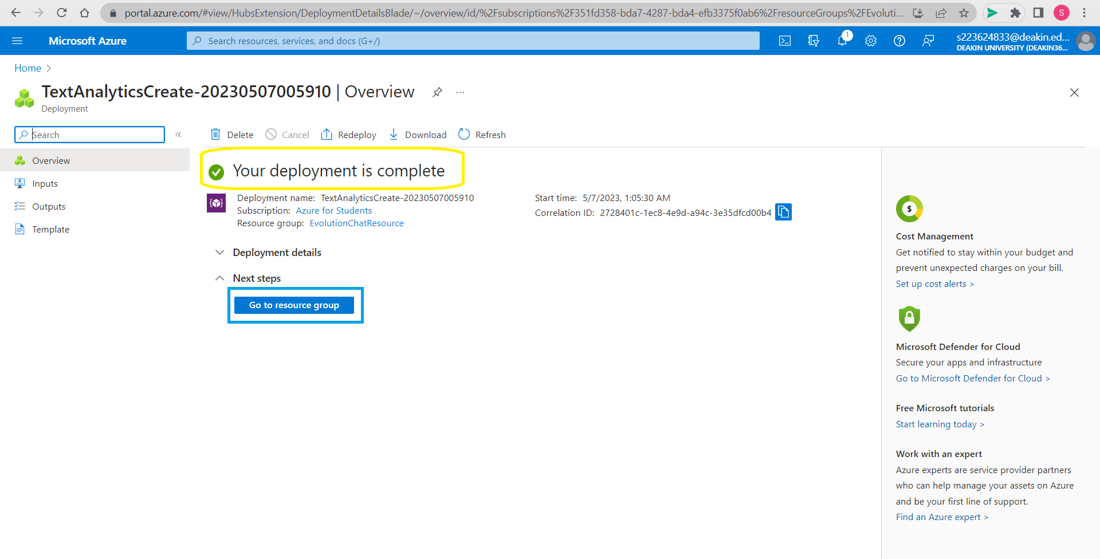

This will complete the deployment and creation of language resource. When we click on *Go to resource group* it will take us to the language resource that is created from where we can go to Language Studio. Deployment for text analytics resource is complete now go to resource group.

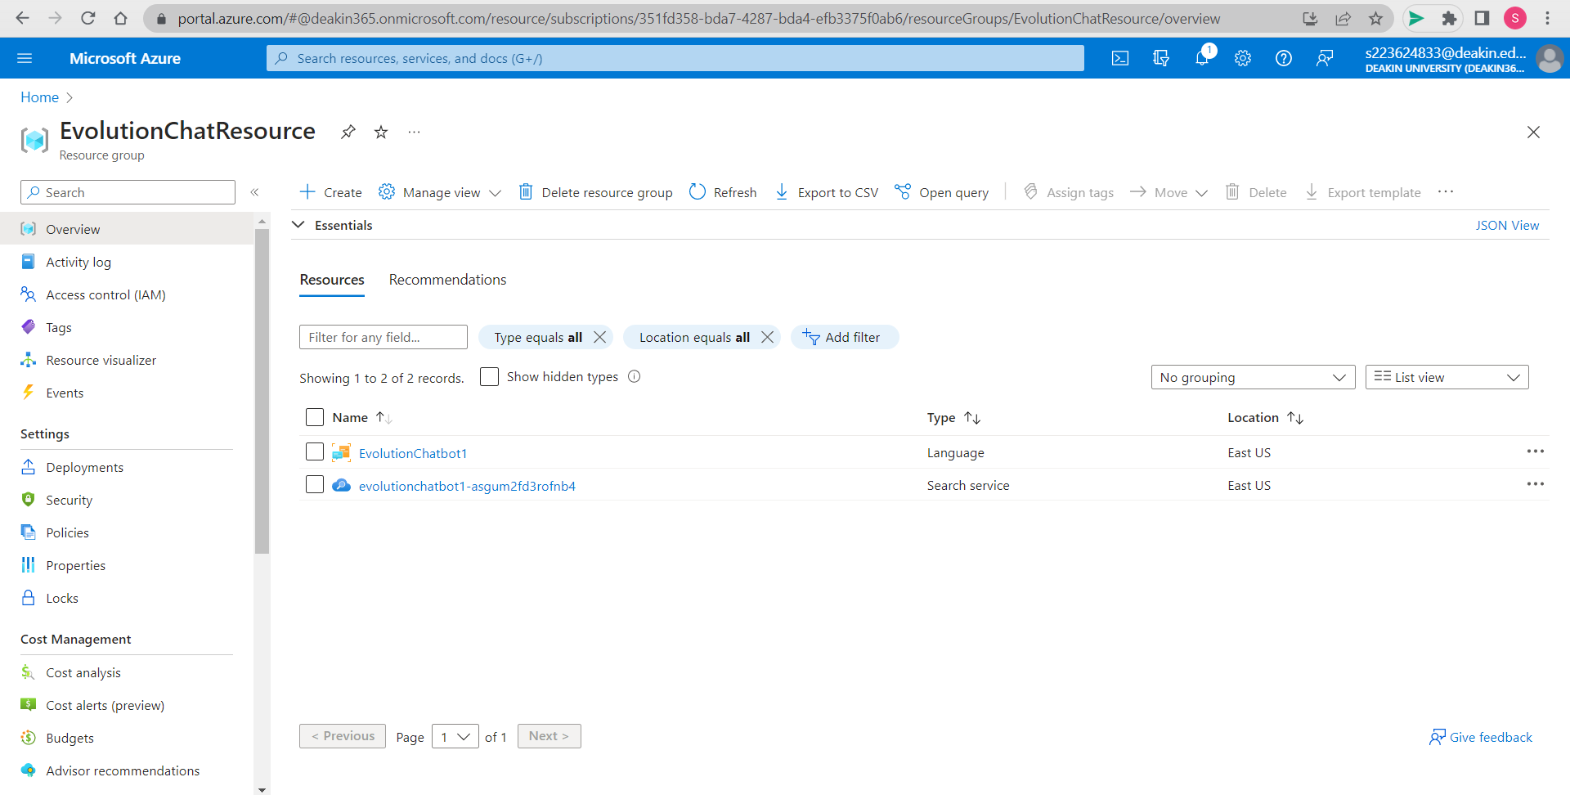

Under new resource EvolutionChatResource that we created we can find resources created for text analysis i.e., EvolutionChatbot1 and search service offered by Azure. All these resource location is East US.

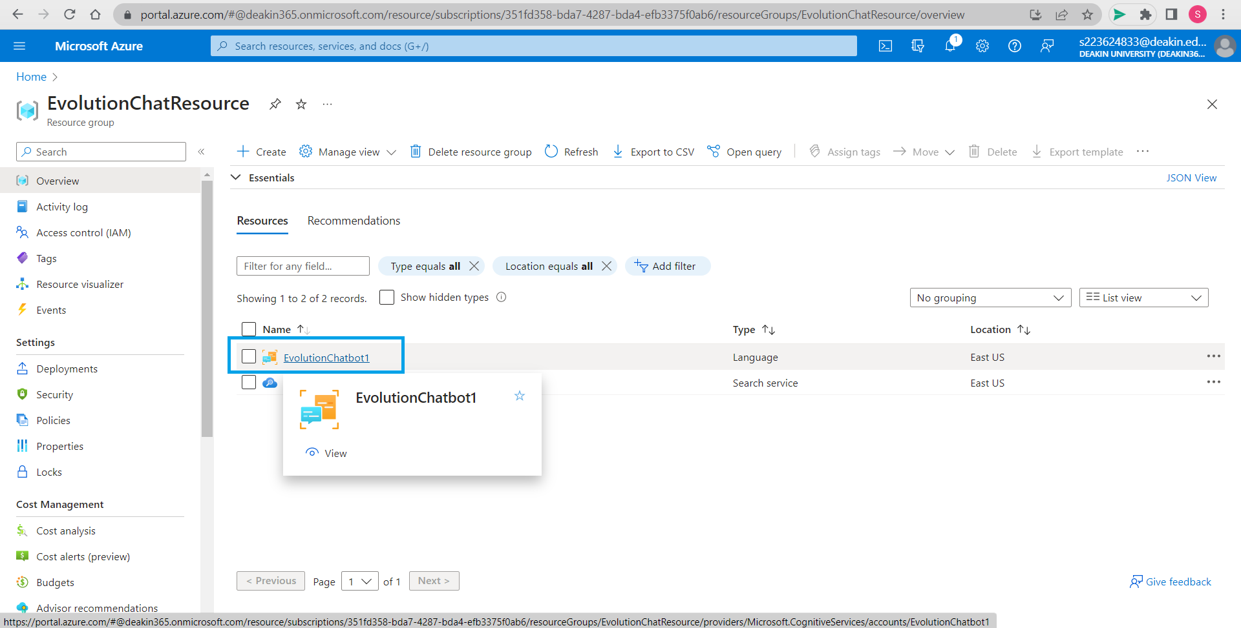

We can now select language resource EvolutionChatbot1 that we created

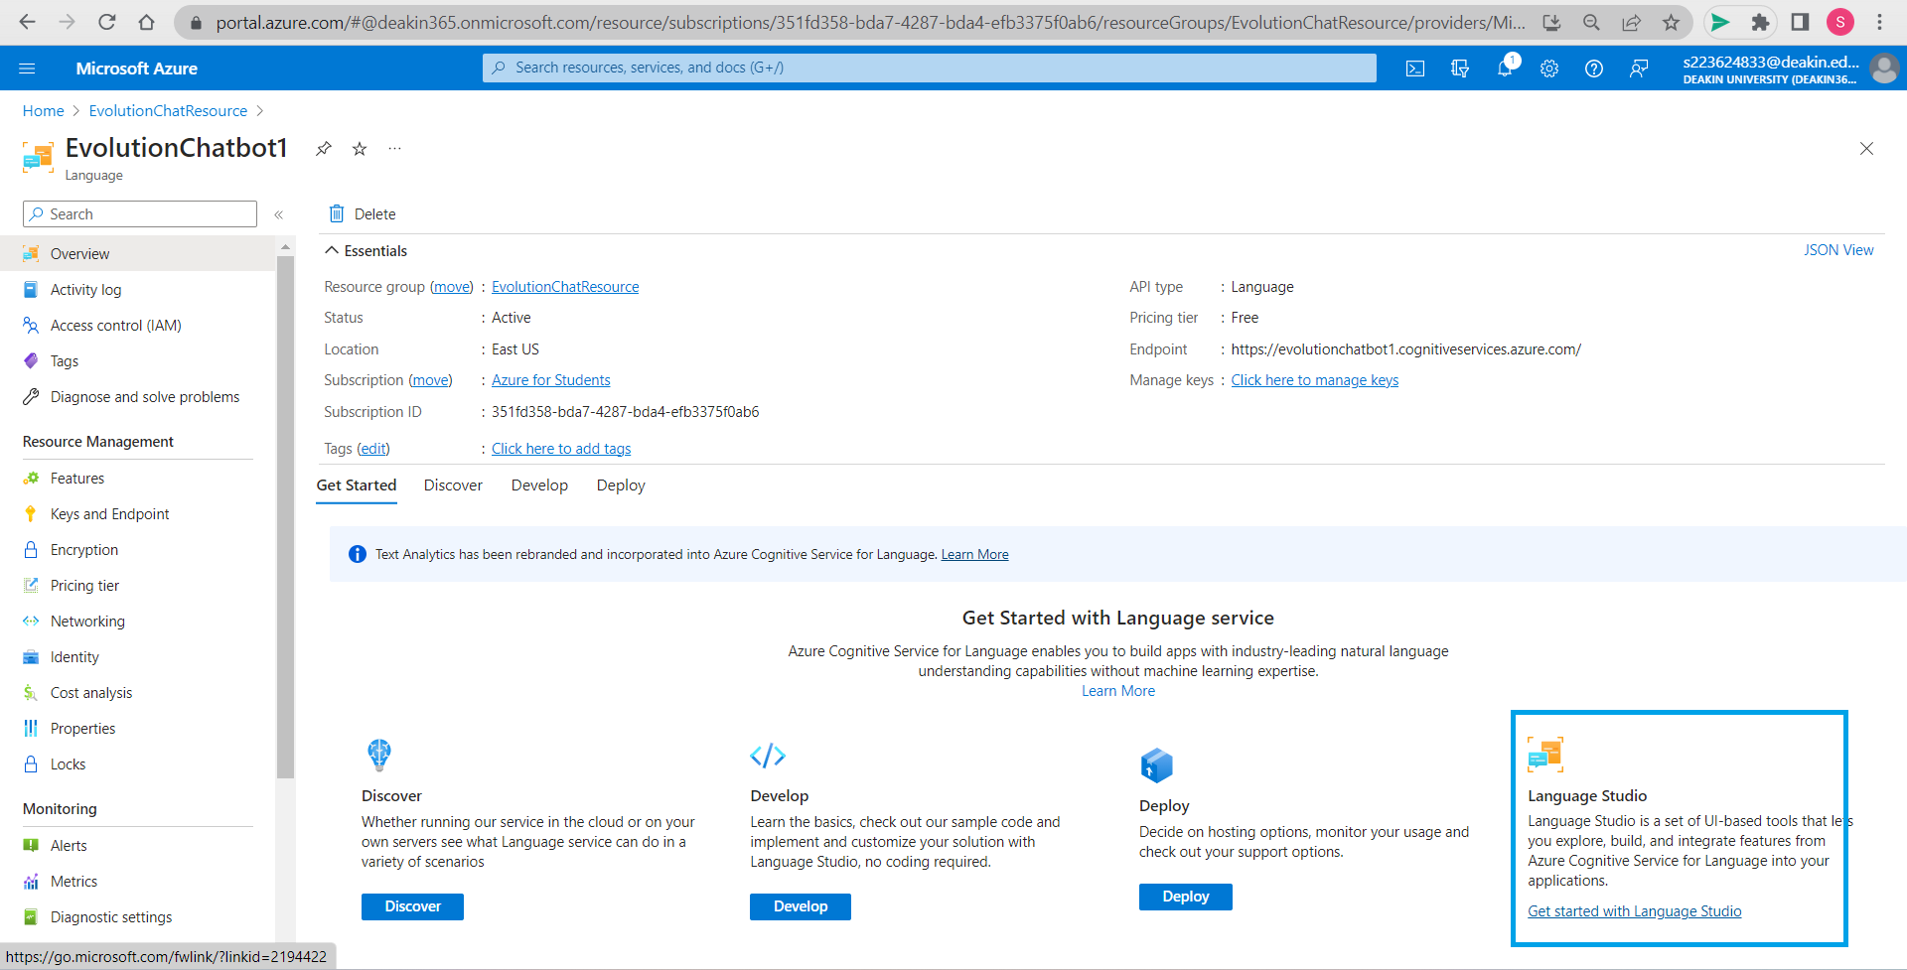

We can check the details for the resource created and go to Language Studio. Click on *Get started with Language Studio.*

# Step 2: Log into Language Studio

Click on *Get started with Language Studio* to launch Language Studio.

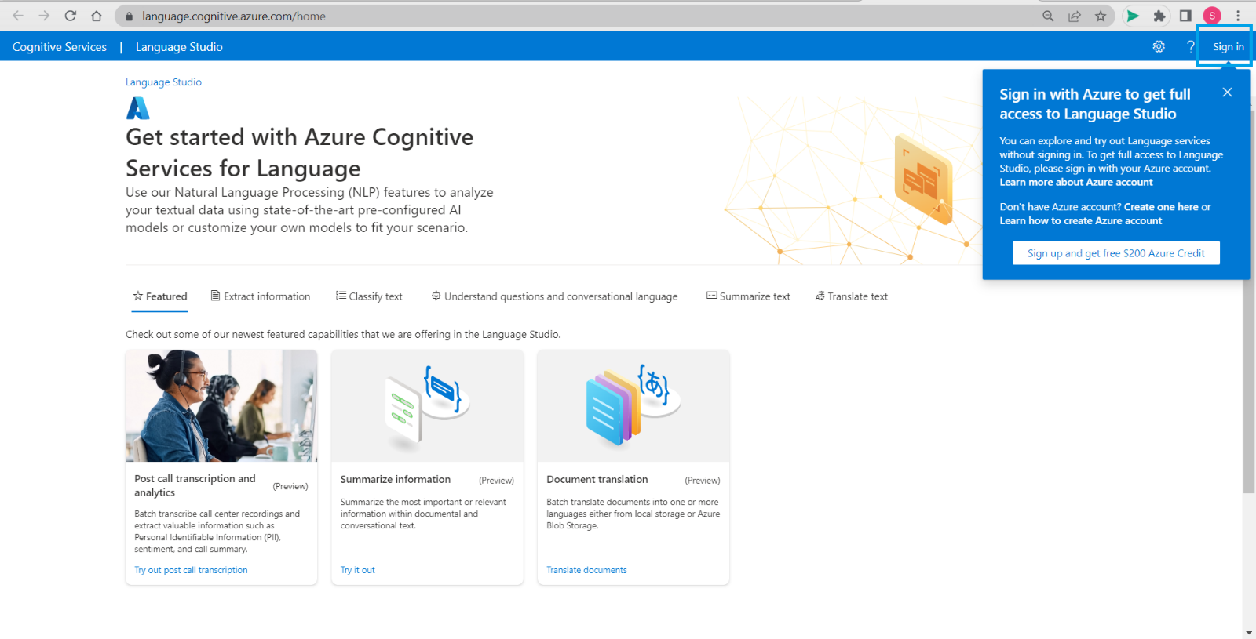

Log into Language Studio by clicking on *Sign in.*

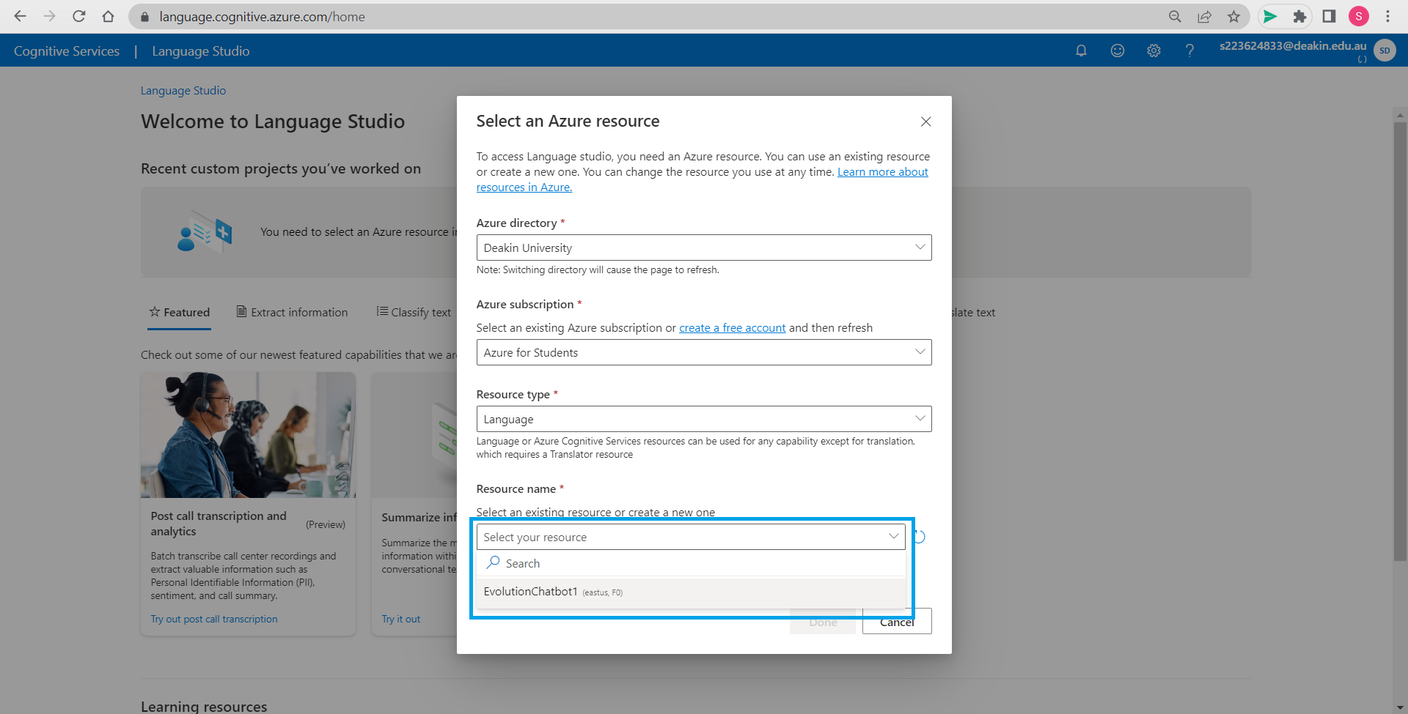

From drop down box in Resource name select the resource we created earlier that is EvolutionChatbot1. While logging in, Language studio will ask to select language resource to work on, Select the one created earlier that is EvolutionChatbot1 and check other details that are already filled and click on done once all info is filled.

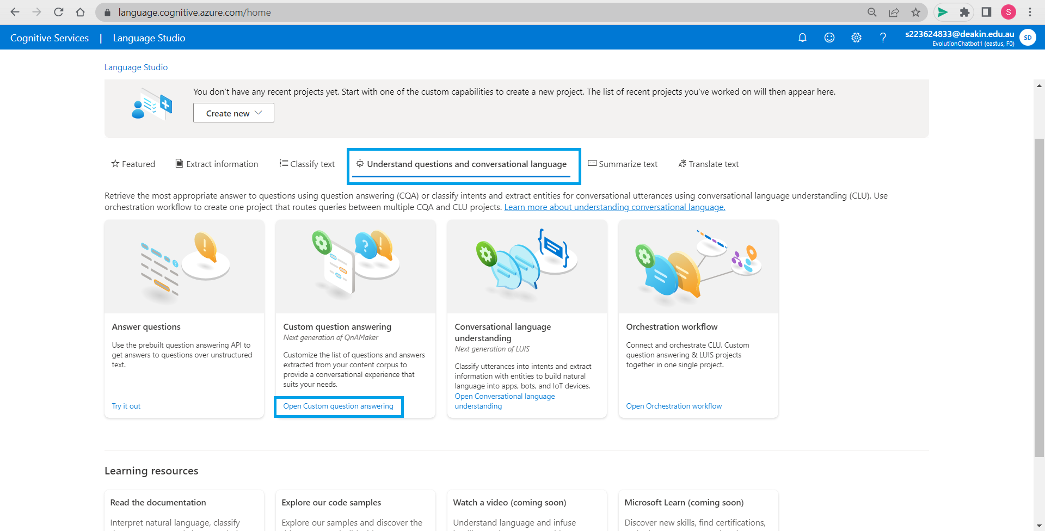

Go to *Understand questions and Conversational language,* Under it find *Open Custom question answering.*

# Step 3: Creating a new project

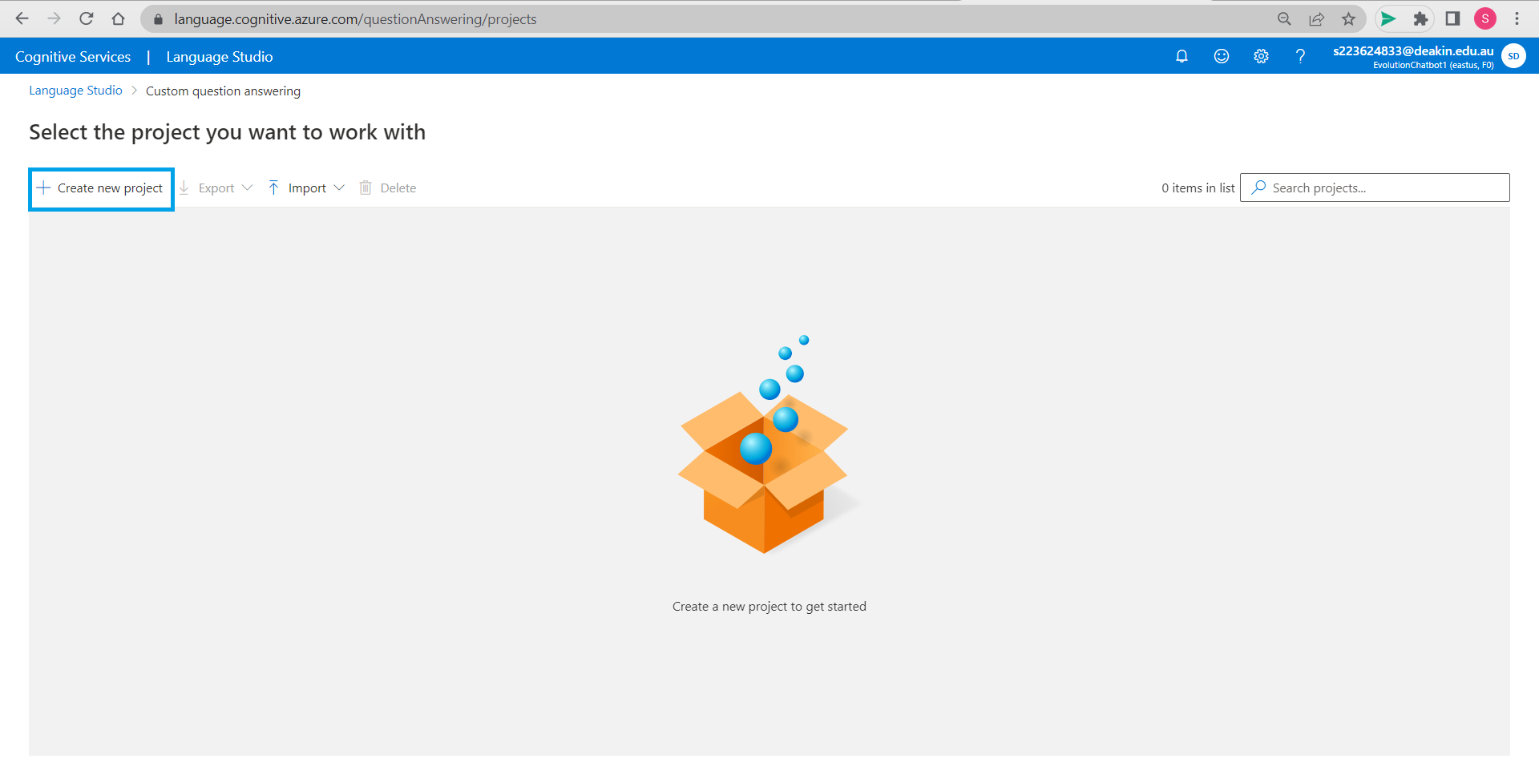

As we already have a Azure search resource we can *Create new project.*

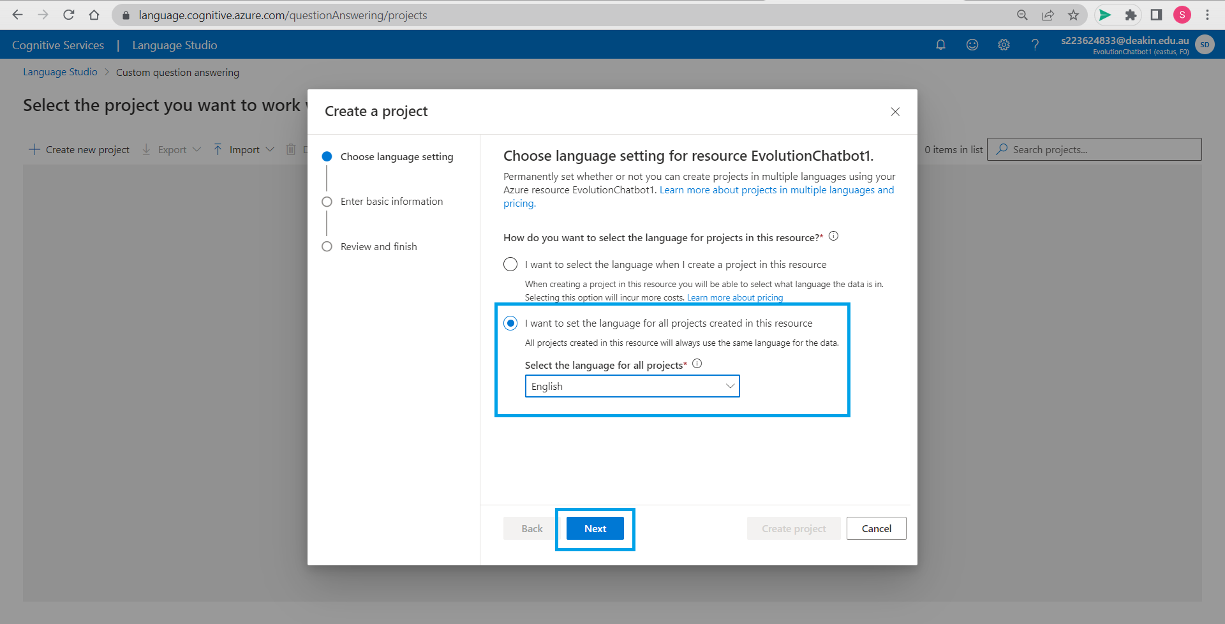

Choose language settings for your resource. There are many options for language but we have selected English and we want to set English for all the projects created in this resource. Press next.

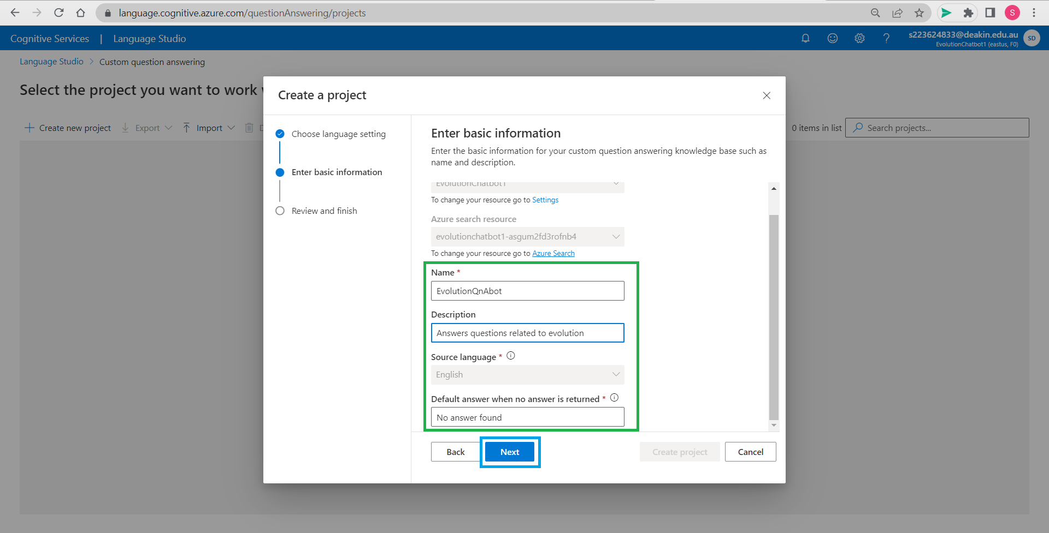

When we click on next, we will have to fill in some basic information about the project we are creating like its name and description and we are setting default answer as *No answer found*.

Project name: EvolutionQnAbot

Click on next.

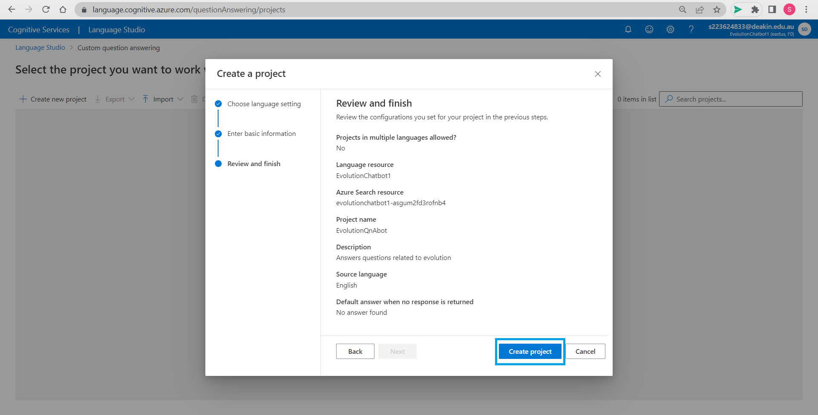

Review the information again and *Create project*.

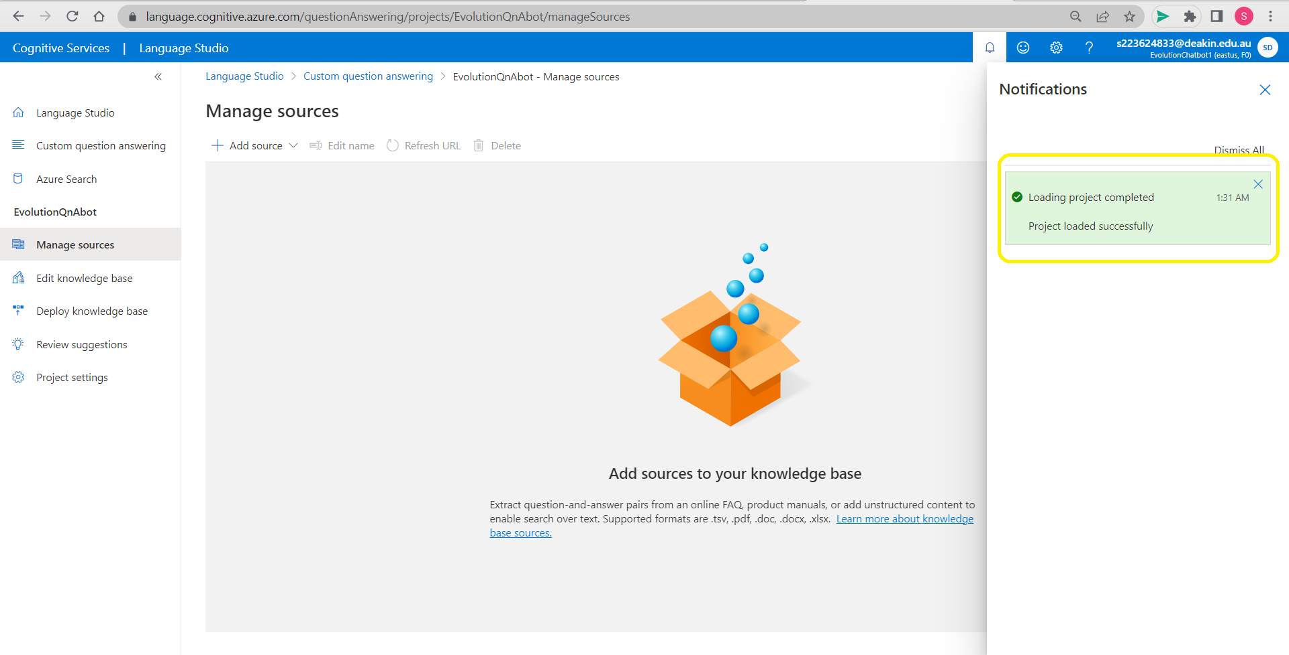

Project is successfully created and loaded and we have more options on the left-hand side of the screen.

# Step 4: Adding source to our project, testing and deployment

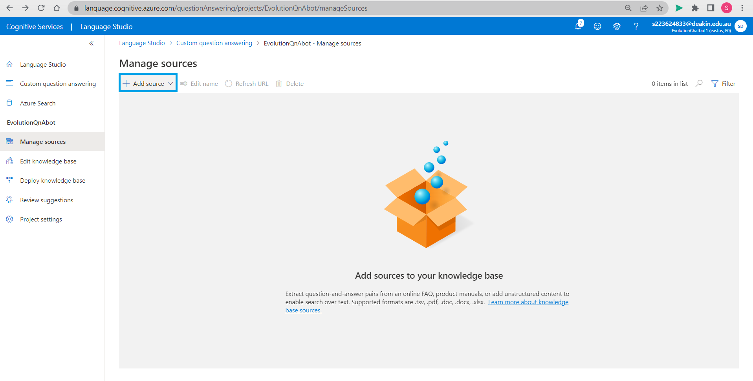

Go to *Add source*.

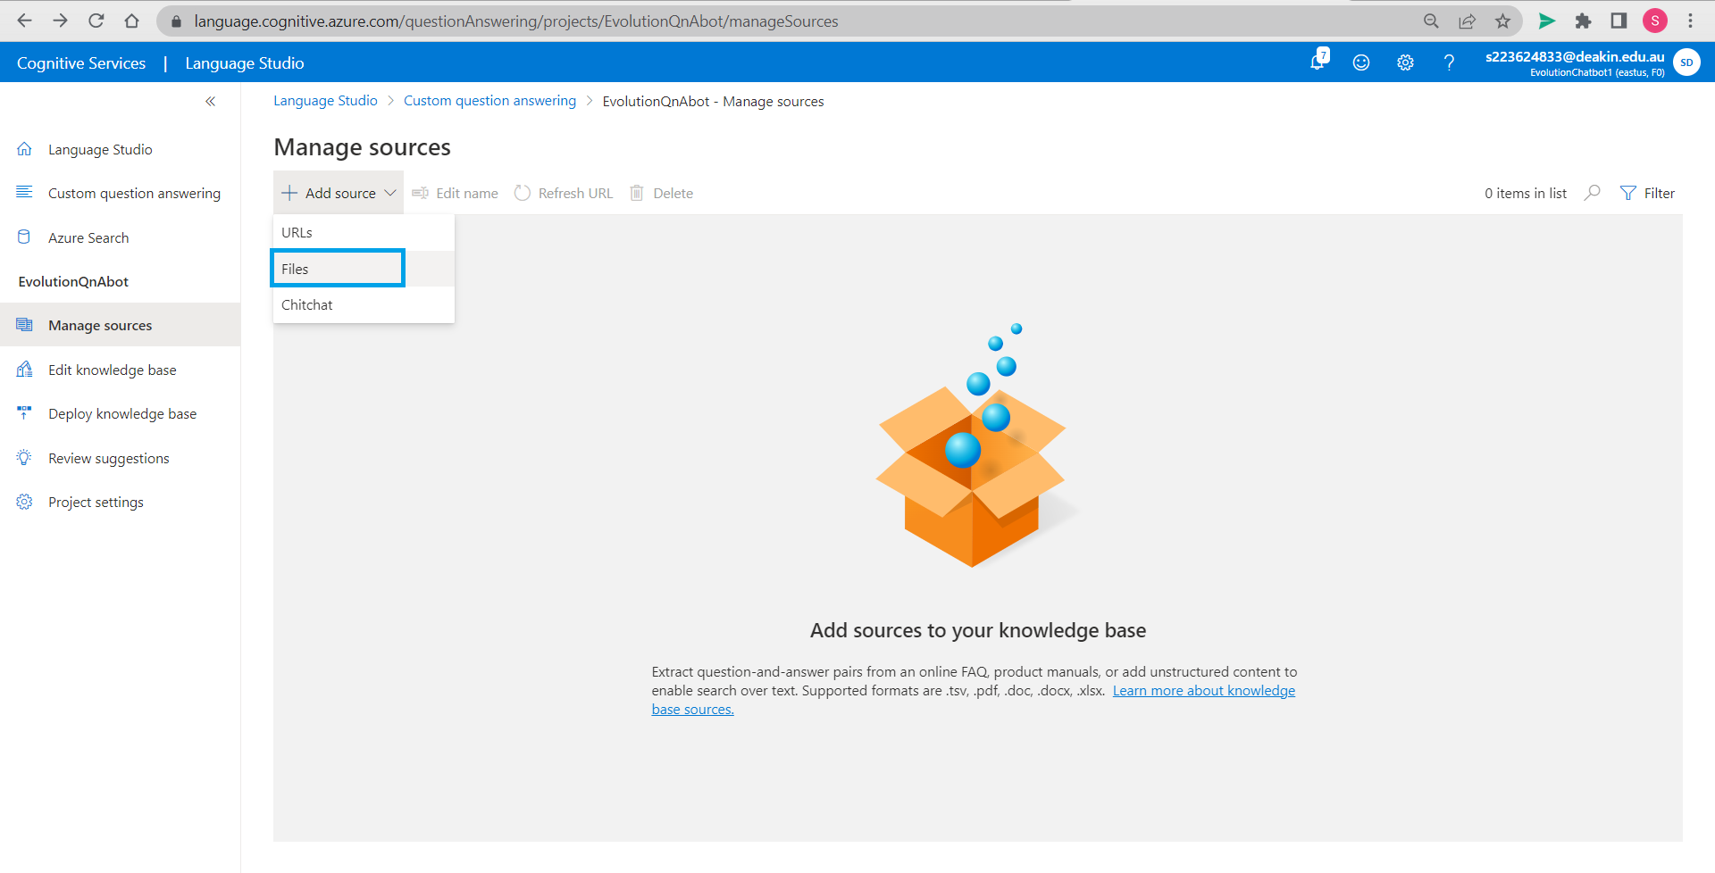

You can select different knowledge sources for your project, we first select *Files*.

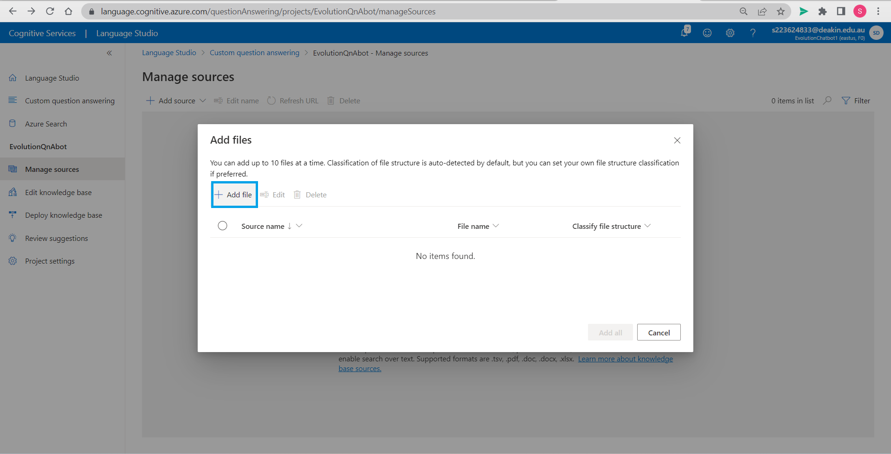

Click on *Add file*.

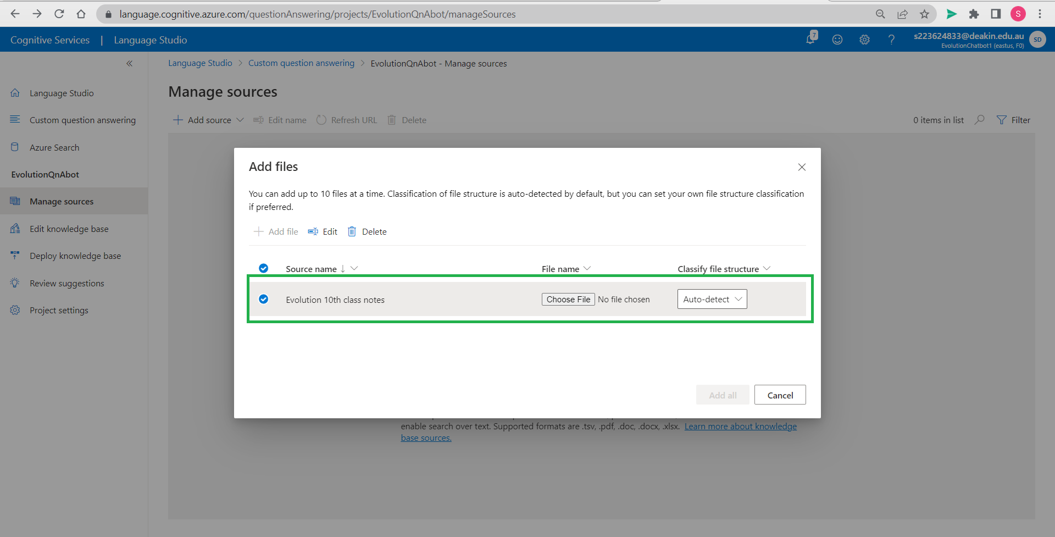

Name the source and click *Choose File* to upload from your computer browse in local drive to open it. We have christened our source as Evolution 10th class notes (Byju’s CBSE study material), it is a pdf file. You may have multiple source file.

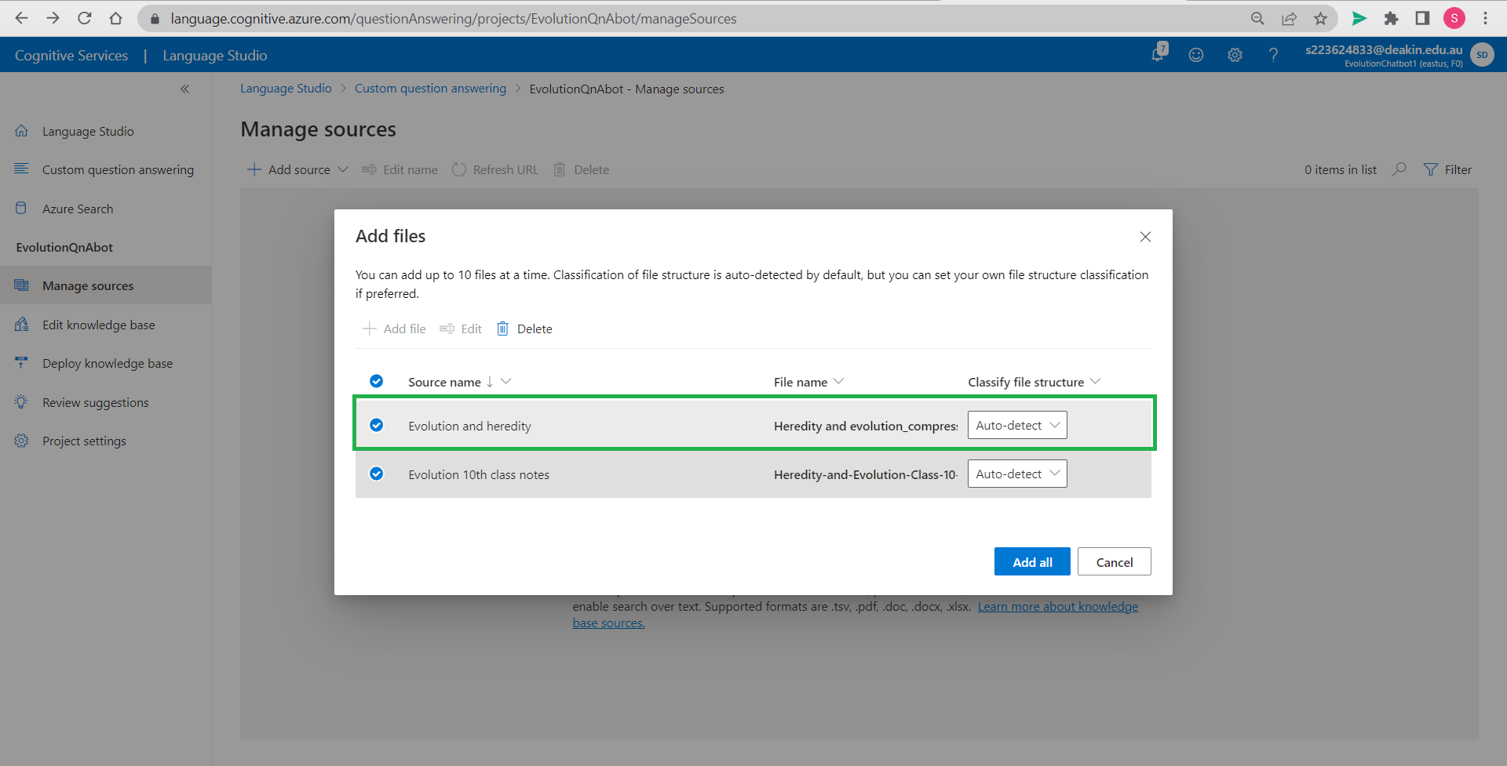

We again chose to add another file (kvs.ac.in) and uploaded from local machine.

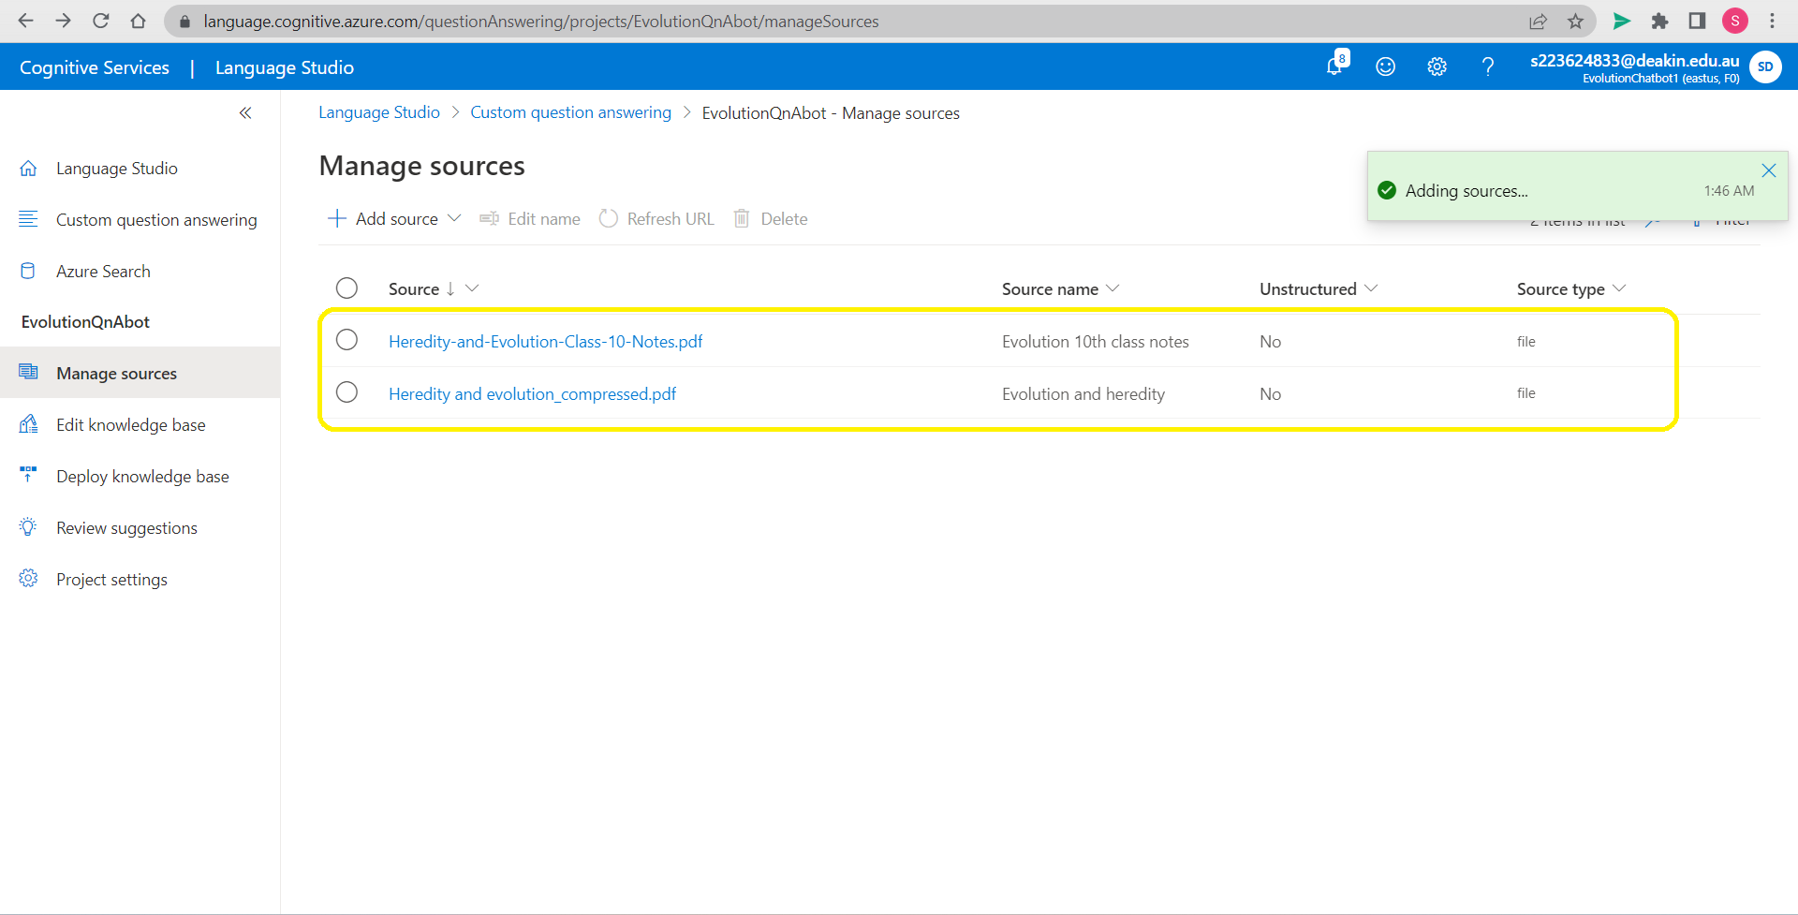

Both our knowledge sources are add here.

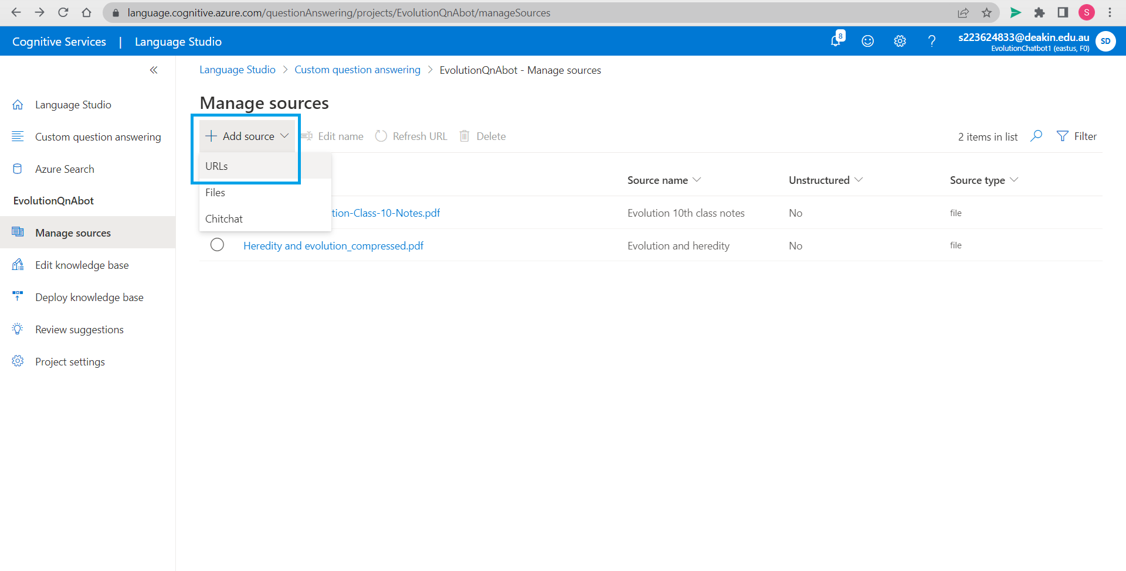

We now adding URLs that will expand our knowledge base and info, webpage will also be analysed before answering.

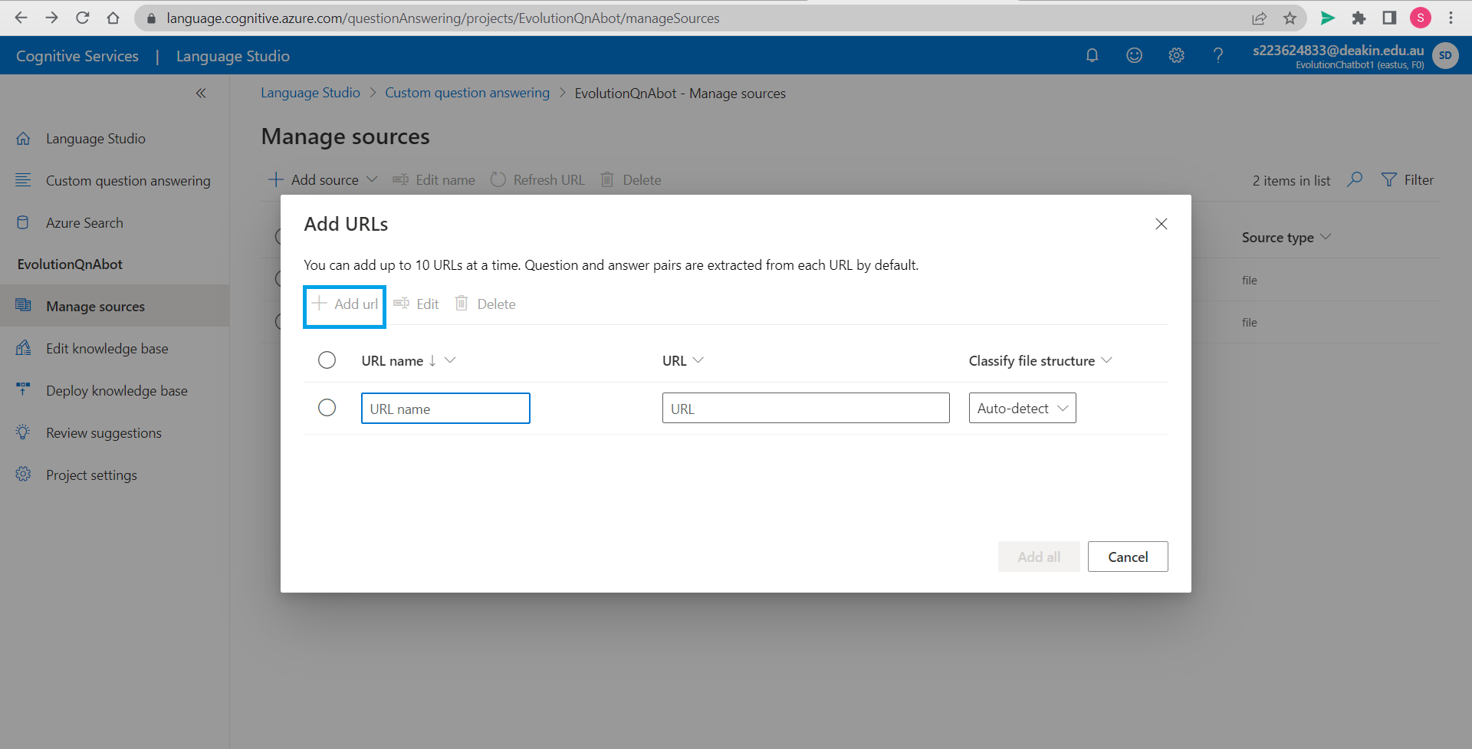

Click on *Add url*.

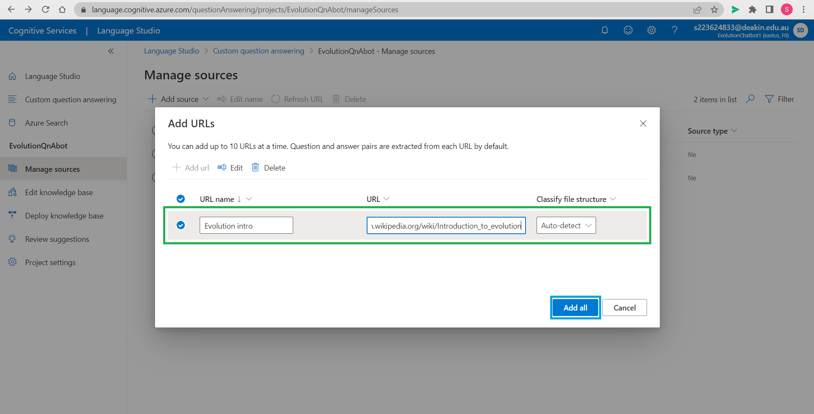

Name URL source(Wkipedia.com) and paste web address to add source. Click on *Add all*.

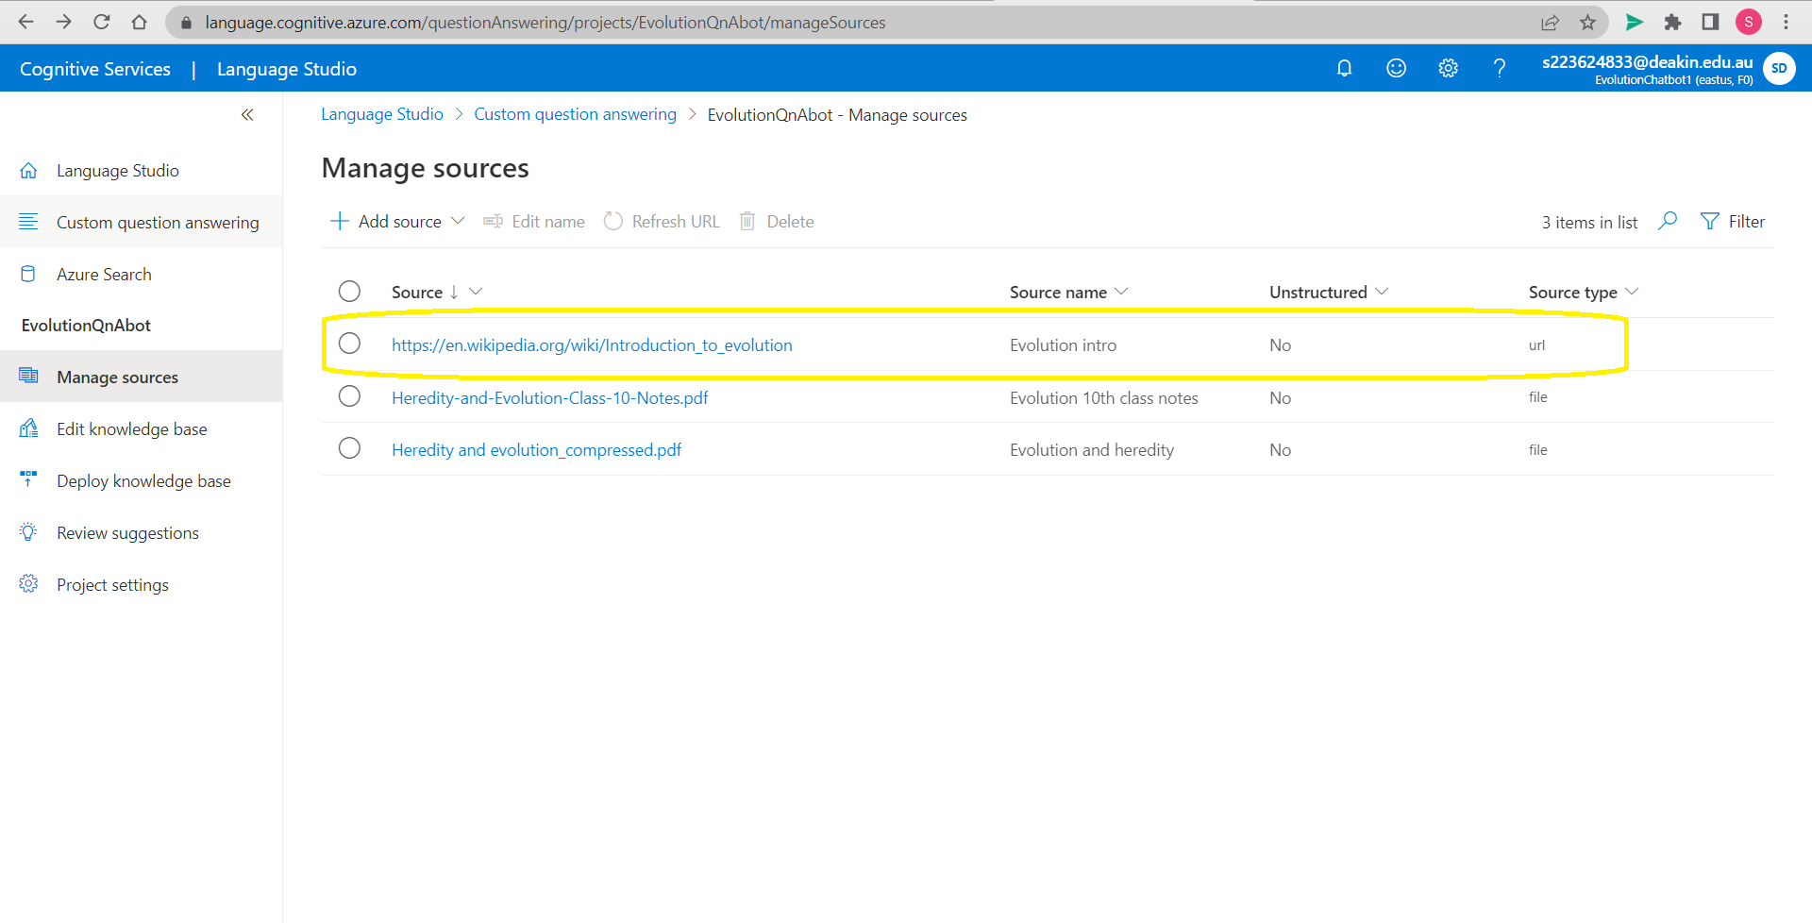

We have successfully added 3 sources including 1 url and 2 file.

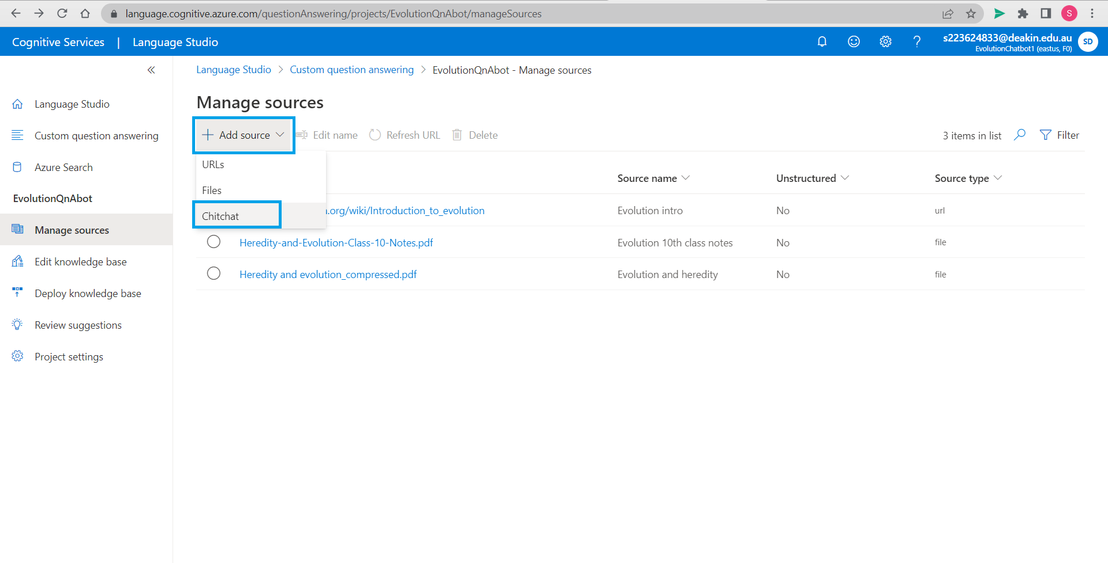

We are also adding a chit chat source available in Language Studio to make small talk to give it a better experience to the user.

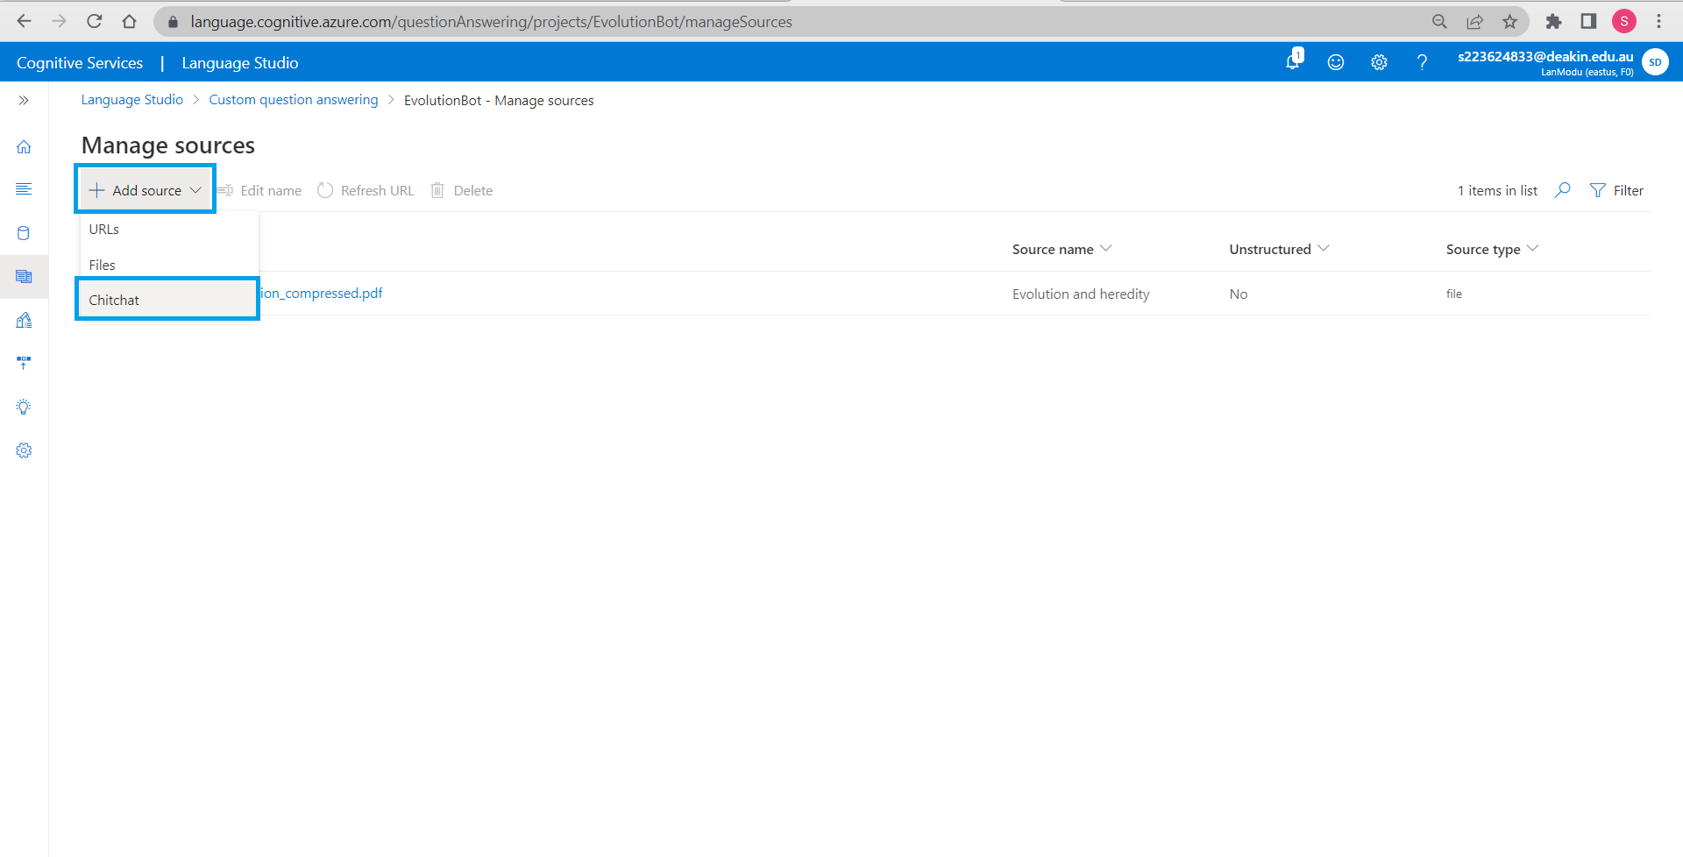

We are also adding a chit chat source available in Language Studio to make small talk to give it a better experience to the user.

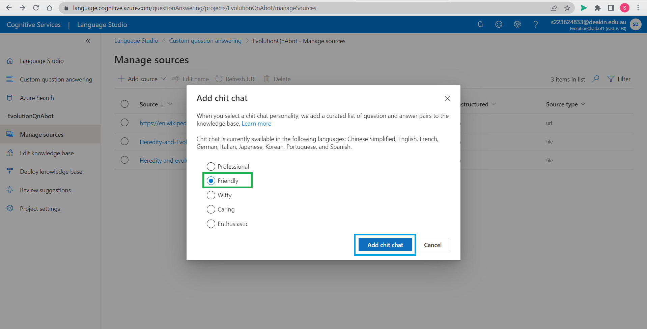

There are multiple options to choose from. We have selected *Friendly* and then click on *Add chit chat*.

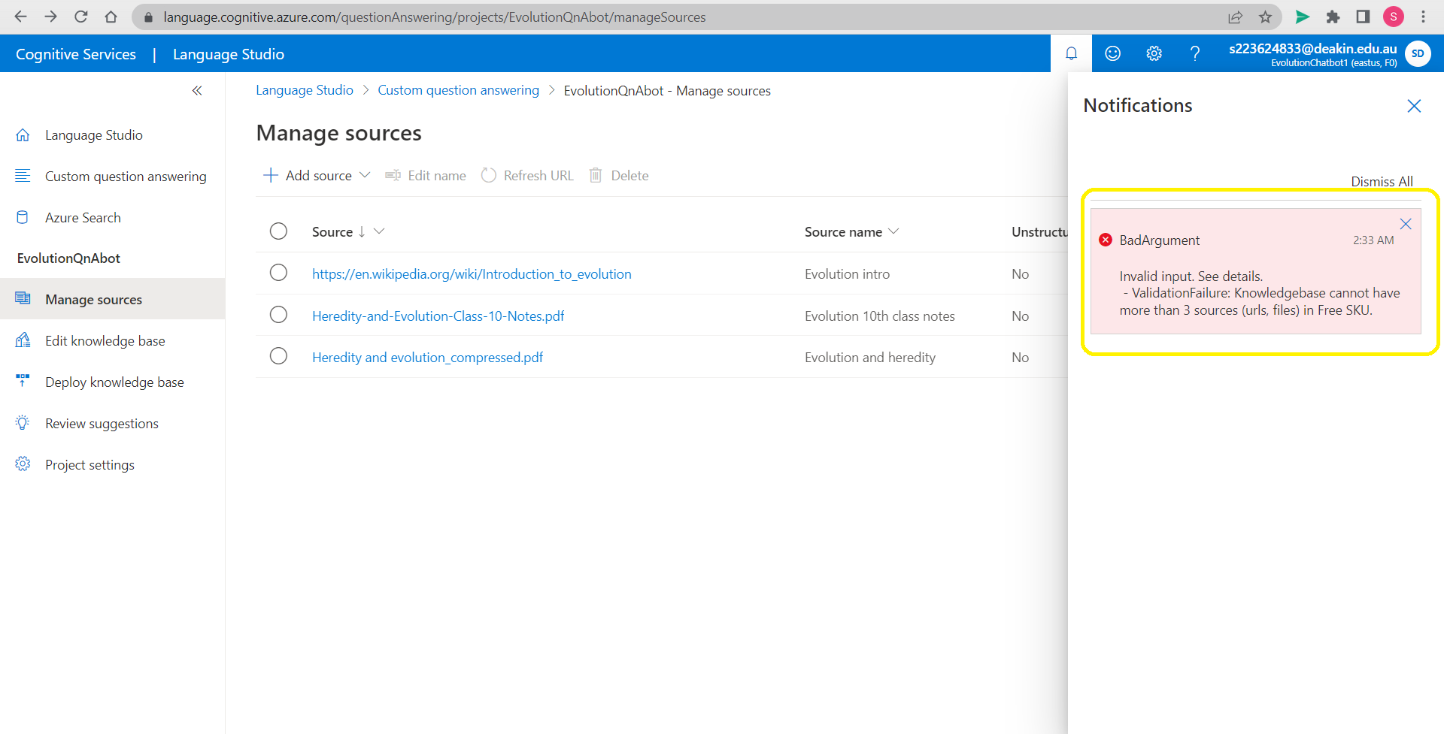

We find that there is an error because we are using Free SKU and it does not allow more than 3 sources.

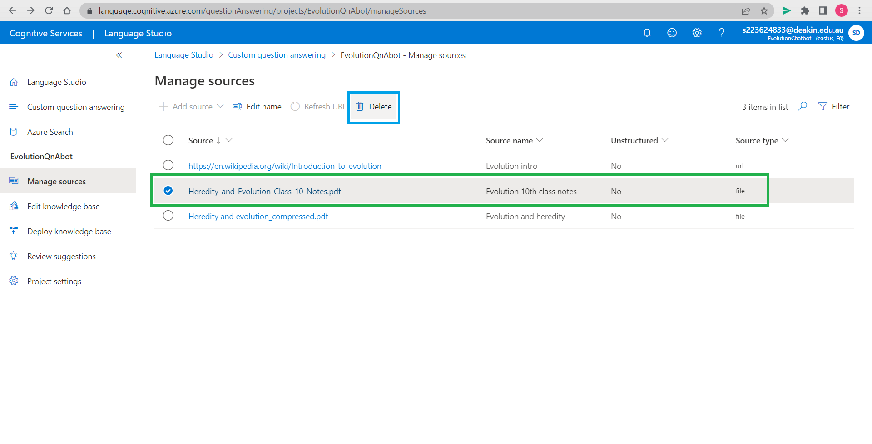

We will select Heredity-and-Evolution-Class-10Notes.pdf and click on delete to remove this source from our knowledge base.

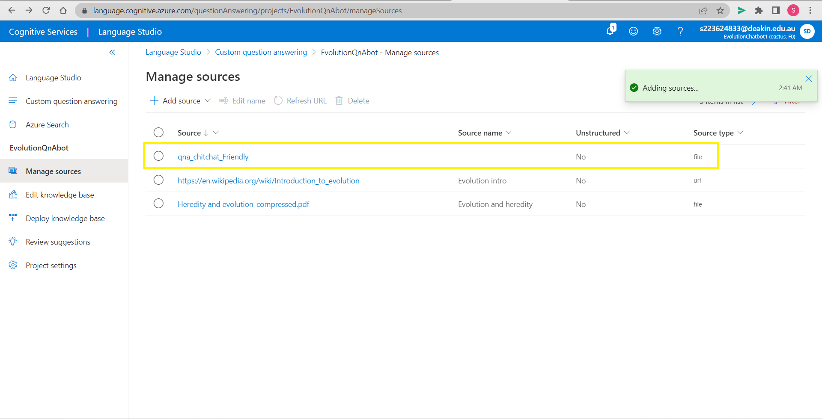

We again try to add friendly chitchat resource feature and this time it is added to our knowledge base.

# Step 5: Editing and testing project created

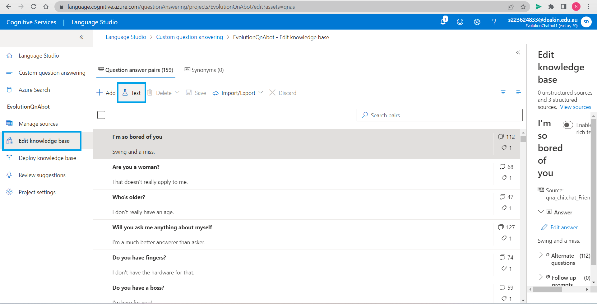

Go to *Edit knowledge* base and check the question answer pairs created by custom Azure, here we can edit questions to add questions. We now click *Test* to check project that is created.

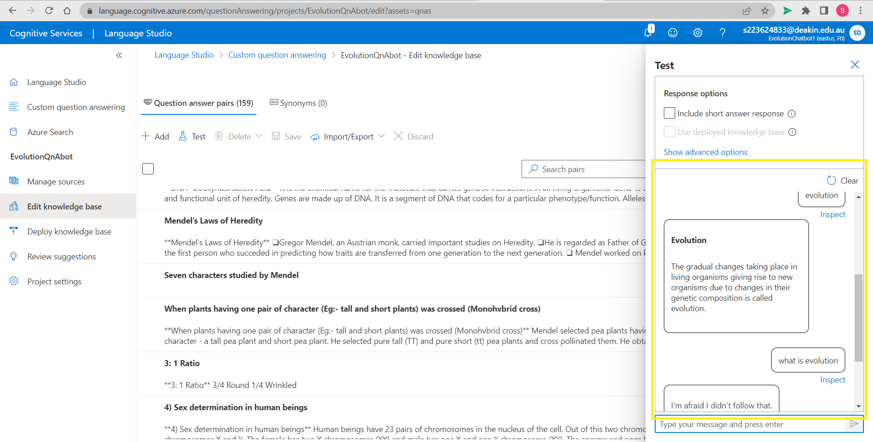

We test by asking questions. We find that it is able to answer to us when question is asked as *Evolution* but when we ask as *What is evolution,* then it is not able to answer the questions. That means we need to give in more utterances to our bot so it can learn from them.

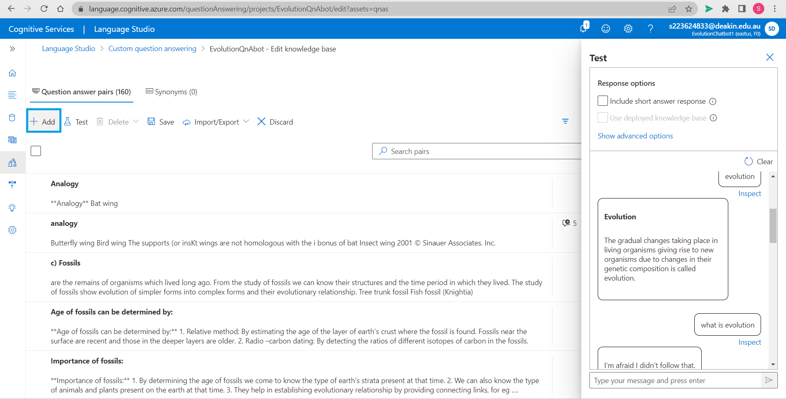

Click *Add* on top left corner of the work space.

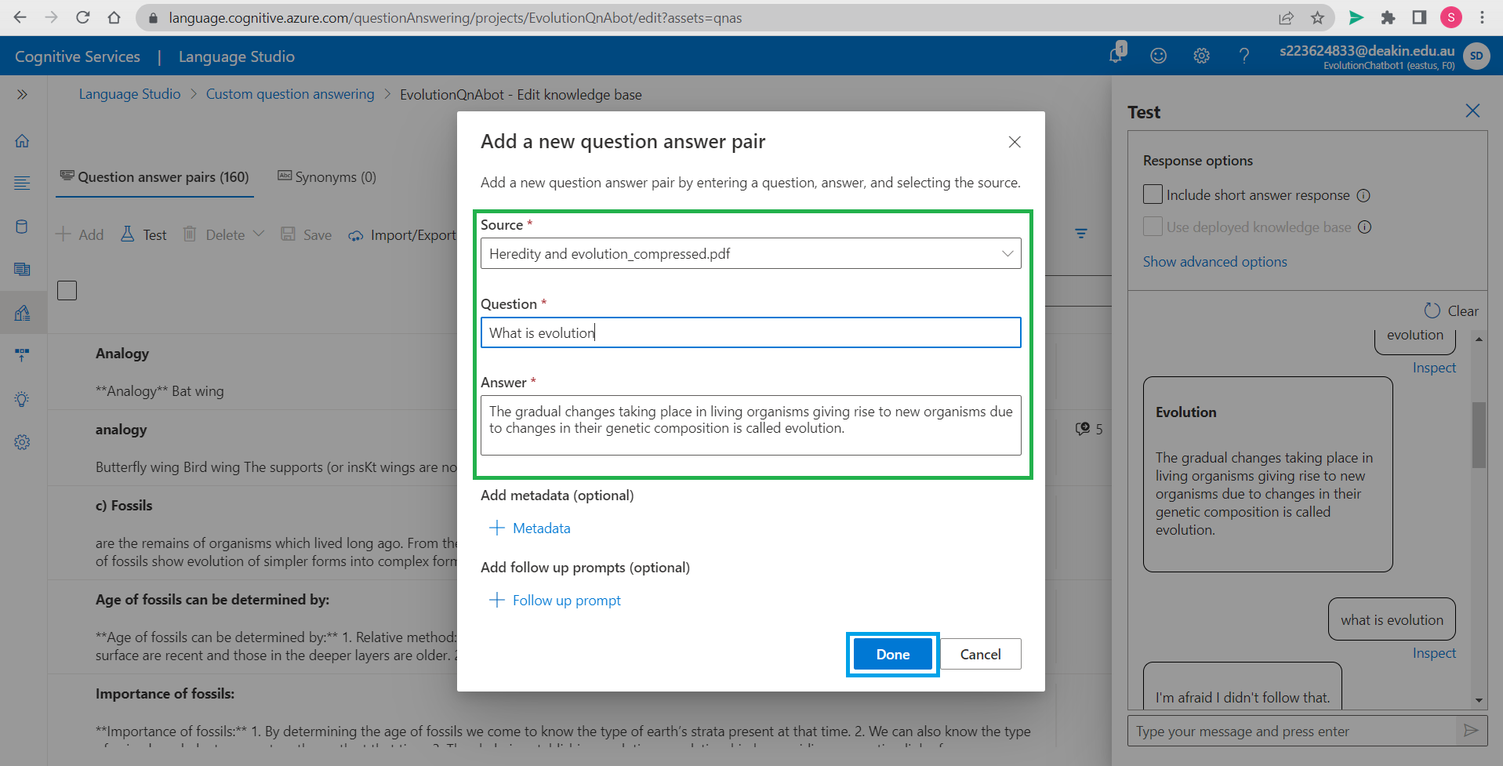

Fill in Source details. Enter the question and its answer. You may also choose to add metadata and follow up prompts. Click *Done* once details are filled.

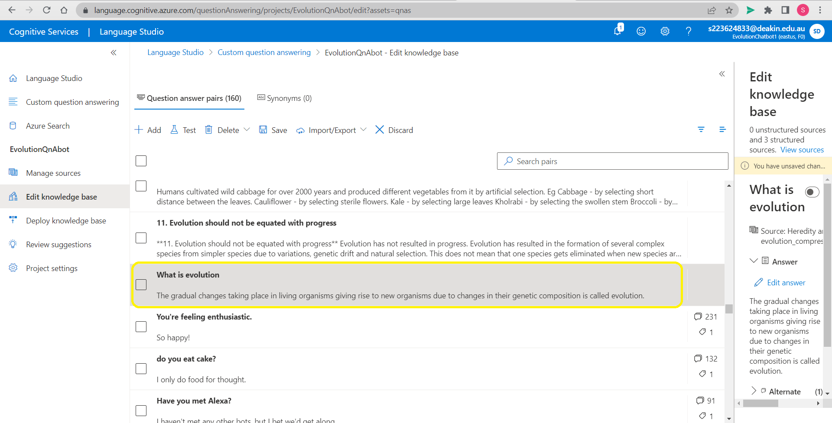

We can find our entry of question and answer in *Question answer pair*.

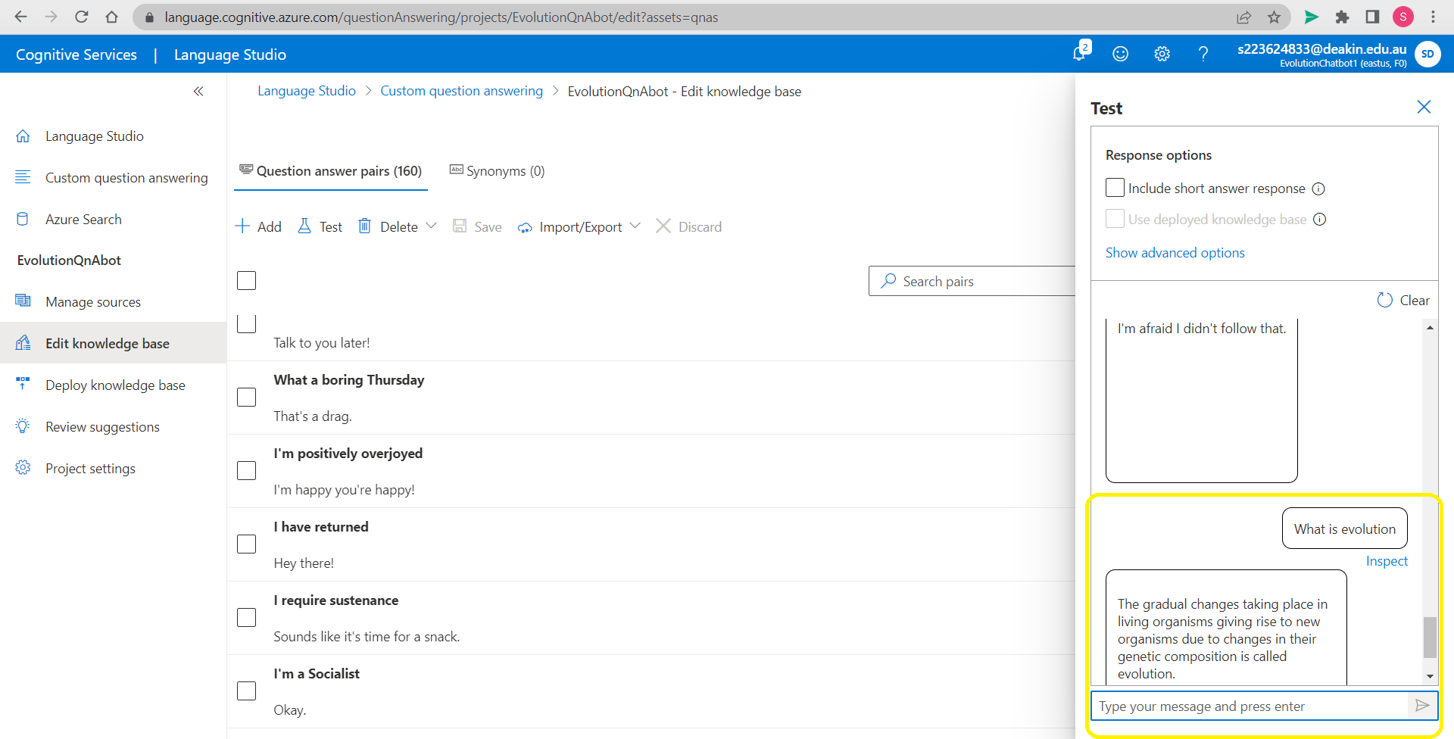

We test again and we are now getting desired results. This way we can add as many utterances as we like.

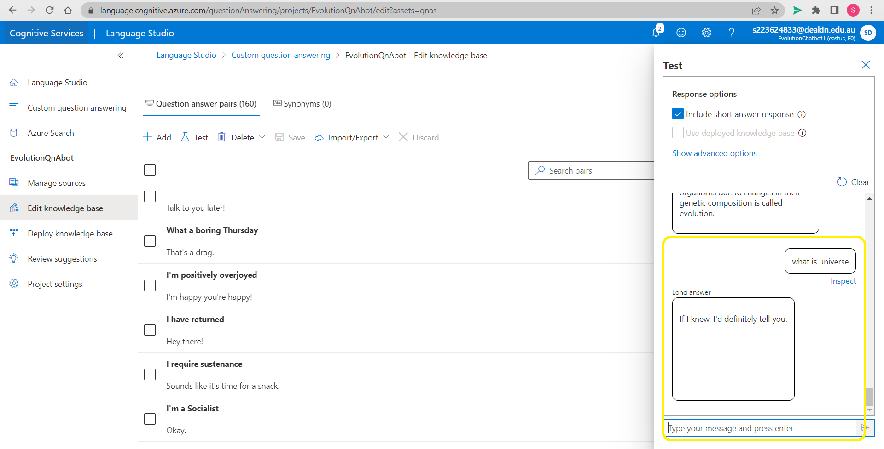

We ask questions that are out of our knowledge base. We see that the response is friendly created by chit chat resource.

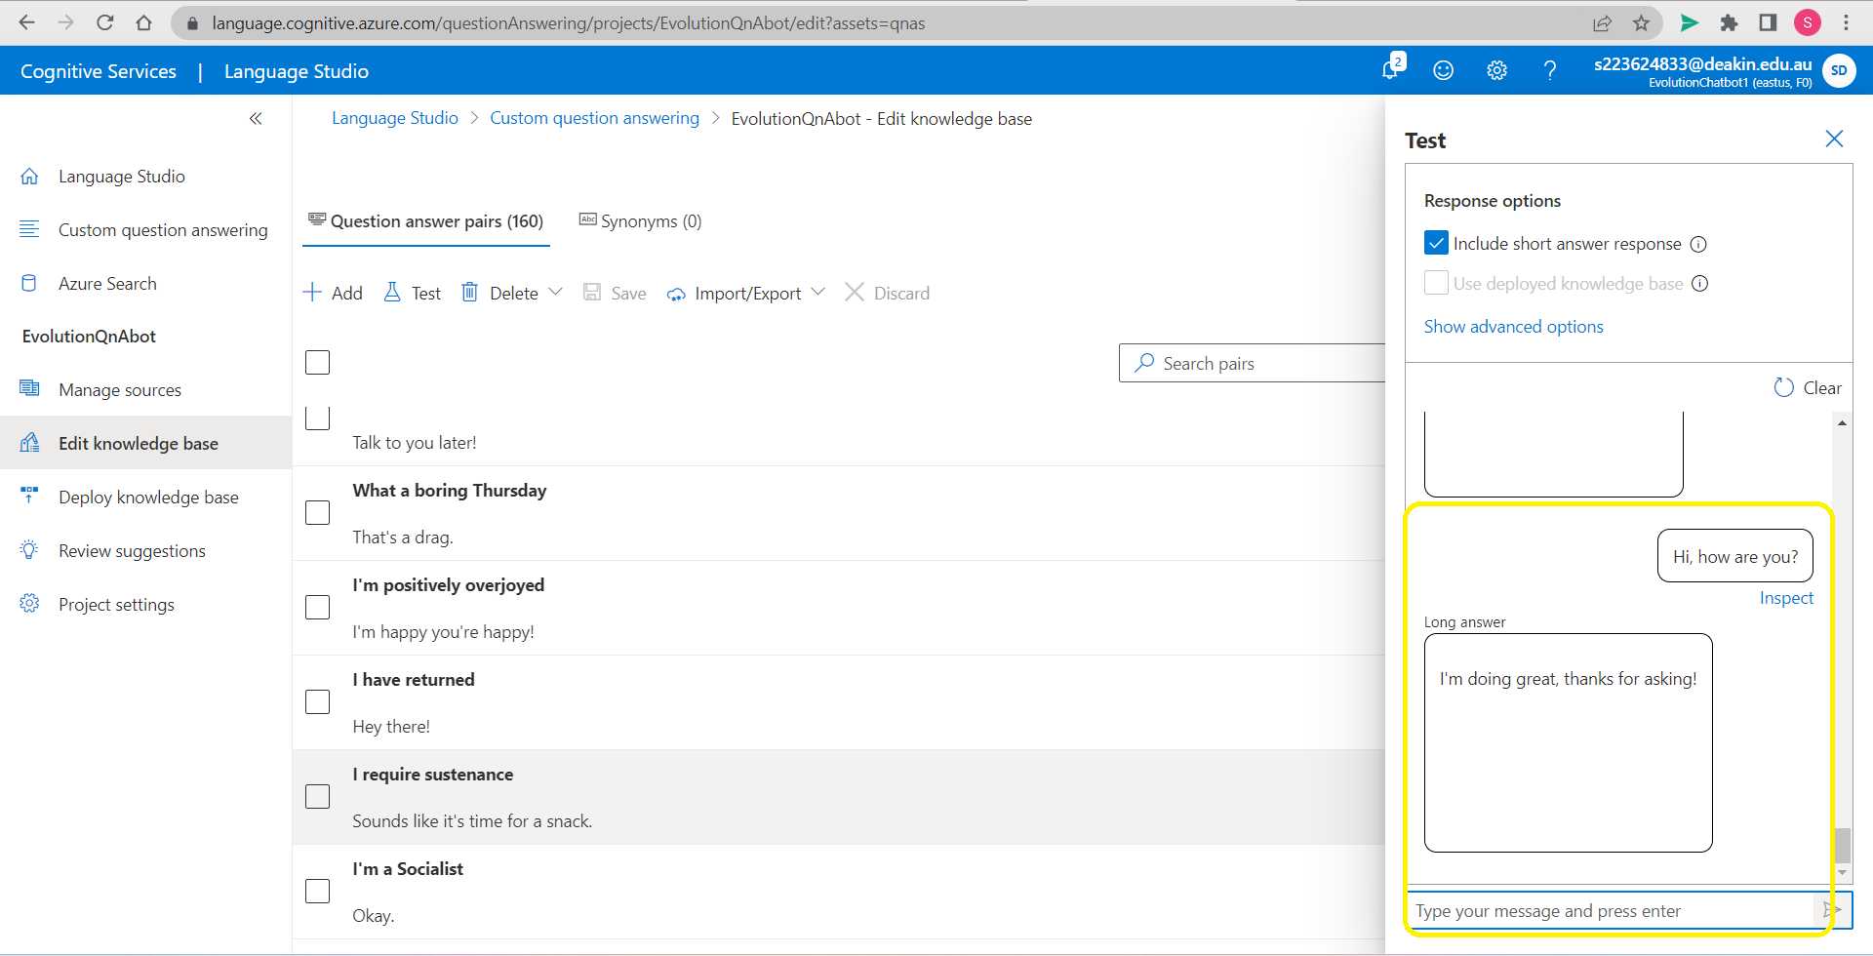

We now test chit chat source and it is giving a good response as expected of it.

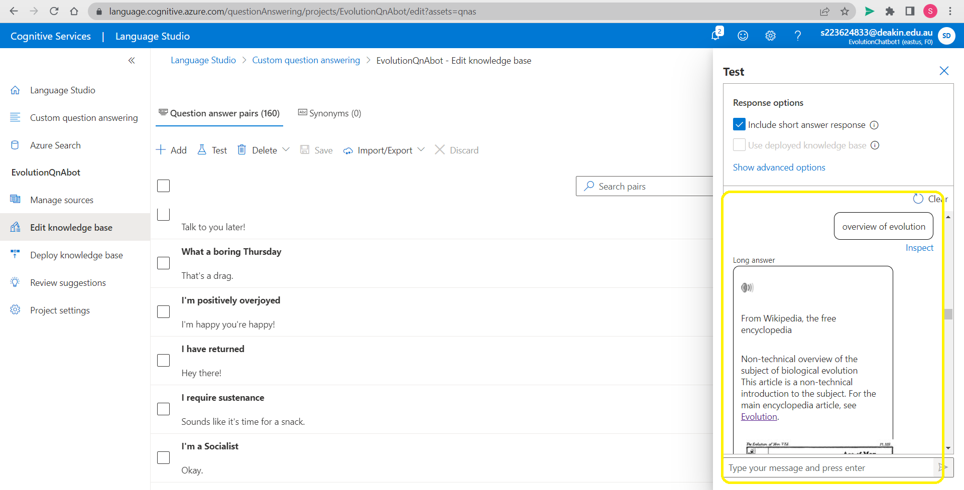

We test knowledge source from url. It has given us a desired result.

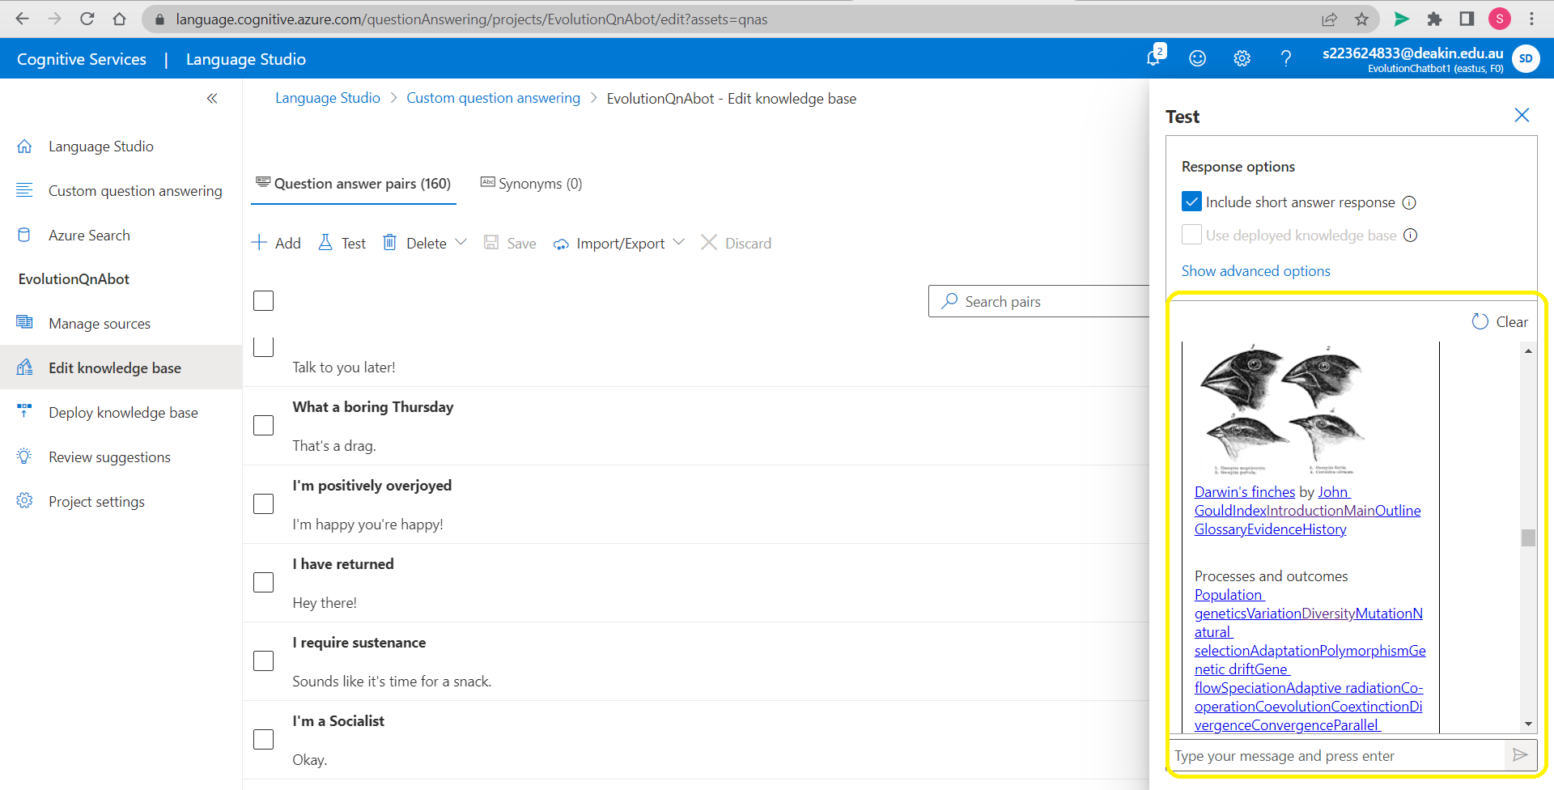

We test more and find that it is providing images for better explanation and also the links provided on web page selected as source.

# Step 6: Deployment of the project

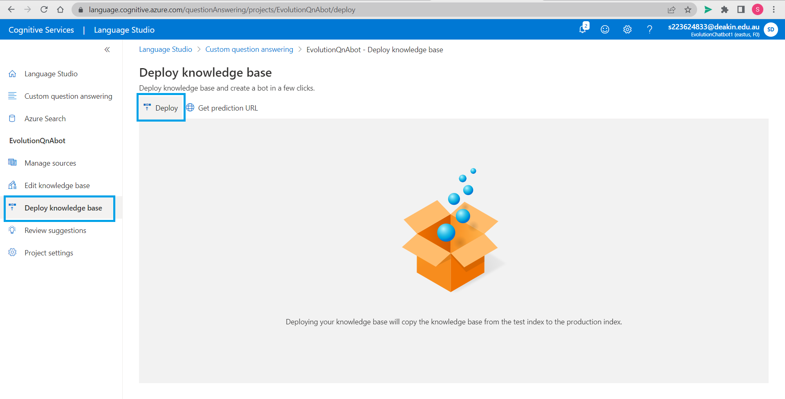

Now we go to *Deploy knowledge base* and click on *Deploy*.

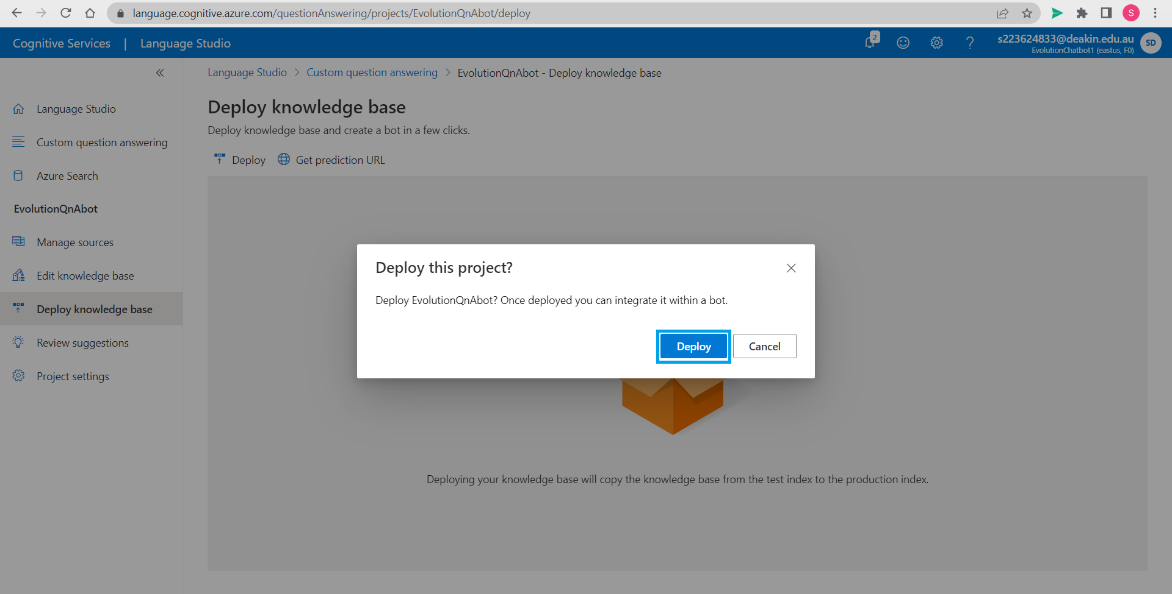

Click *Deploy* to complete the process

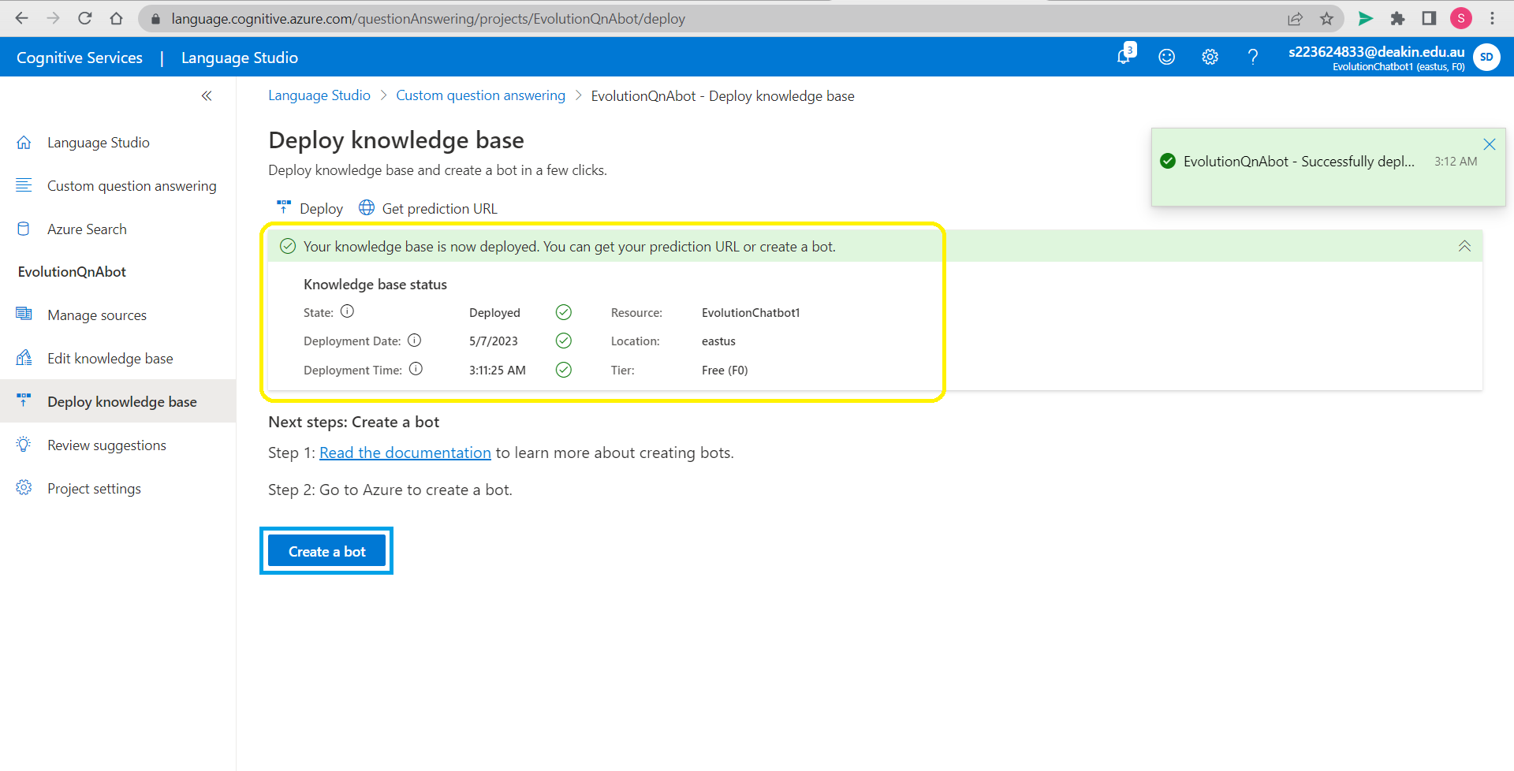

We will be able to see the knowledge base status details after successful deployment and we can go ahead to *Create a bot*.

# Step 7: Create a bot

After clicking on *Create a bot*.

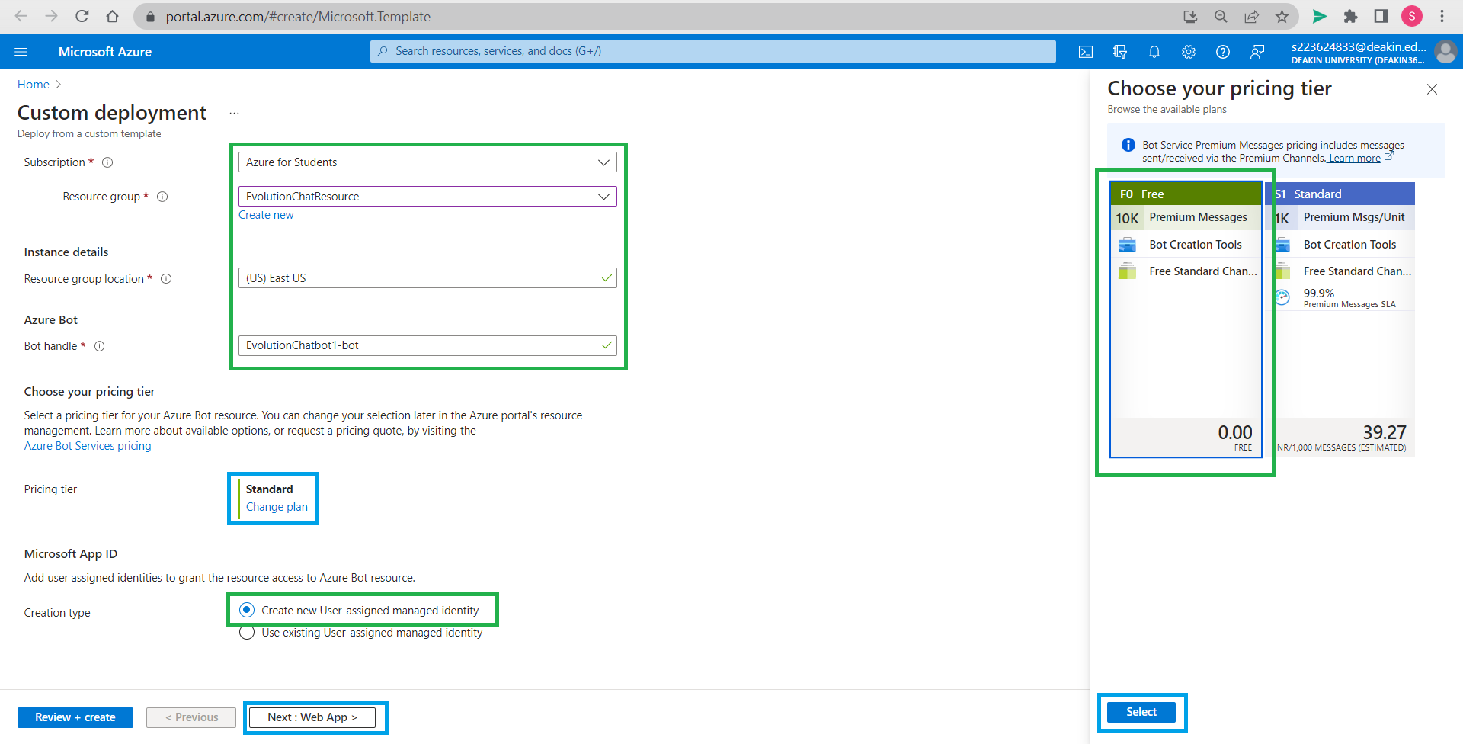

Choose resource group we created earlier (EvolutionChatResource), name azure bot handle we named it EvolutionChatbot1-bot and select *Create new User-assigned managed identity*. Click on *Change plan*, select F0 Free plan and click *Select*. The details required are filled now click *Next:Web App >*.

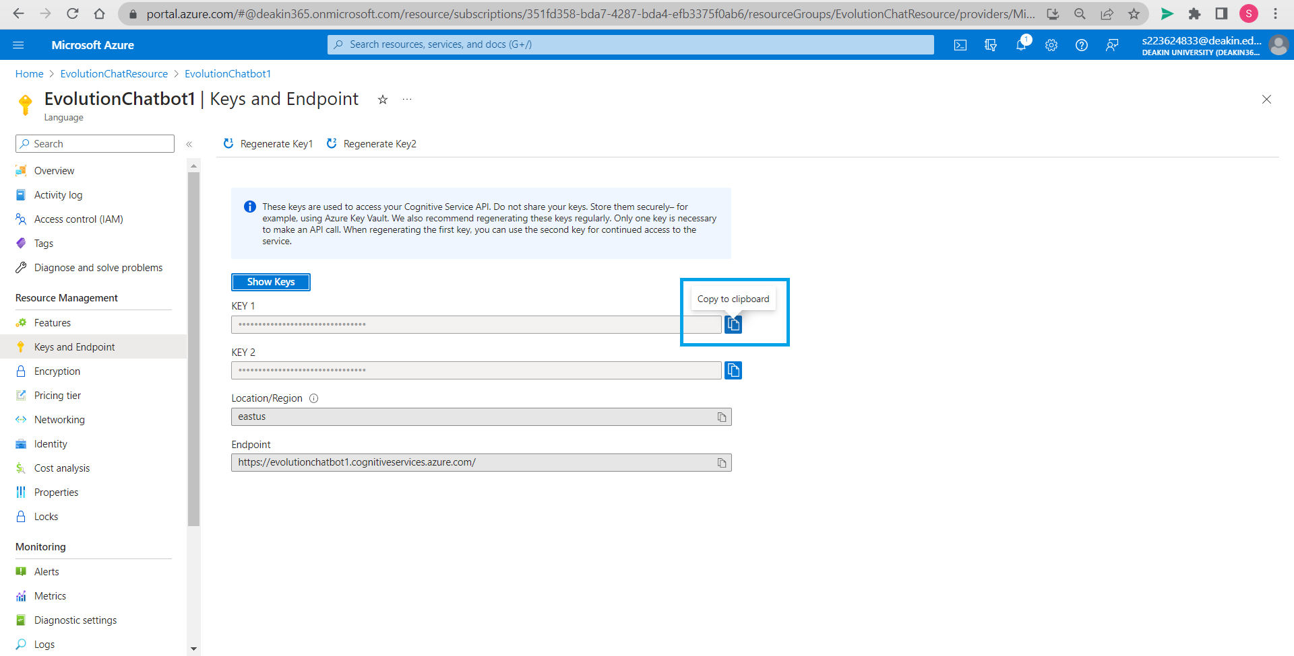

Open resource EvolutionChatbot1 in another tab and copy the KEY 1 as shown in the image above.

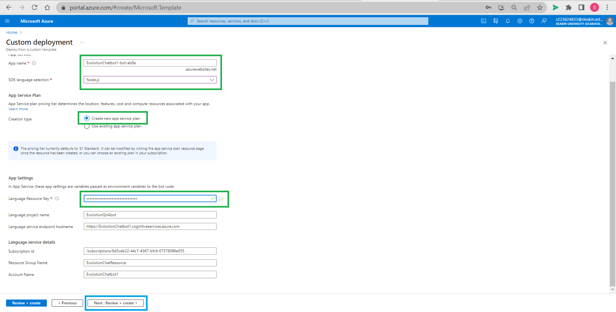

Name the App, we have selected Node.js as SDK language selection, one can select other languages here. *Select Create new app service plan*. Paste Language Resource Key where it is asked. Now click on *Next:* *Review + create*.

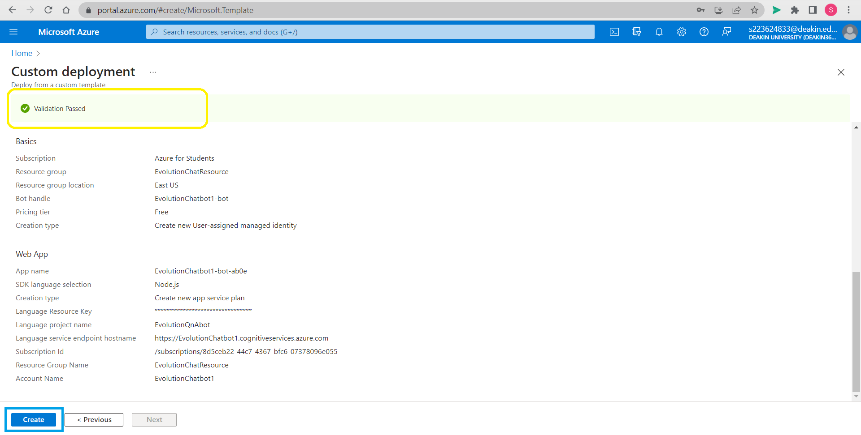

Once validation is passed go on to *Create* to finish deployment.

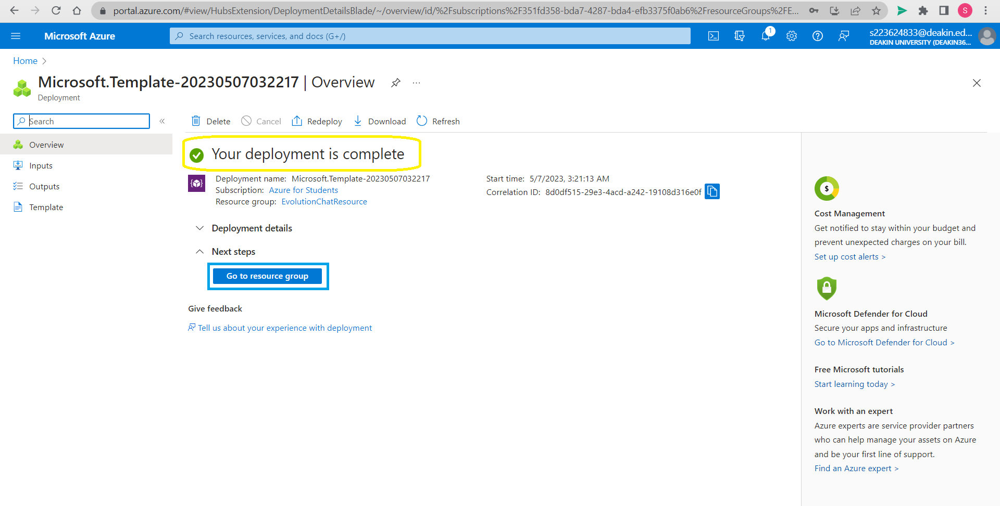

Deployment is complete for azure bot, go to resource group.

# Step 8: Testing our bot in Azure resource

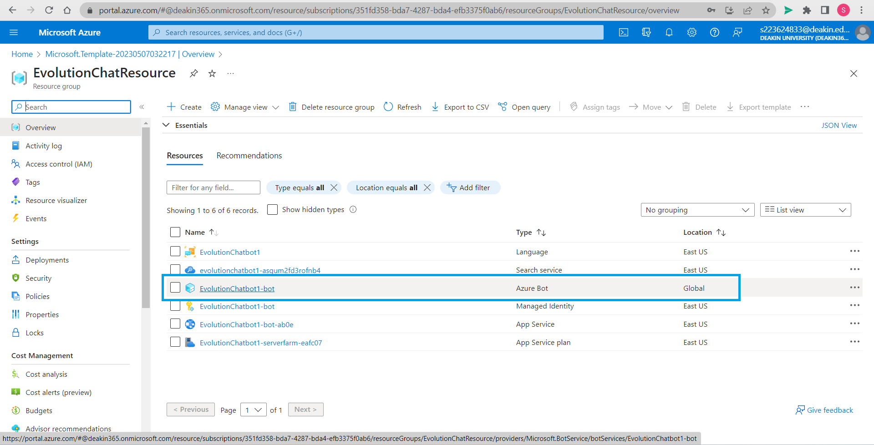

We find Azure bot is created and location shows as Global. Select the bot we have created in the resource group.

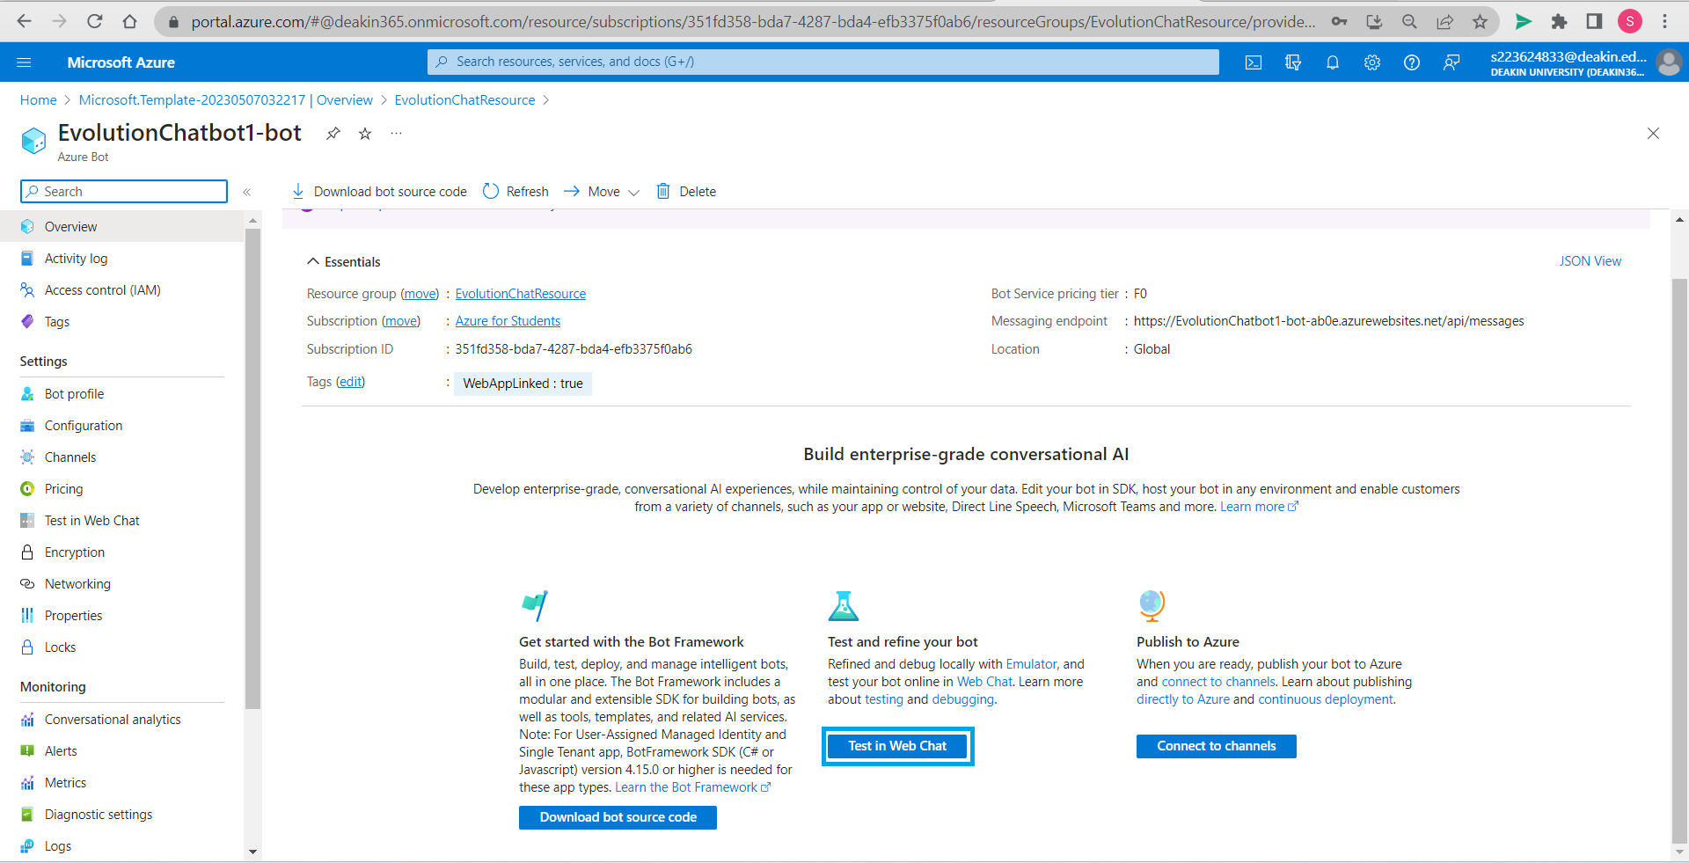

Select *Test in Web Chat* to open testing space to test our bot.

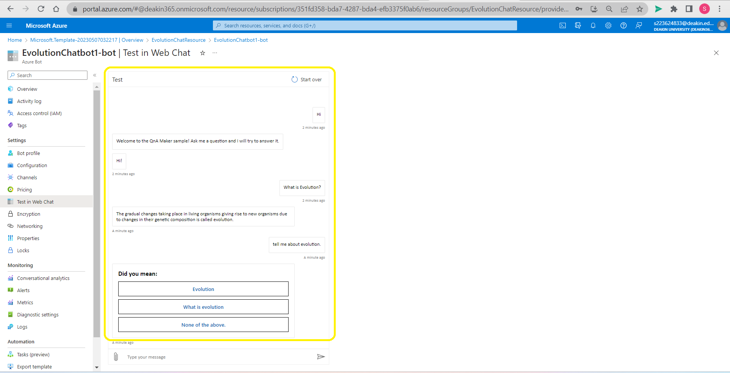

We can test our bot here and when it is confused it asks for help from the user as it learns.

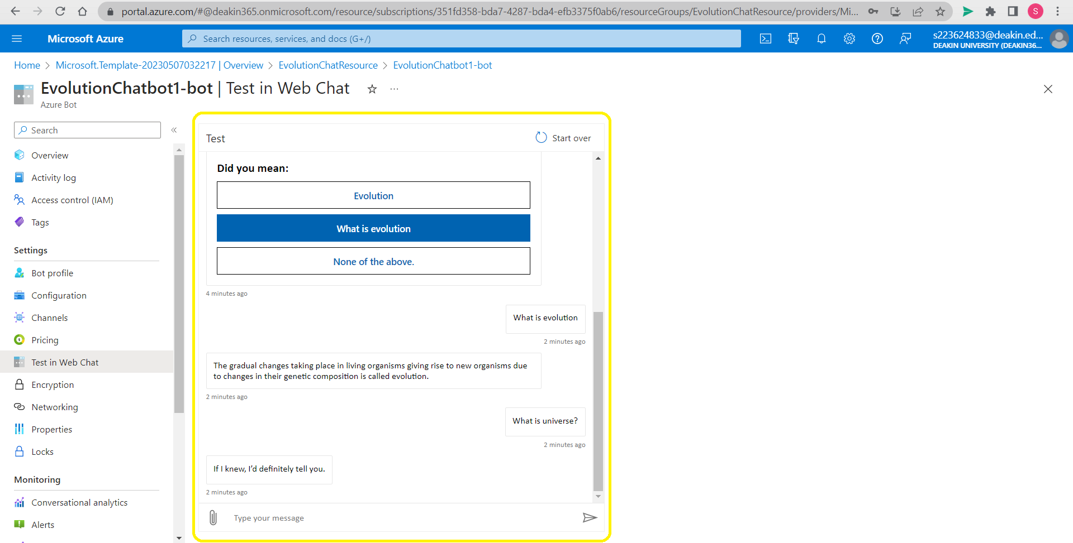

We ask questions outside our knowledge base and test.

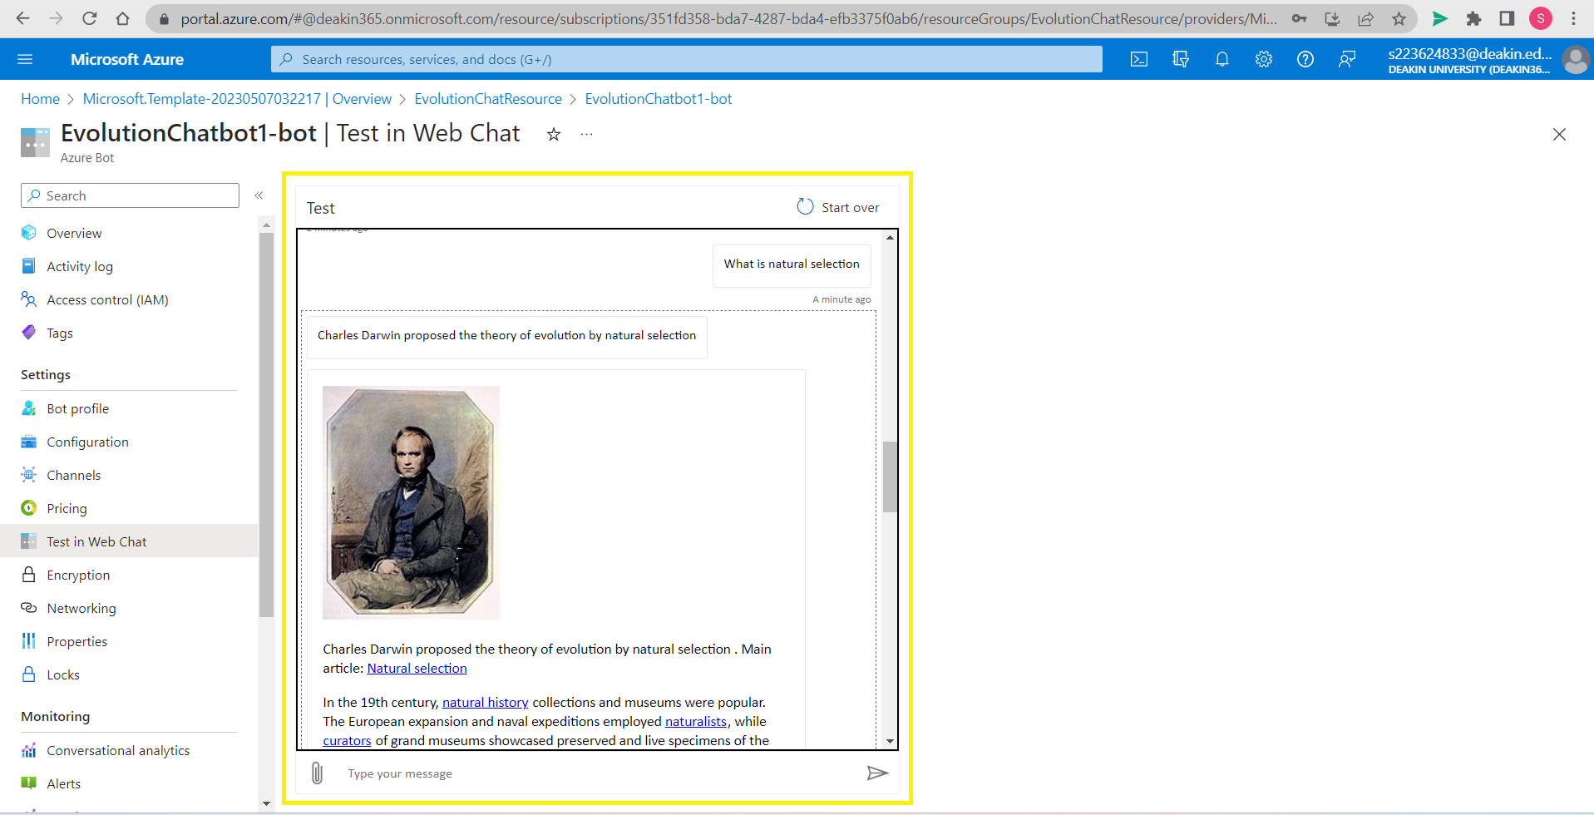

Bot is able to find answers in webpage url provided to knowledge base. It is giving satisfactory results.

# Step 9: Creating an app on Meta for Developers

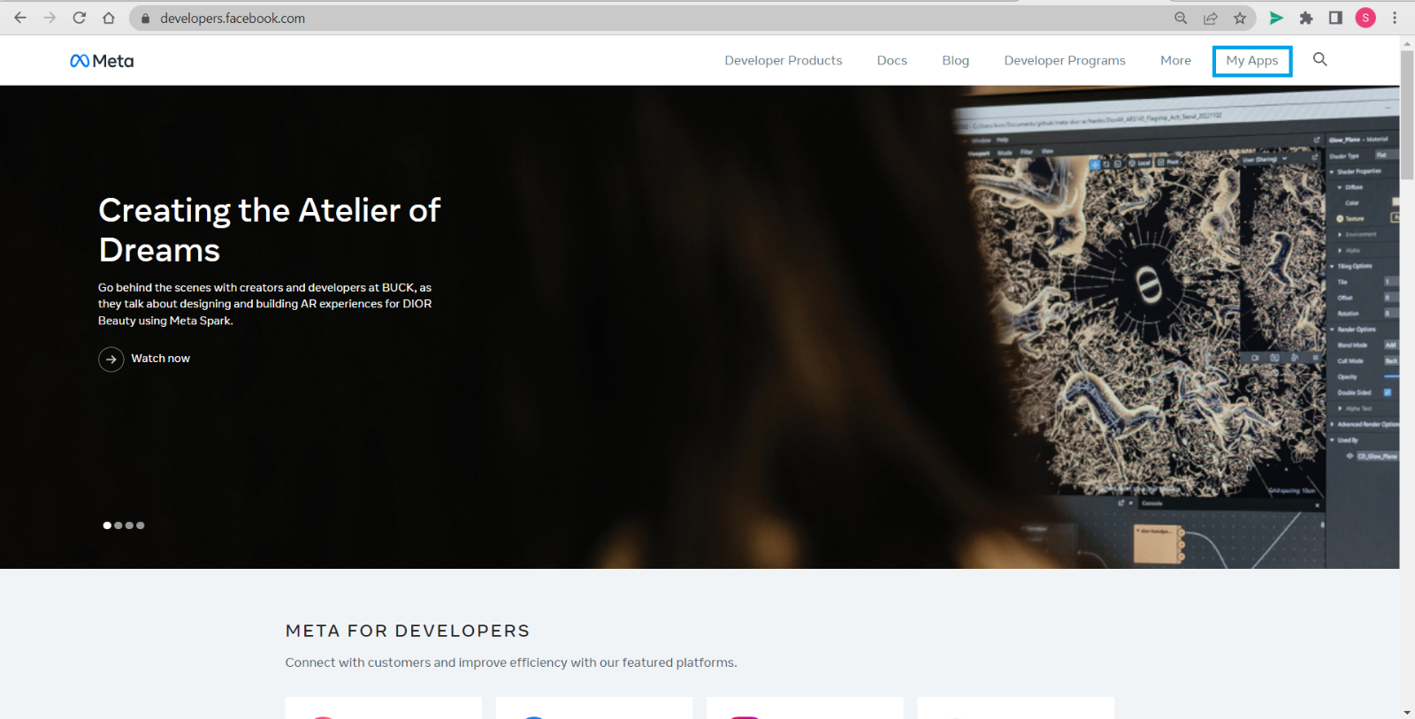

Open Meta for developers in another tab. Click on *My Apps.*

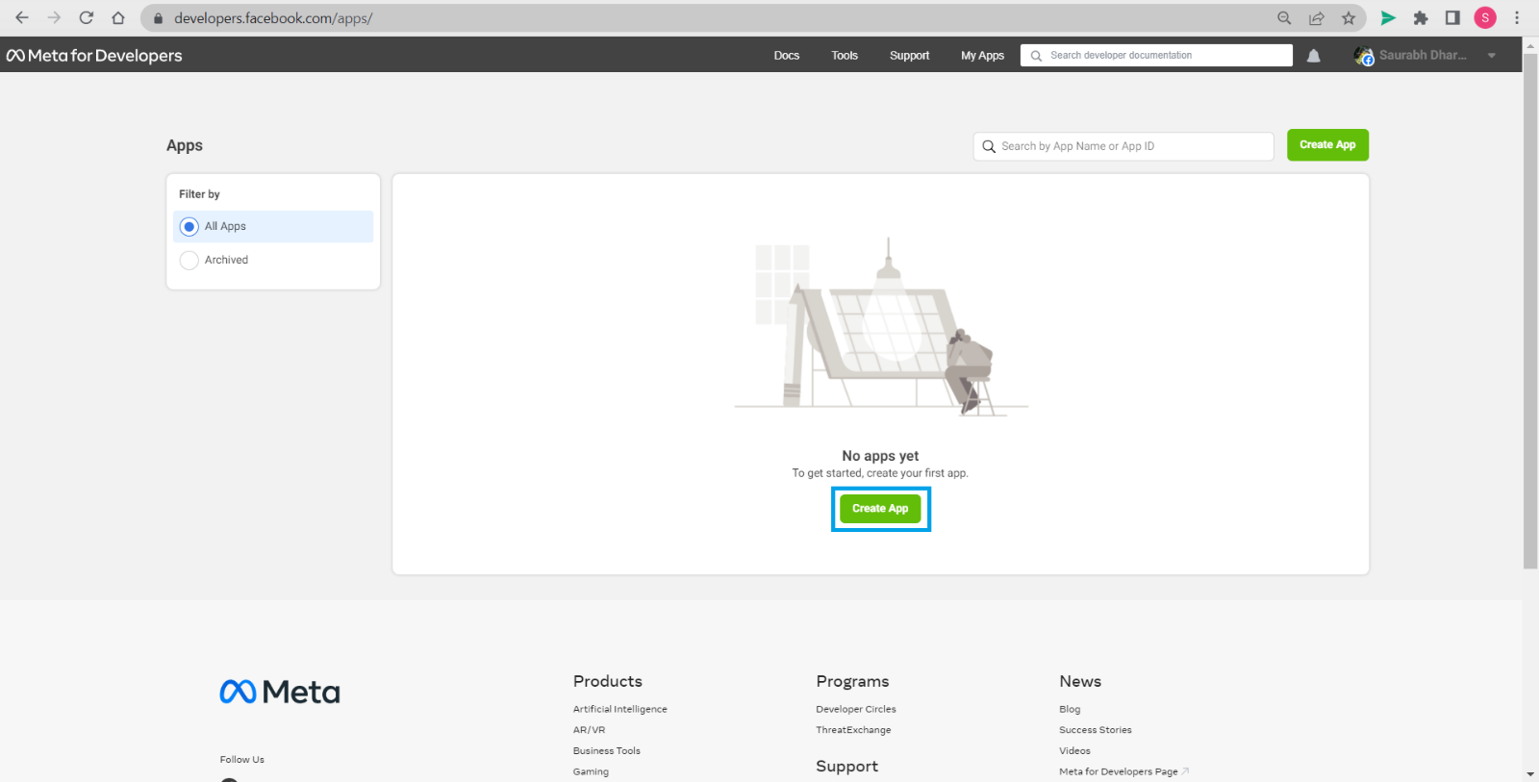

In Meta for Developers and press *Create App*.

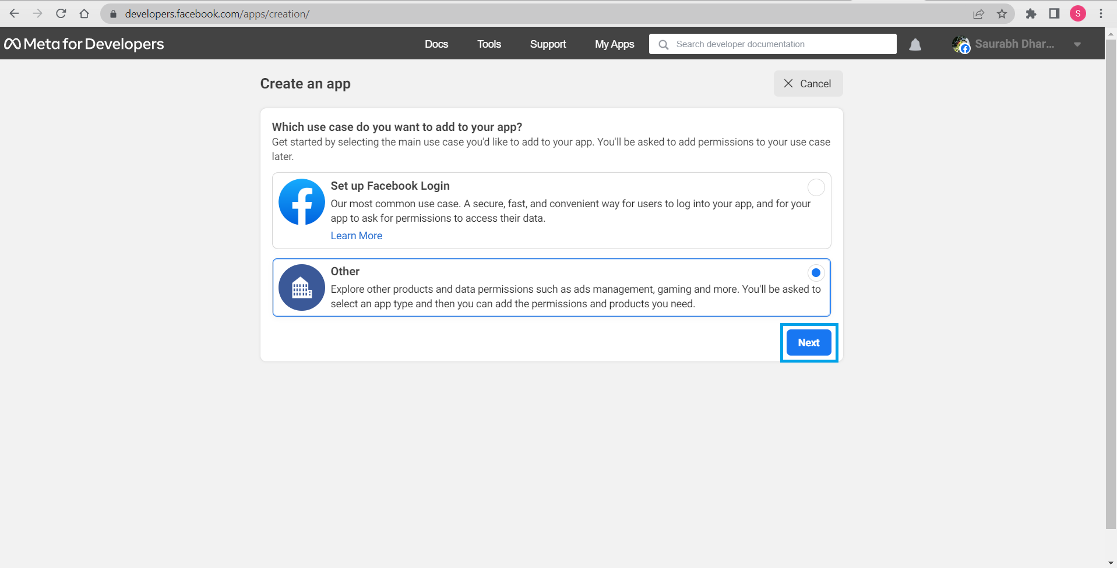

Select other and then *Next*.

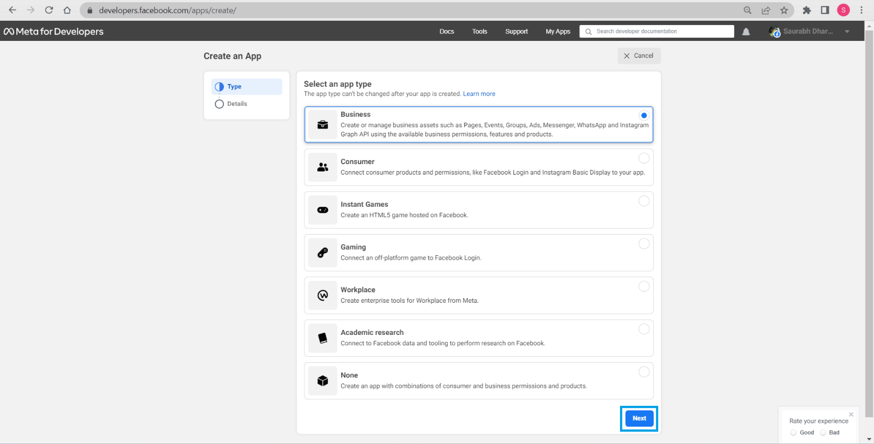

Select type of app, we selected business from the various options available. Press *Next*.

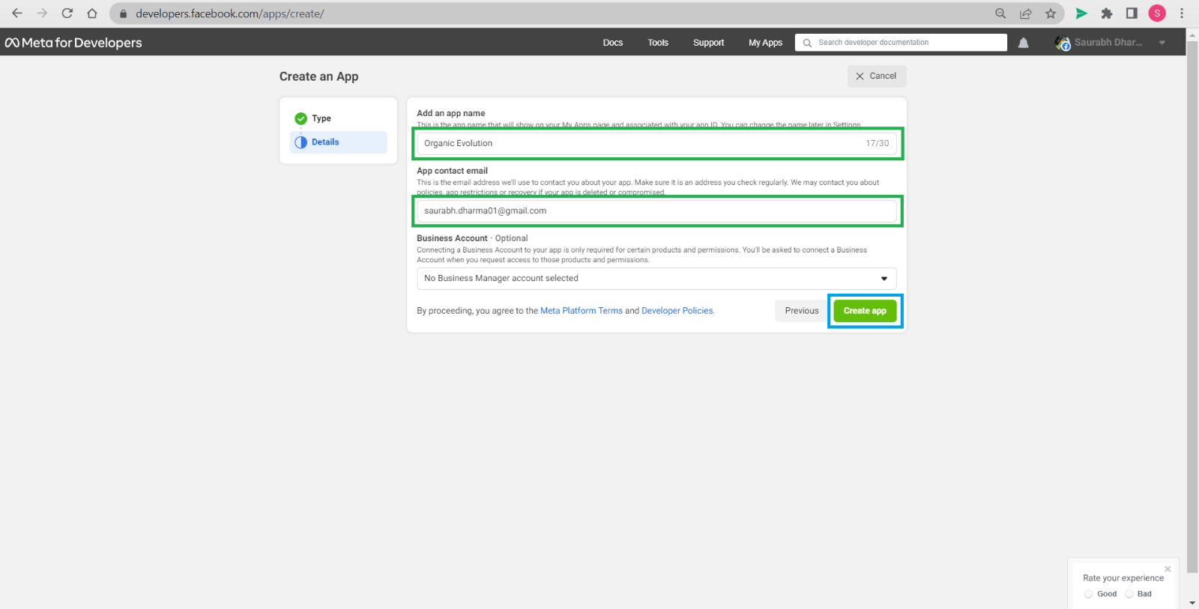

Enter the name of the app that you may wish and a contact email address and then *Create app*.

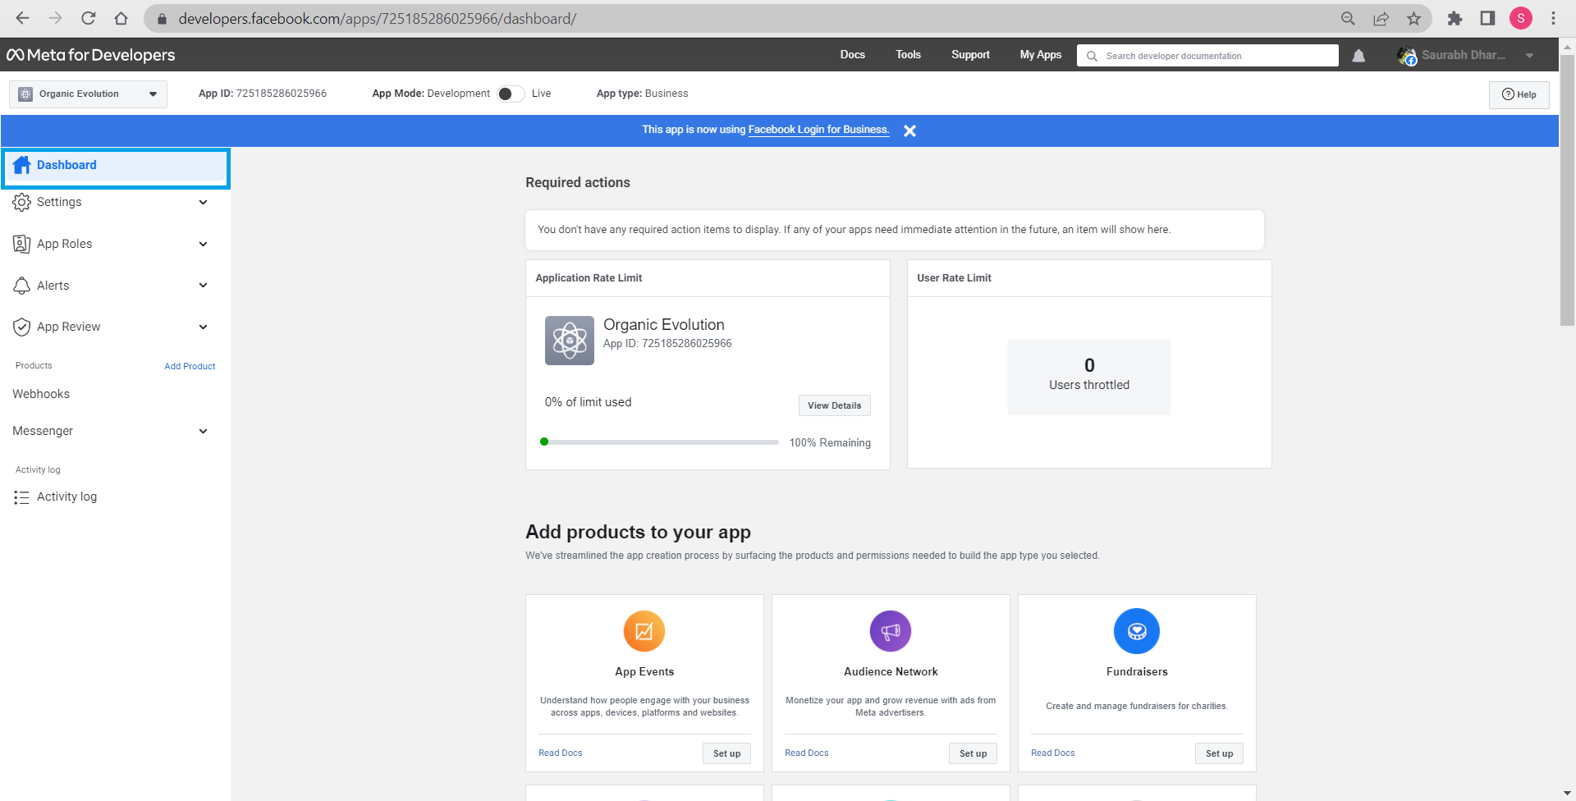

Now we can check app created in our Dashboard.

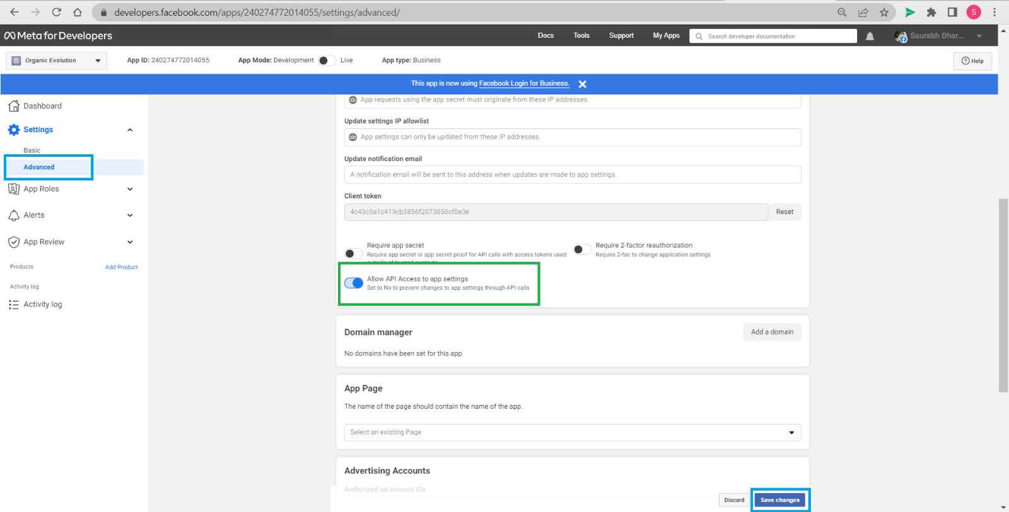

Select advanced settings and enable *Allow API Access to app settings and* save changes.

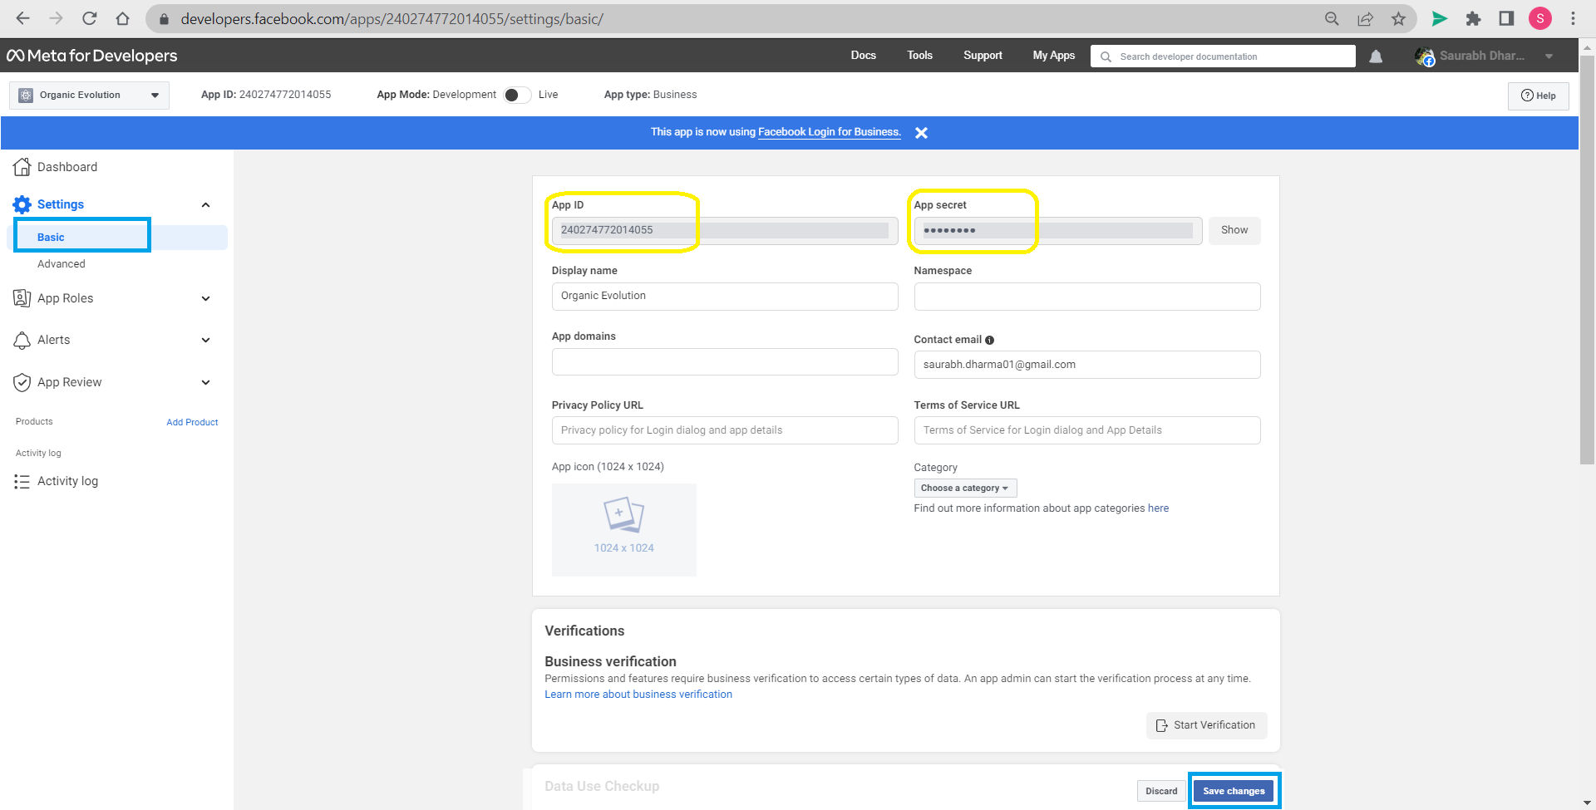

Under basic settings we can find App ID and App secret. Do not share App secret with anyone, copy it and keep it safe.

# Step 10: Messenger setup

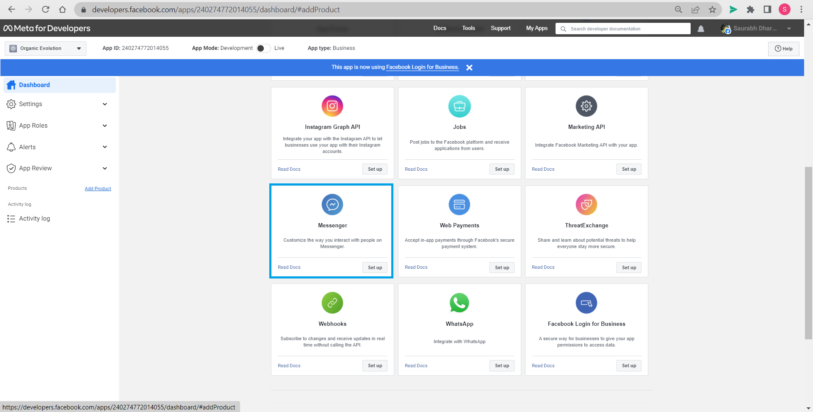

Go to add product on the left-hand side bar and find Messenger. Click on *Set up*.

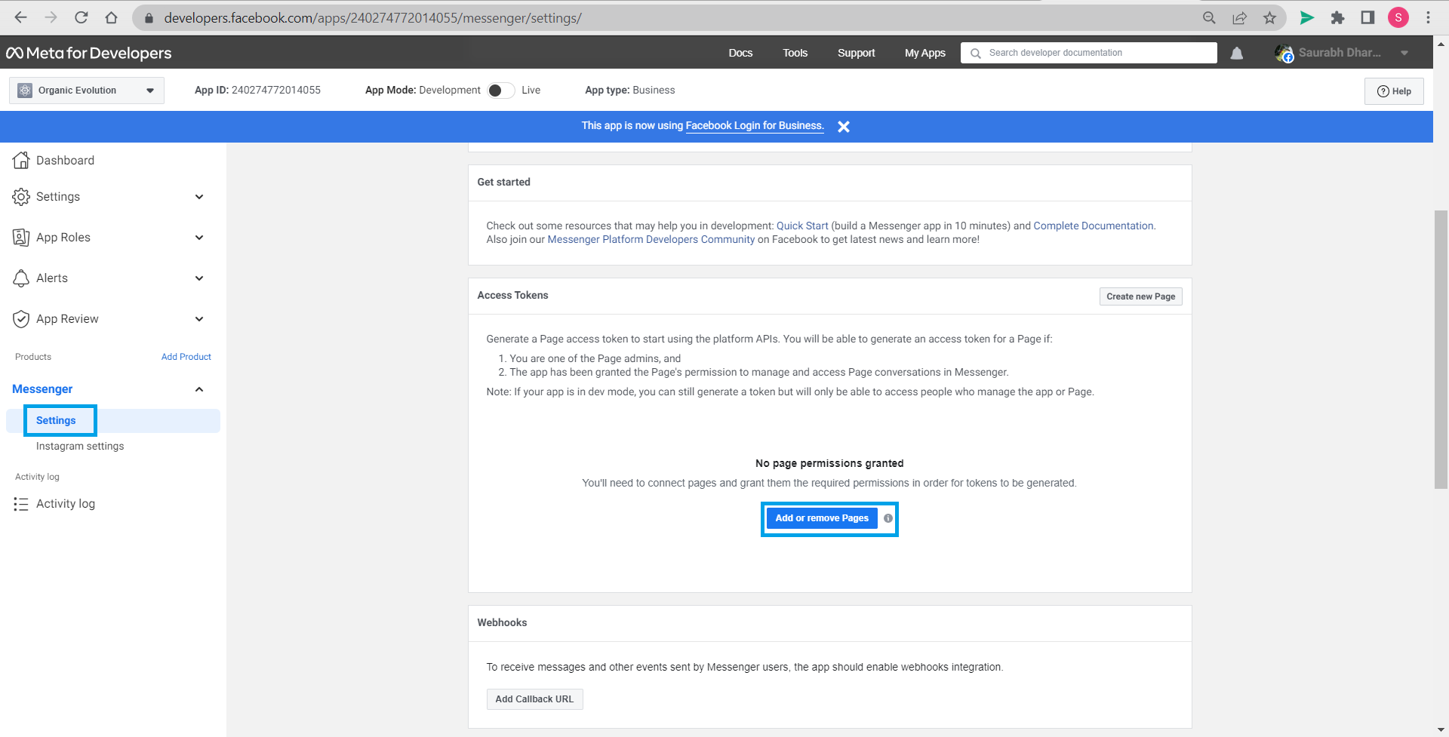

Once Messenger is set up, we can check the settings and *Add or remove Pages* for the app developed.

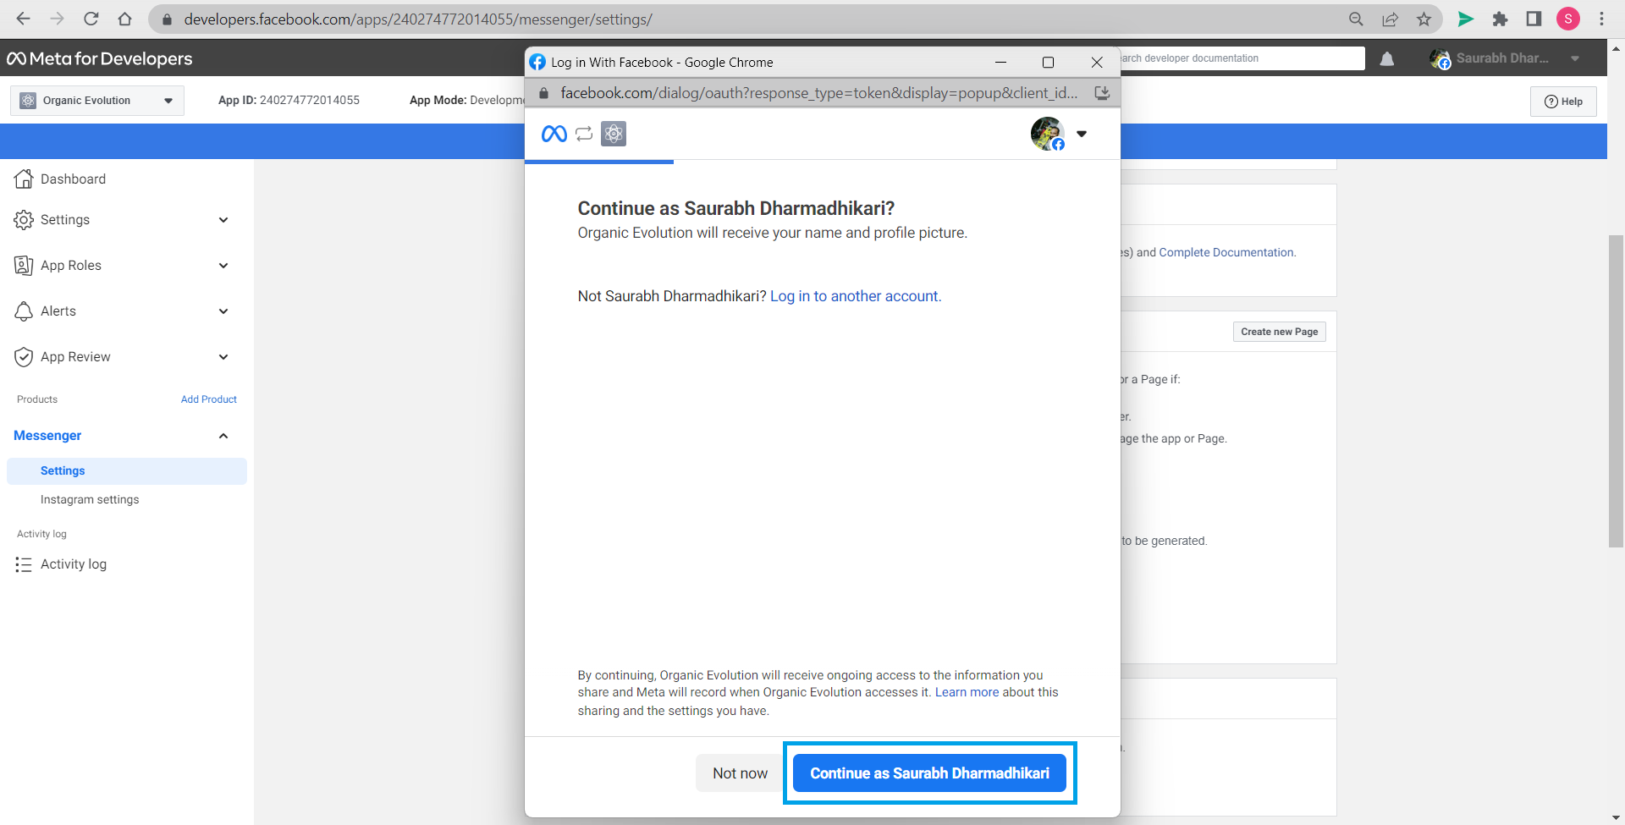

Continue with your account ID.

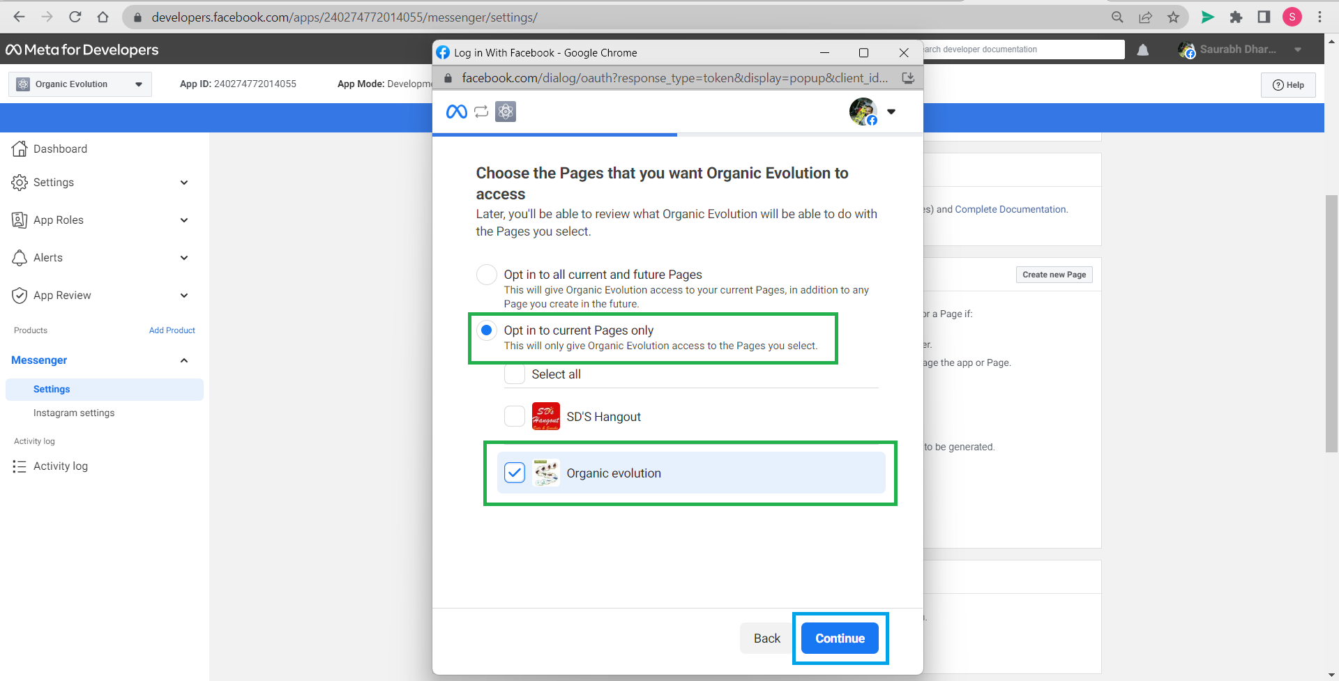

Give permission to app to access pages. We have opted for current page only and *Continue*.

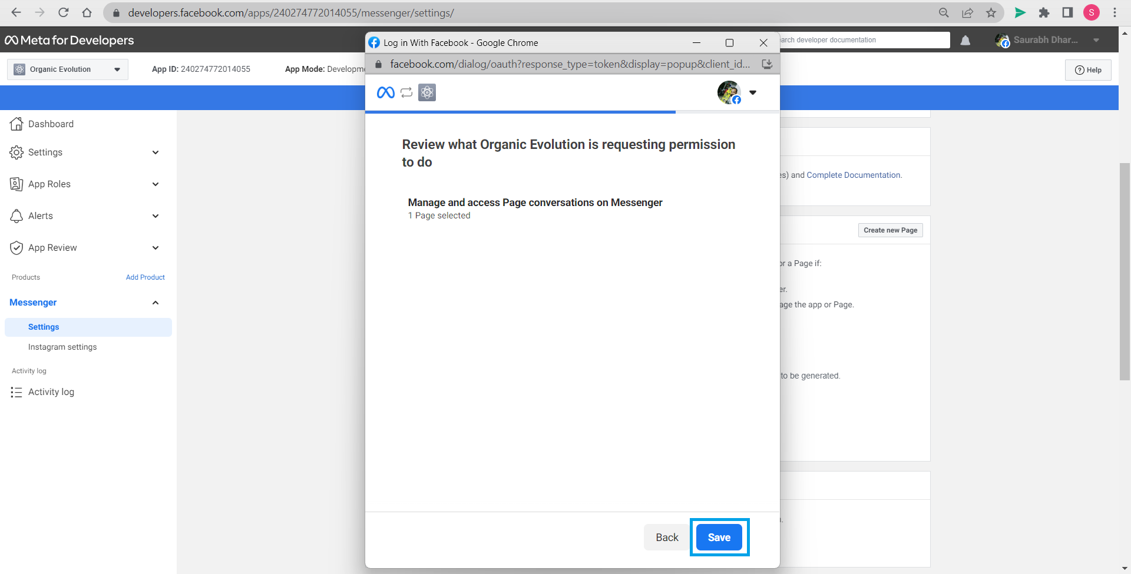

Review and *Save*.

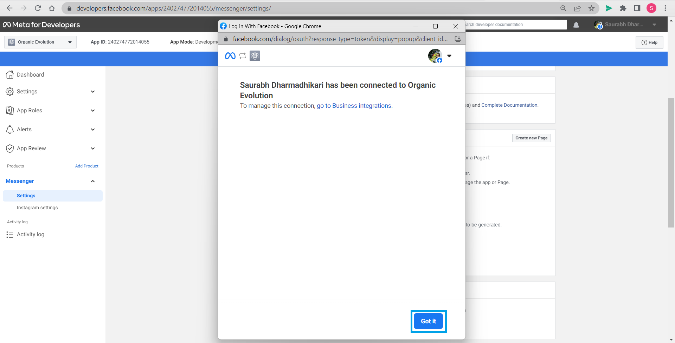

Account is now connected to Account id. Click *Got it*.

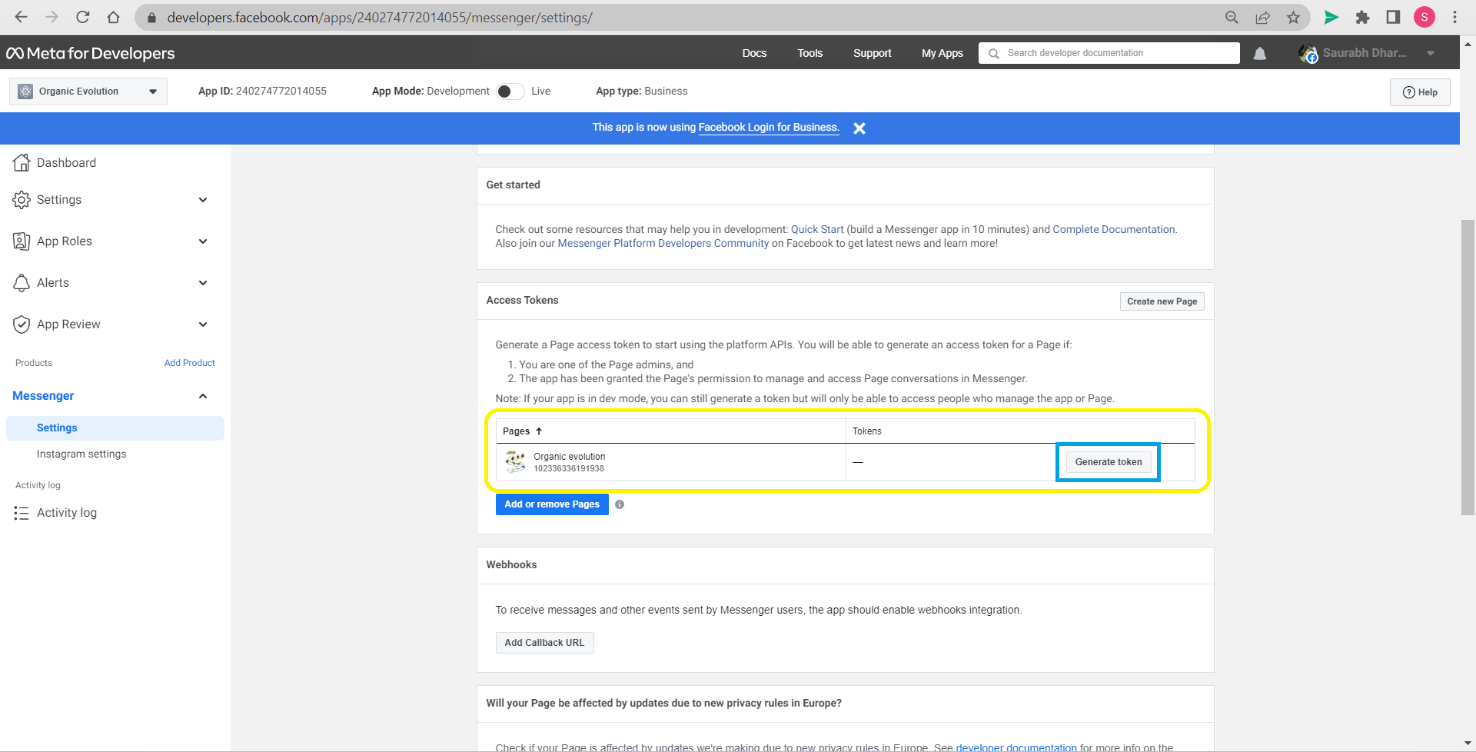

Page is added click generate token.

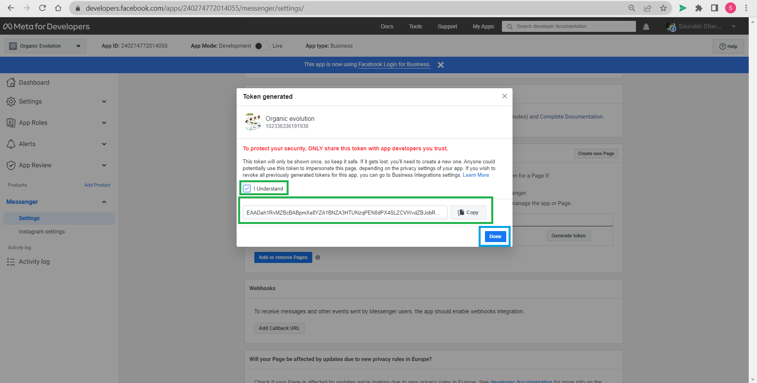

Tick, *I understand* and copy the token, click done, keep token safe. Continue by clicking *Done*.

# Step 11: Attaching Facebook app to azure

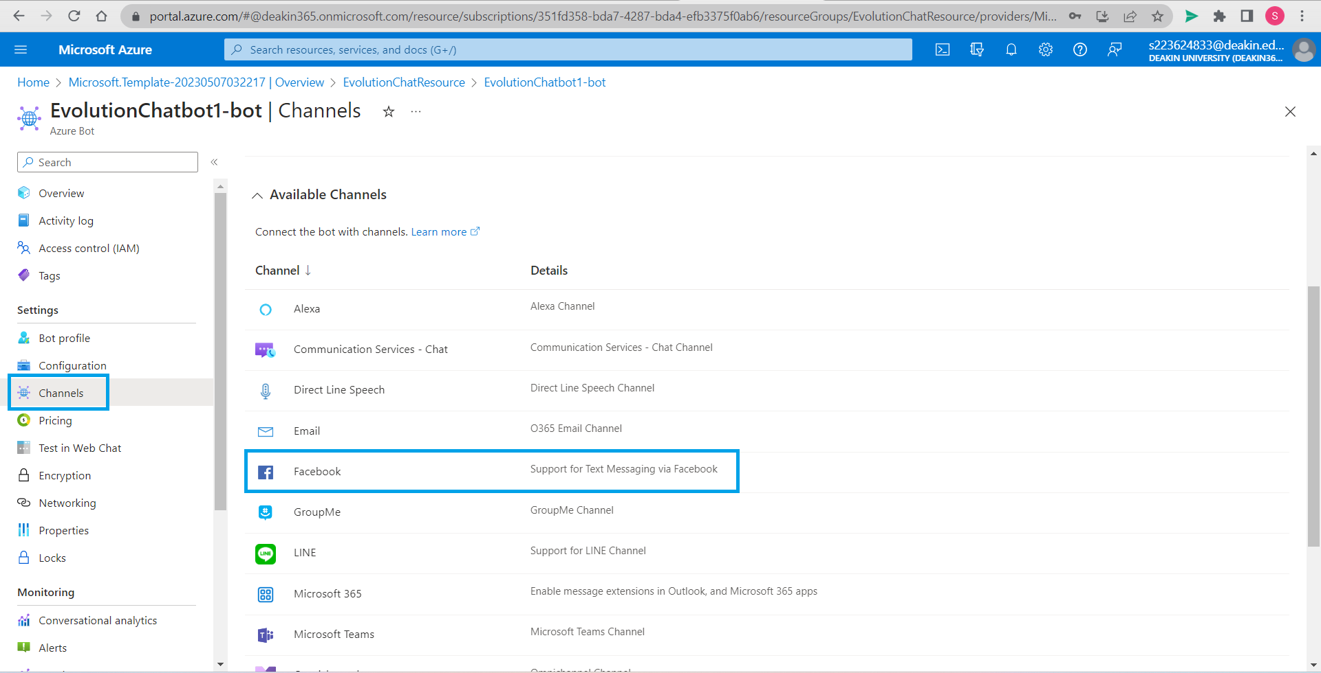

Go back to azure tab, open Azure bot resource, go to channels and select Facebook.

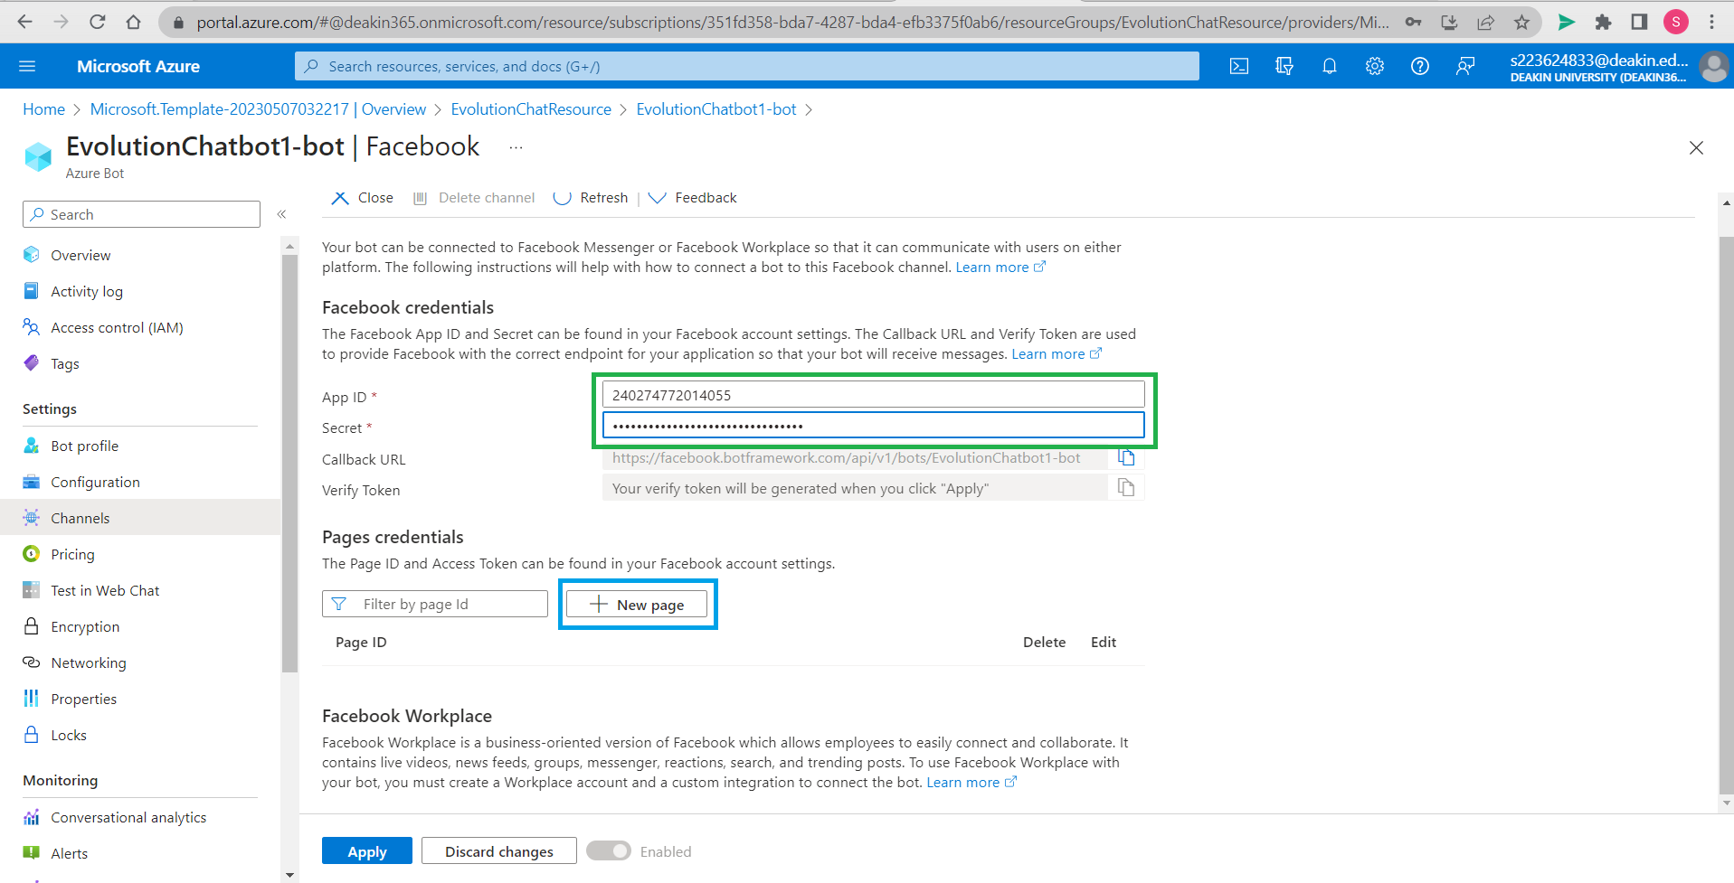

Paste app id and app secret, click on *New page*.

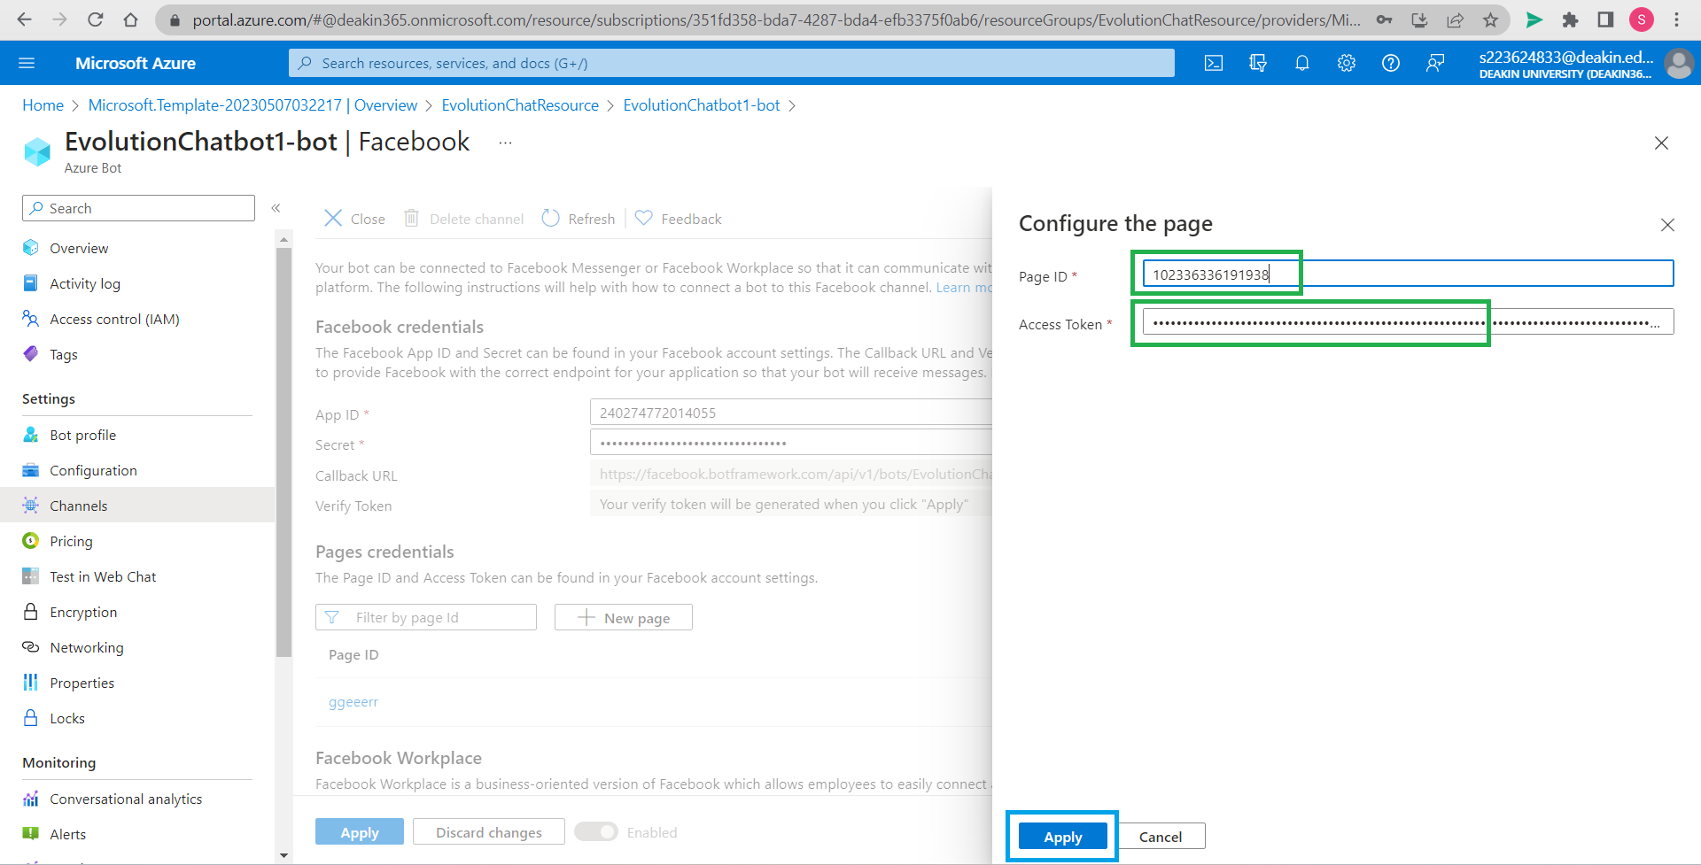

Enter page_id and paste access token and press *Apply.*

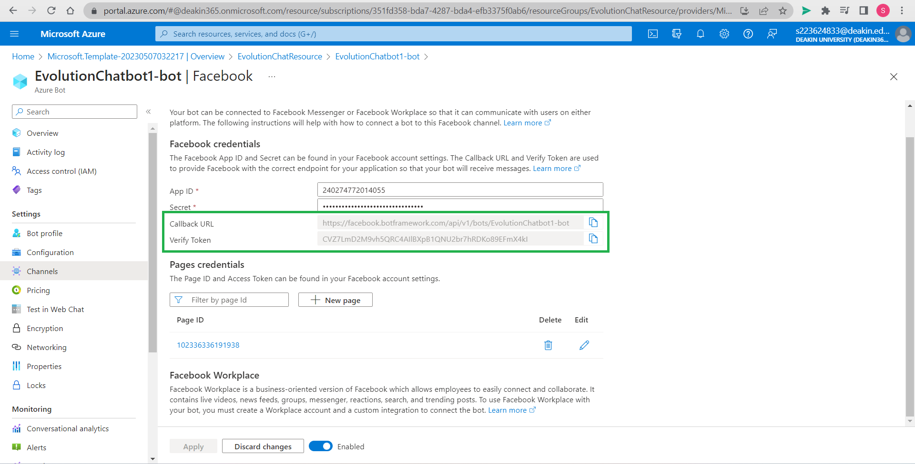

Copy call-back URL and verify token generated in Azure and keep it safe.

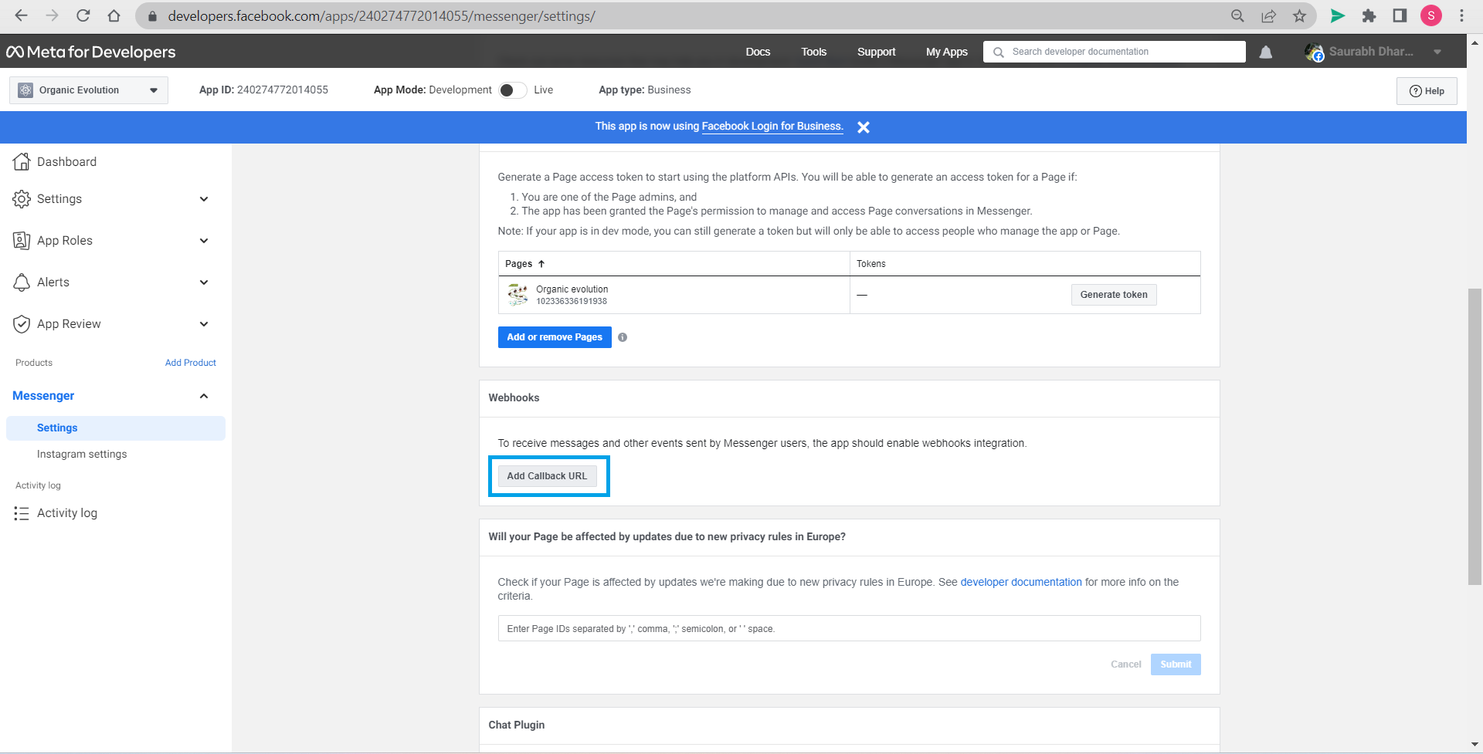

Go back to Meta tab, *Add call back URL* in messenger settings.

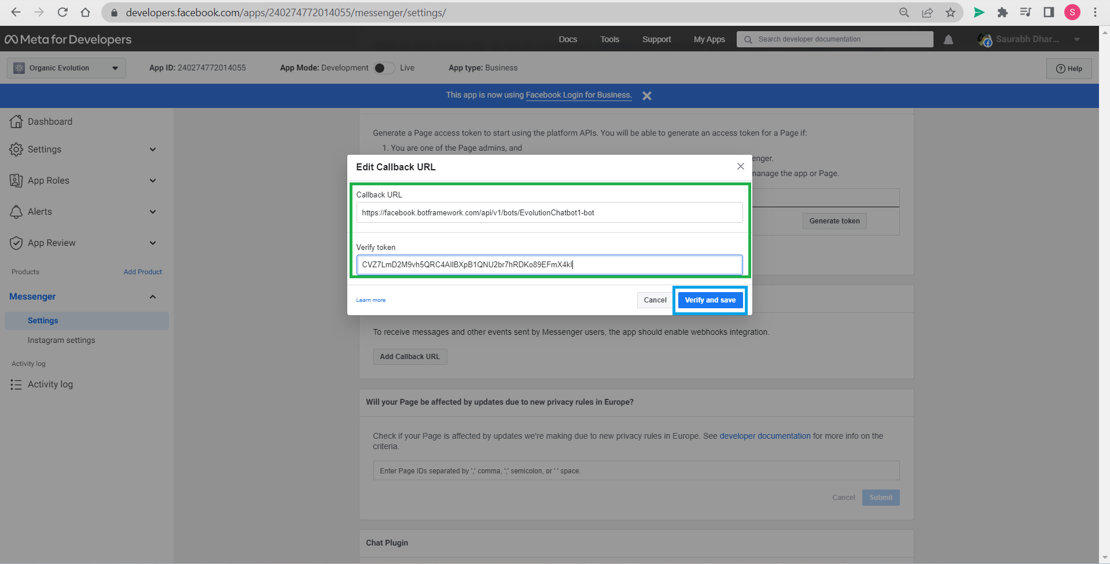

Fill Call-back URL and verify token. Go ahead with *Verify and save*.

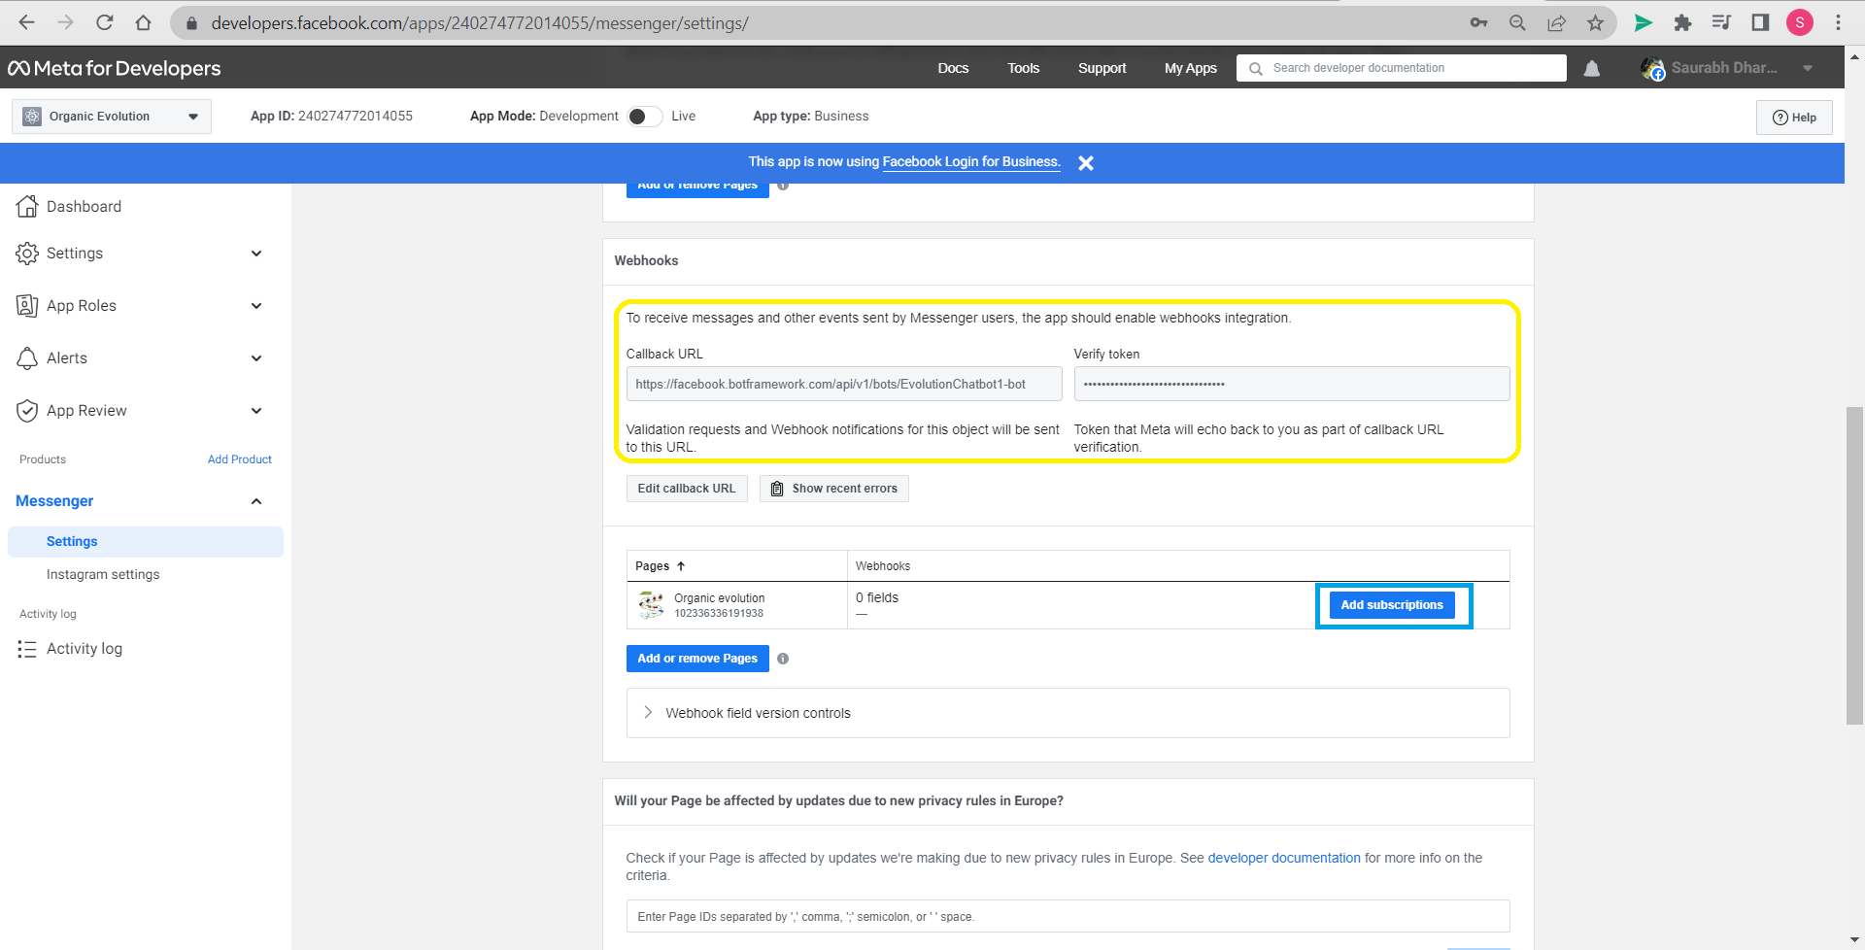

We can see under Webhook now we see that Call-back URL and verify token are added, now click *Add subscription*.

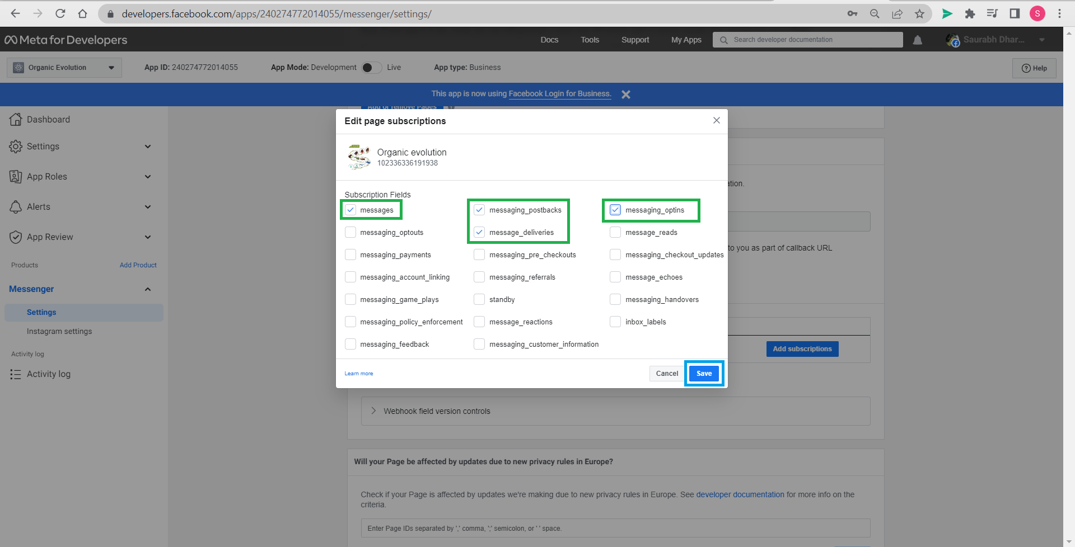

Select fields suitable and *Save*.

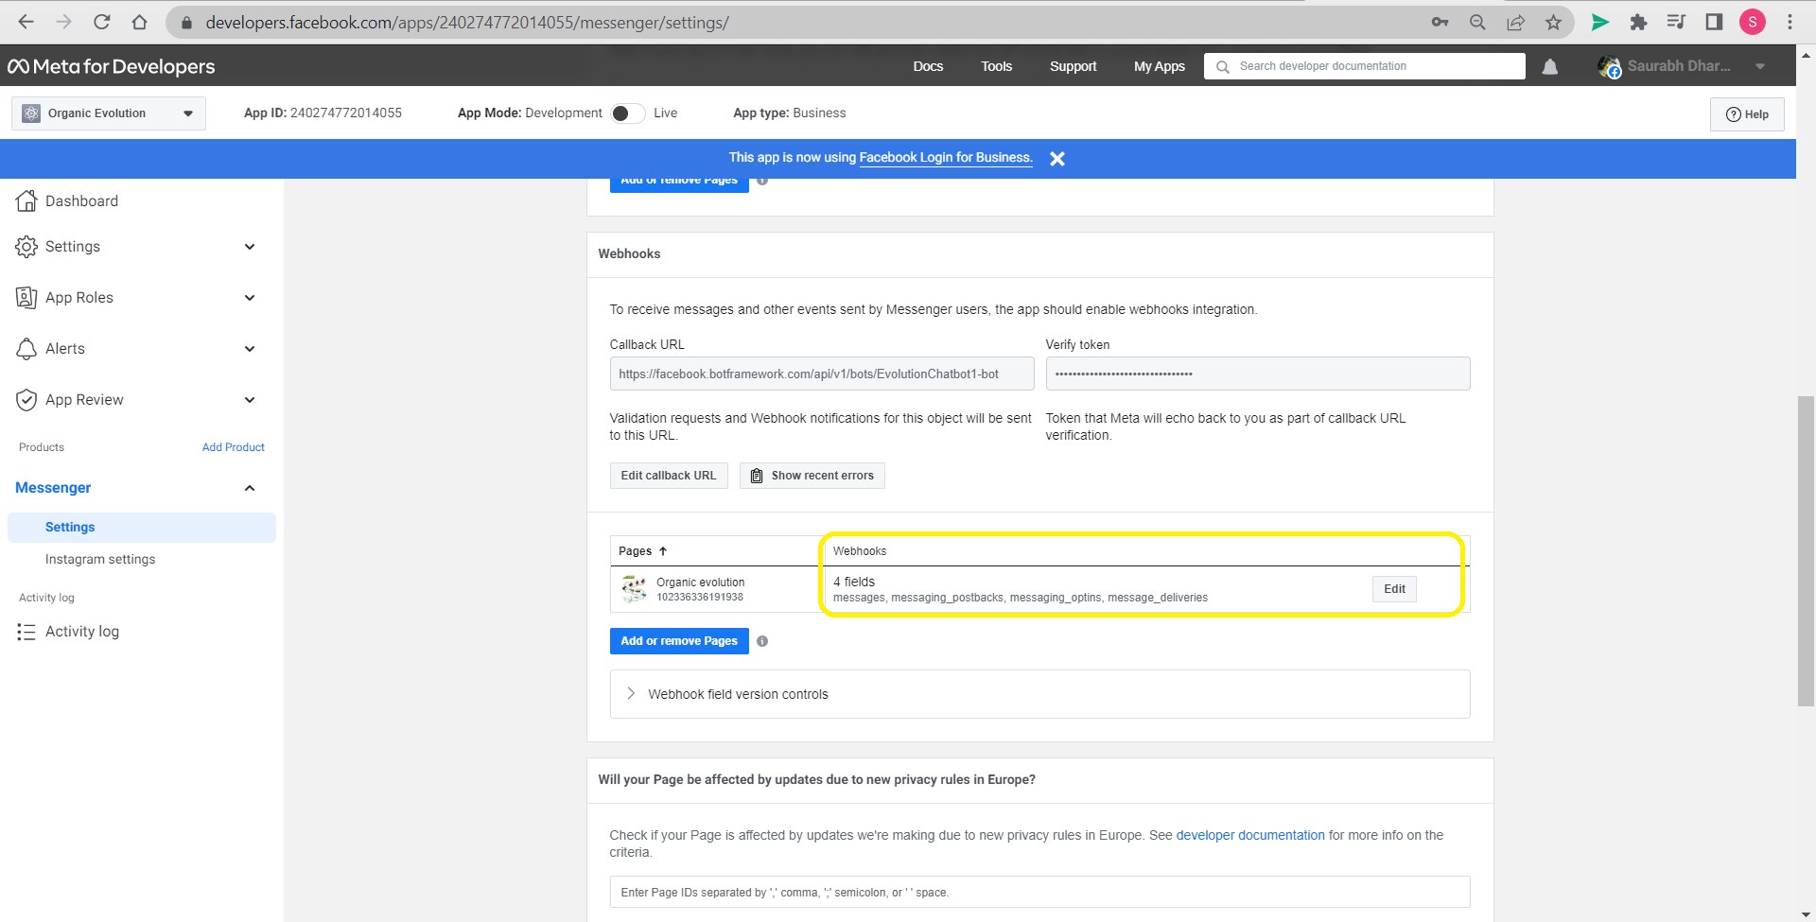

Fields are also show up now and can be edited.

# Step 12: Testing app created

Now that Azure bot and Facebook messenger app are attached, we can see that it is working.

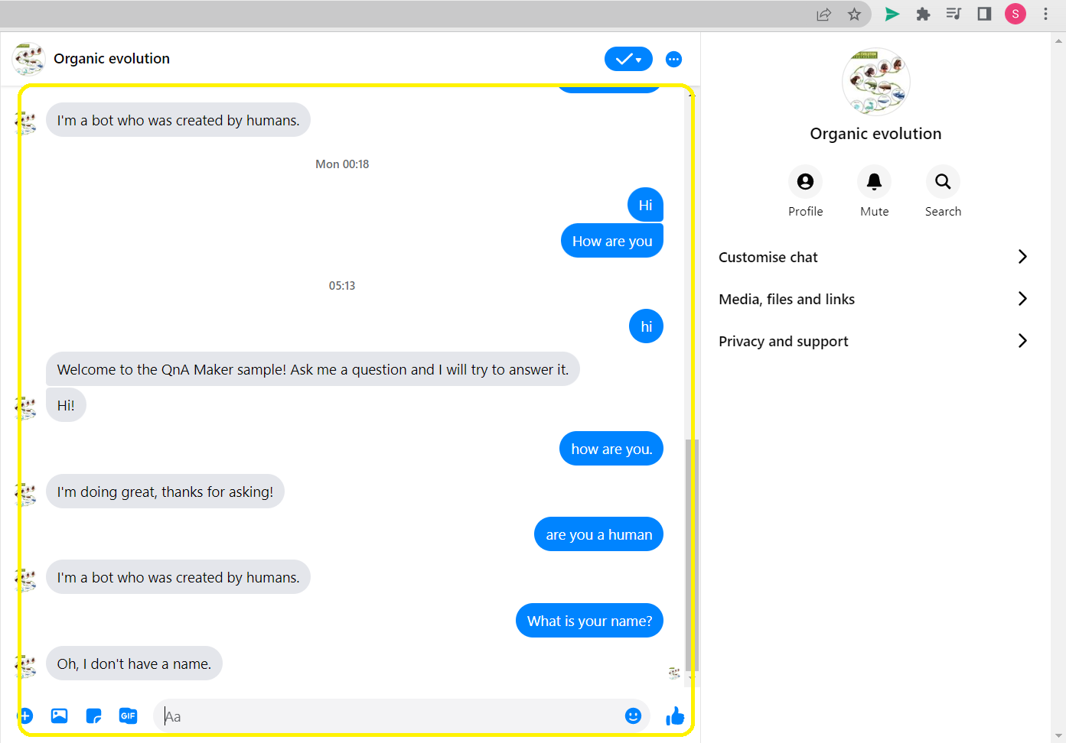

We can chat in Messenger page to test now.

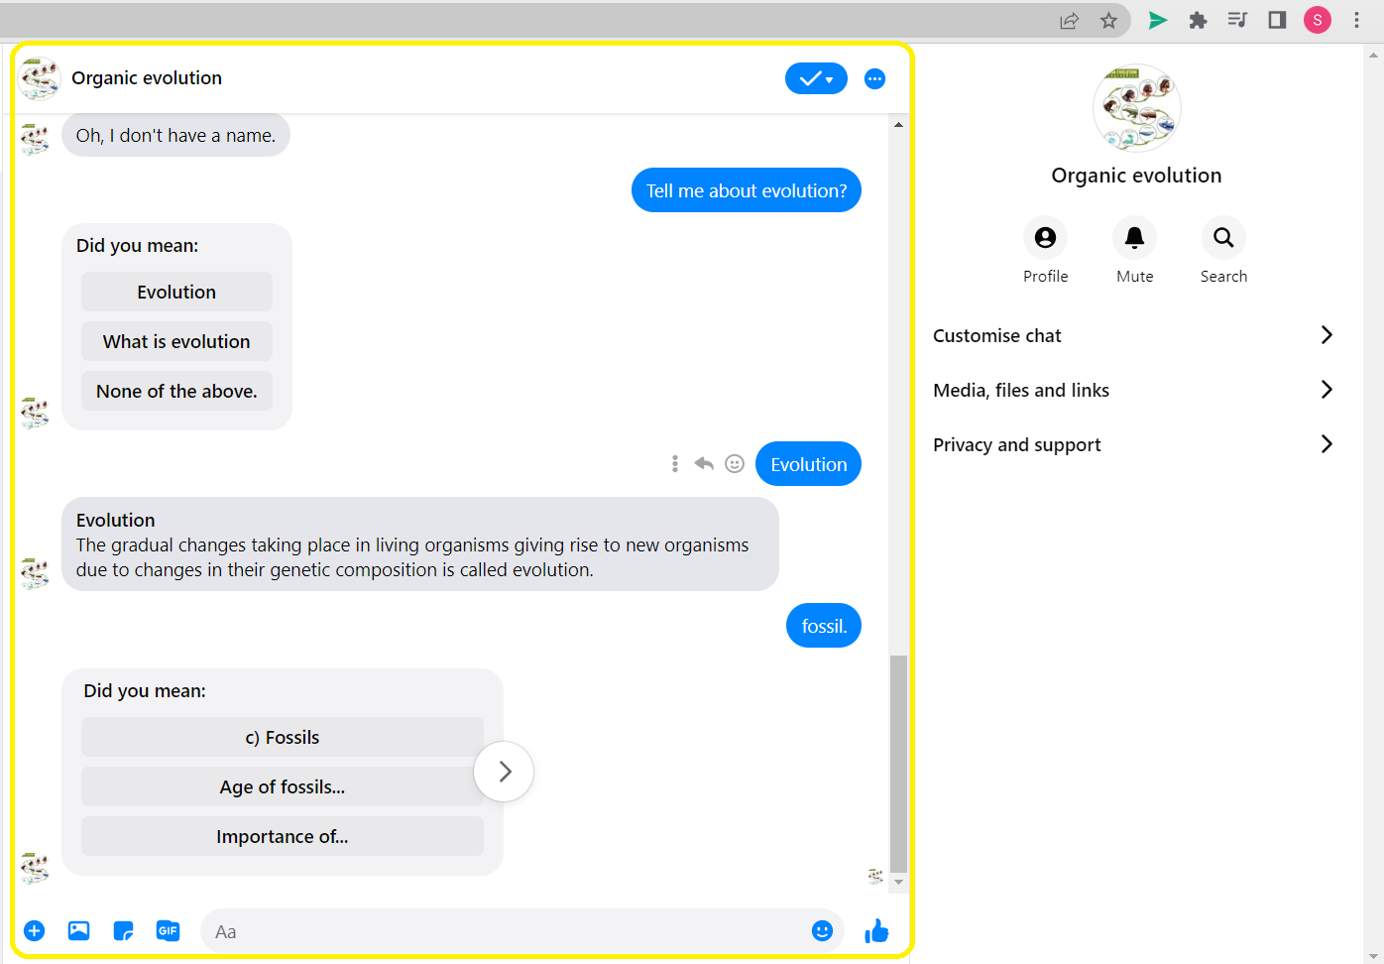

It is answering well for knowledge base in pdf but could be improved by providing more utterances.

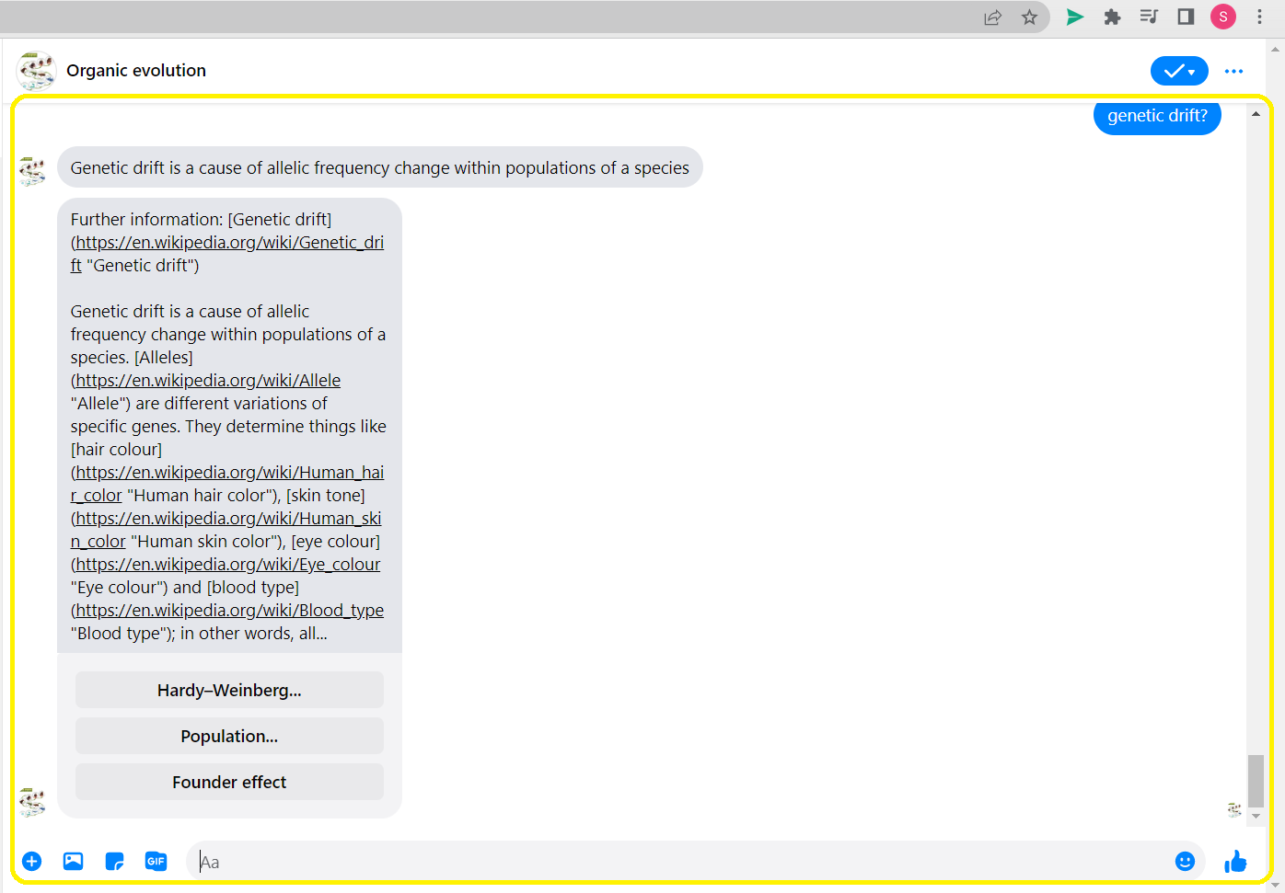

It is also able to answer from the web page source.

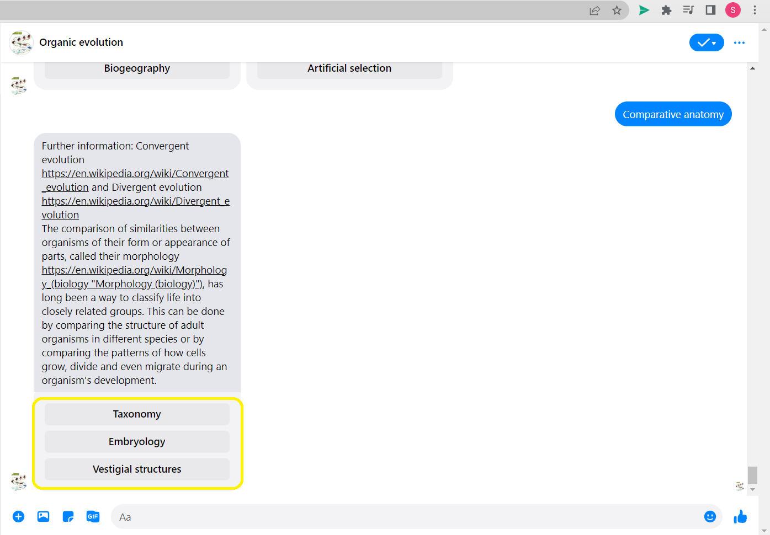

We also observe that bot is suggesting info on more topics under the topic asked by user, for further information.

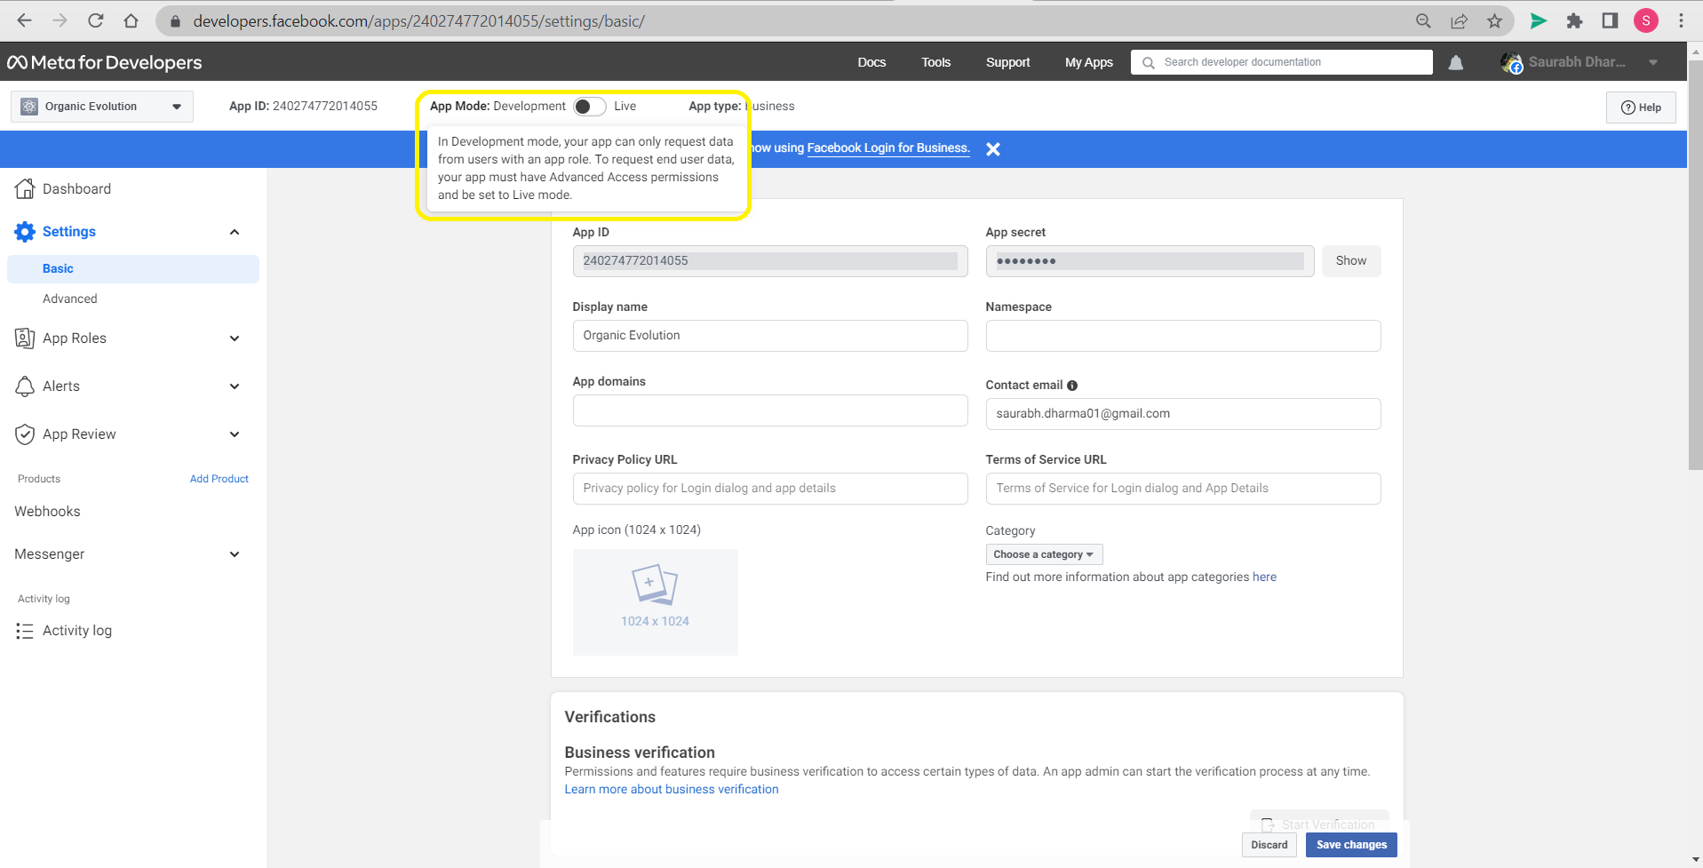

We can make this App live but we require to publish a privacy policy URL for doing this.

# Conclusion:

Making an QnA app on Facebook Messenger was successful and it is giving a satisfactory result as we chat. This bot can further be analysed and improved. Also, we can add more data sources to this machine son it is updated with knowledge source.

**References**

Kendriya Vidyalaya Sangathan (n.d.). Heredity [Online]. Available at: https://no1patna.kvs.ac.in/sites/default/files/Heredity_0.pdf (Accessed: 06/05/2023).

BYJU'S (n.d.). CBSE Class 10 Science Notes: Chapter 9 - Heredity and Evolution. Available at: https://byjus.com/cbse-notes/cbse-class-10-science-notes-chapter-9-heredity-and-evolution/ (Accessed: 06/05/2023).

Wikipedia contributors (2021). Introduction to evolution. In: Wikipedia. Available at: https://en.wikipedia.org/wiki/Introduction_to_evolution (Accessed: 06/05/2023).